## Test Evidence

**Note: A number of tests in this section, particularly from Test IDs 0 to 20, were performed during an earlier stage in development. Because of this, some sections of the UI were not fully implemented. However, the functionality that they are being tested for has not changed since their tests were performed.**

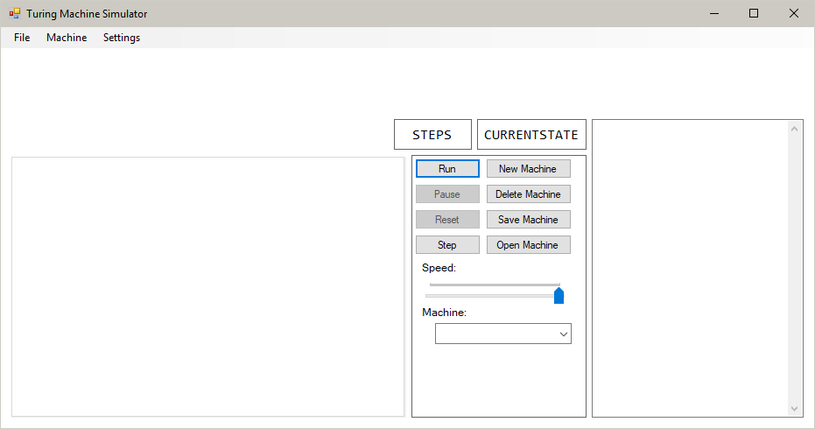

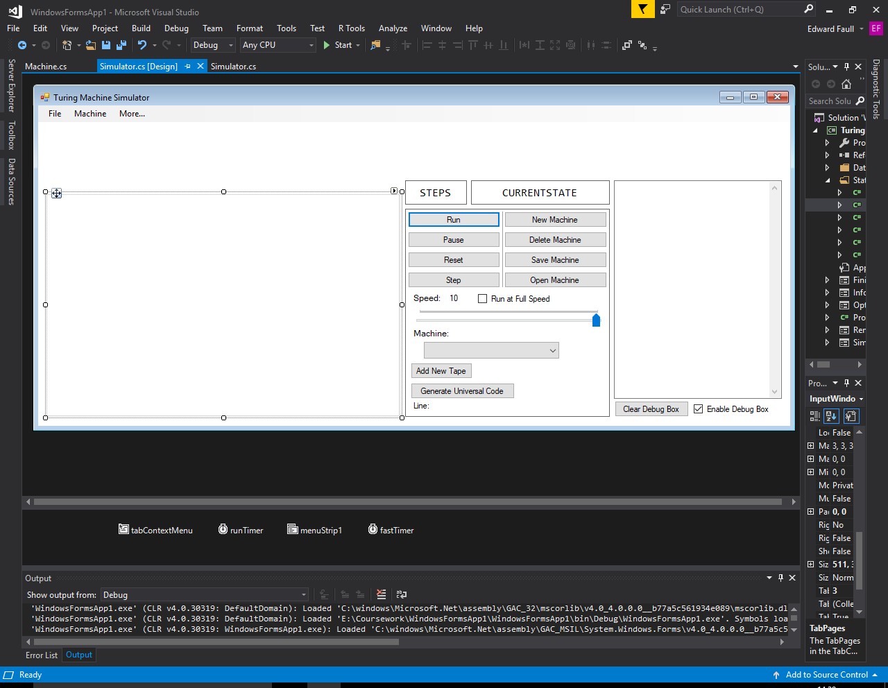

When the solution is built, the program loads a UI identical to the design in Visual Studio. The text editor (bottom-left) contains no tabs and there is no tape (top) loaded in the machine. The only difference between the built program and the design in Visual Studio is the design of the individual elements. The solution is built in Windows 10, so the design of the window will be based off the pre-set design settings of this operating system, while the Visual Studio editor uses the design from another operating system.

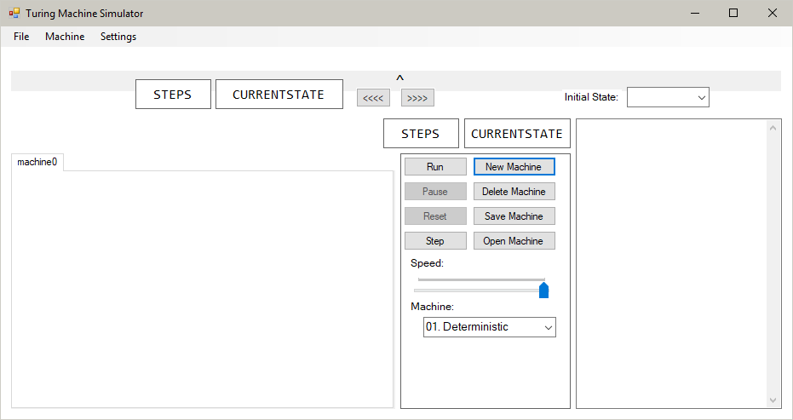

A new machine with all fields blank is created. This creates a new tab in the text editor with the name “machine0”, and a new, blank tape is produced with the read/write head in the middle of the tape. The initial state is blank and the machine variant is Deterministic.

After pressing ‘New Machine’:



After pressing ‘Close Machine’:

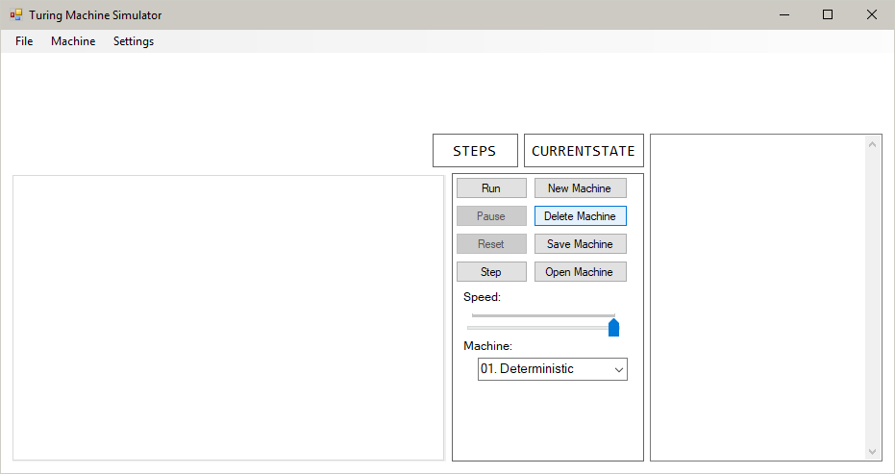

Deleting the machine removes the selected tab from the text editor, and also removes the tapes from the program.

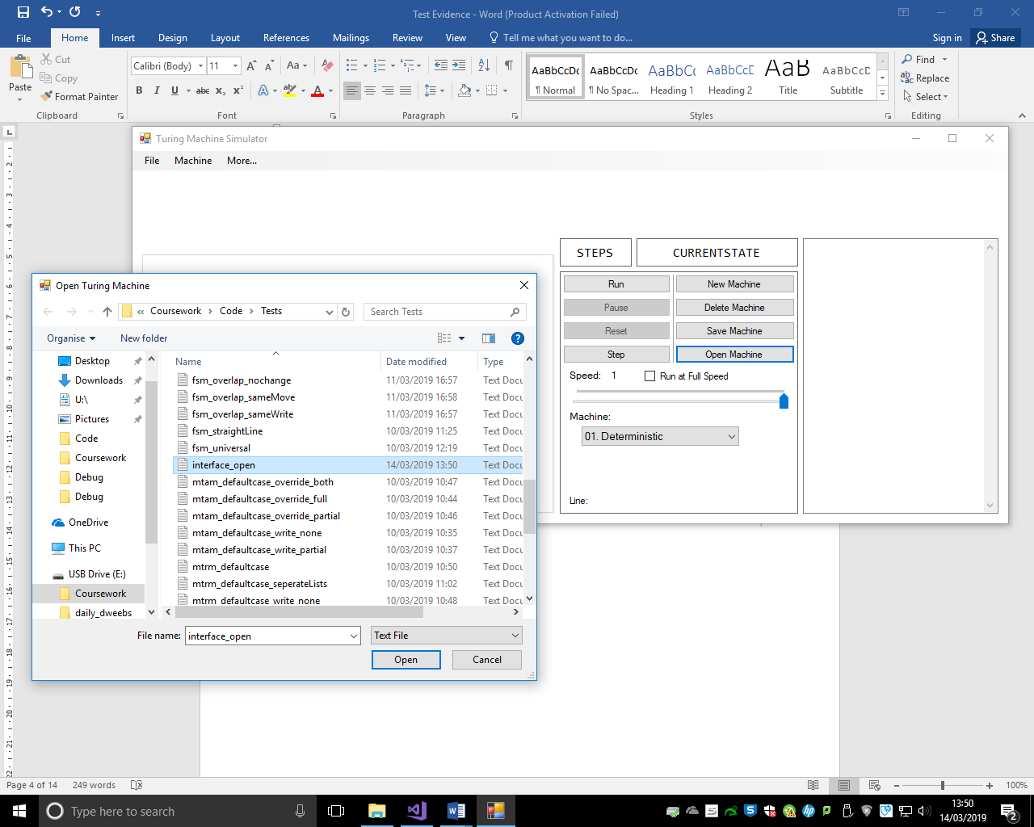

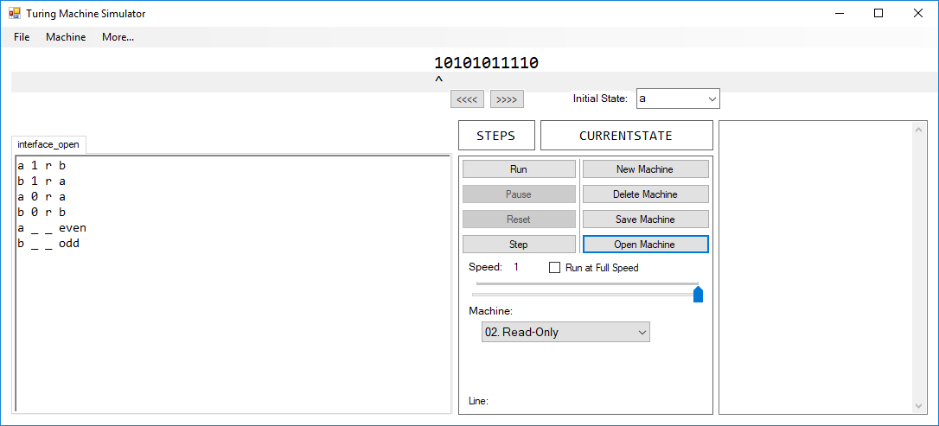

After selecting “interface_open.txt”, the file is read and the values are set correctly according to what is specified in the text file. The machine is Read-Only, its initial state is “a” and its tape is “10101011110” with the read/write head set to 0. The set of transition functions is identical to that of the text file’s.

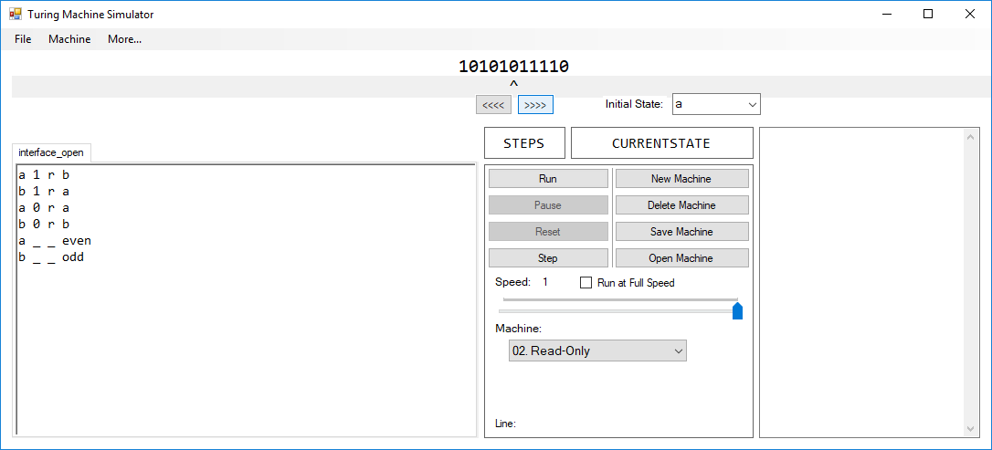

The read/write head has been moved to the 6th character in the tape. No other values have been changed. 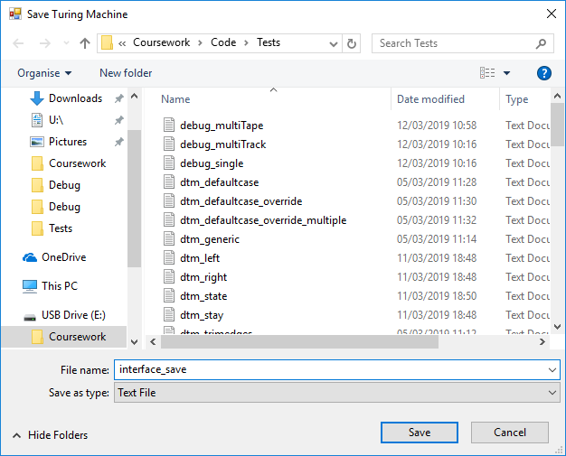

Saving to “interface_save.txt”, we can see that the resulting text file has successfully moved the read/write head value from 0 to 5:

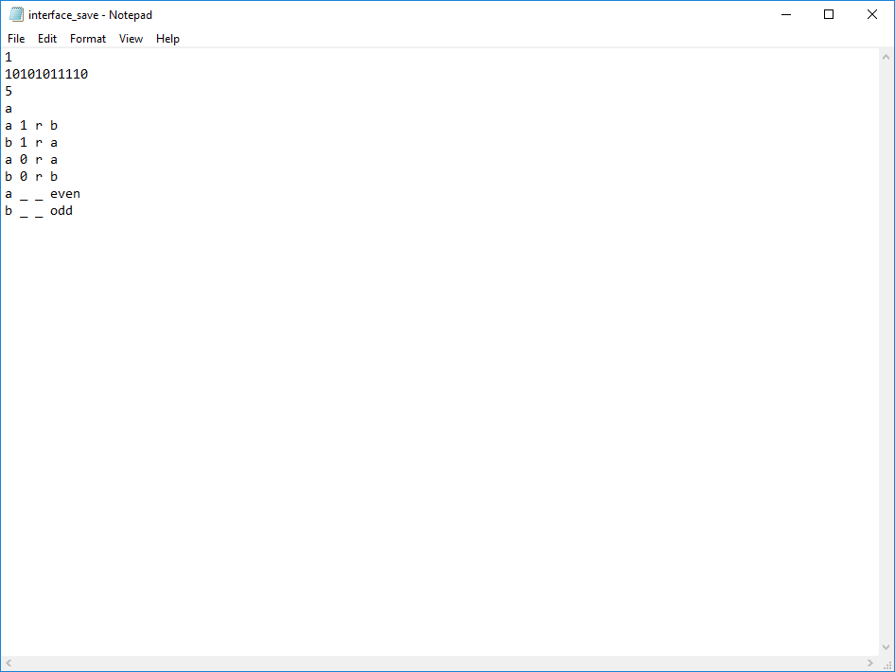

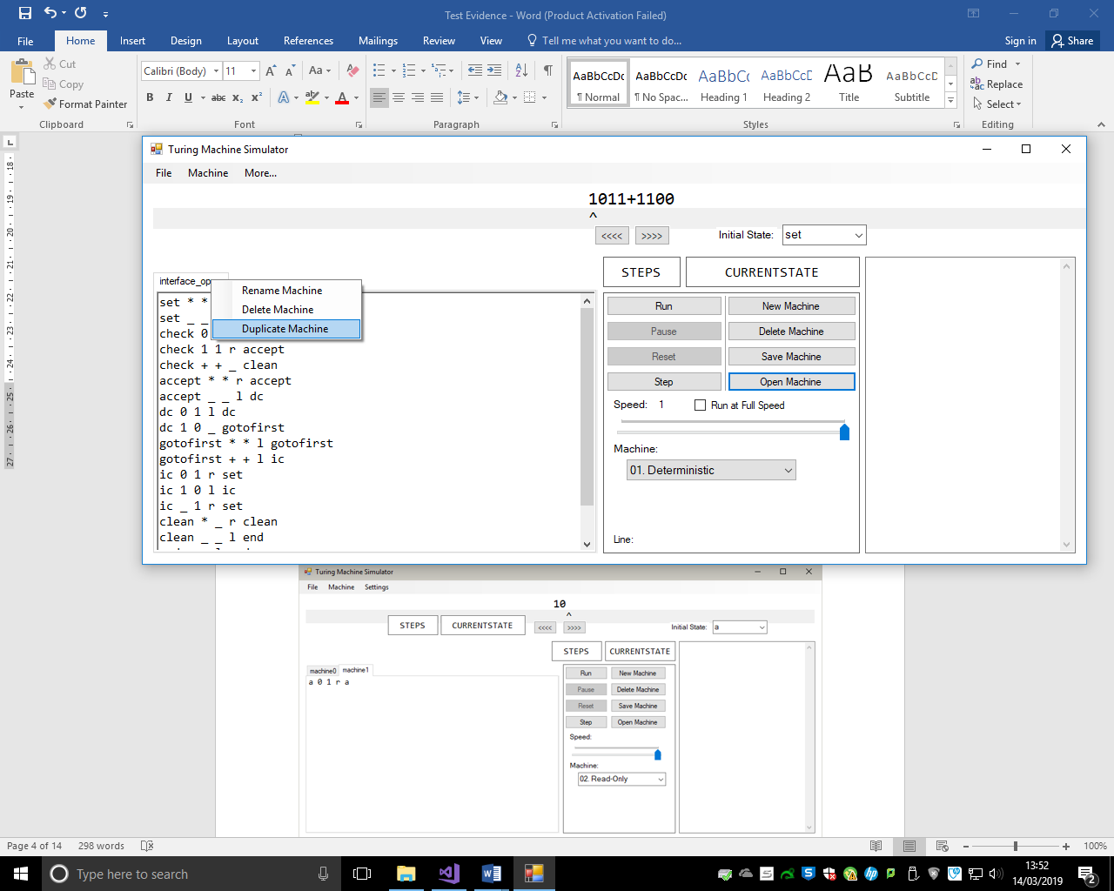

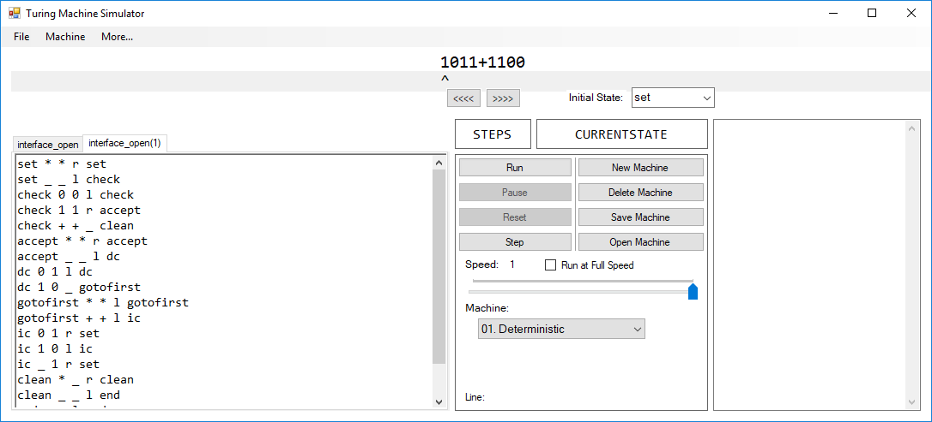

The duplicated machine is identical to the first machine. The name of the duplicated machine is the name of the original with a “(1)” on the end, which is correct.

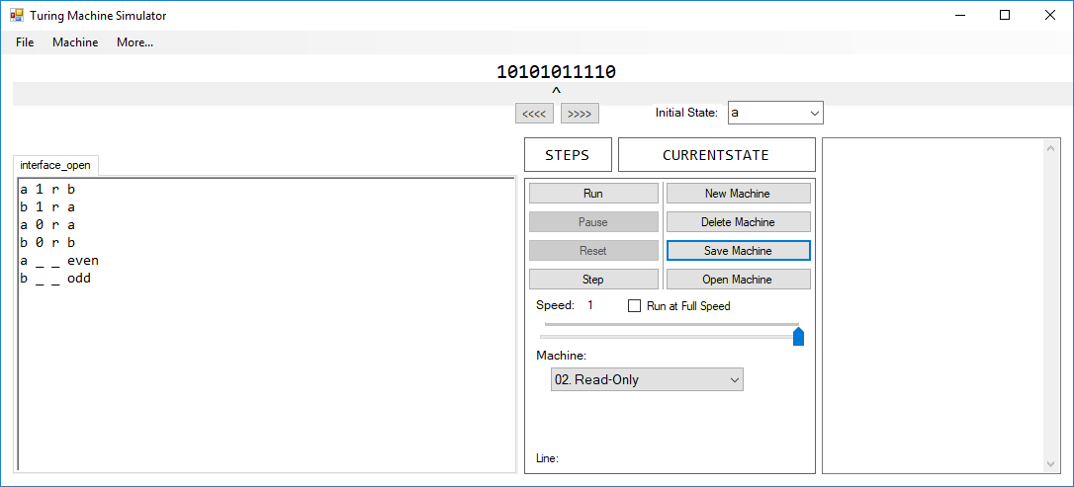

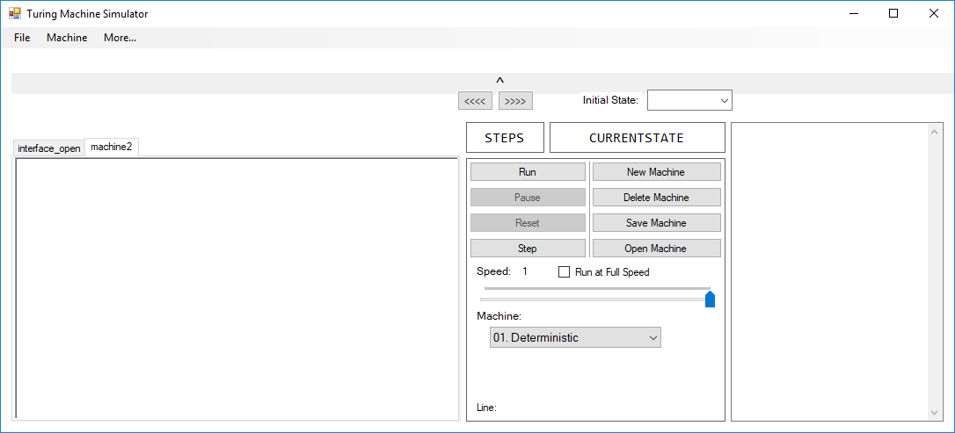

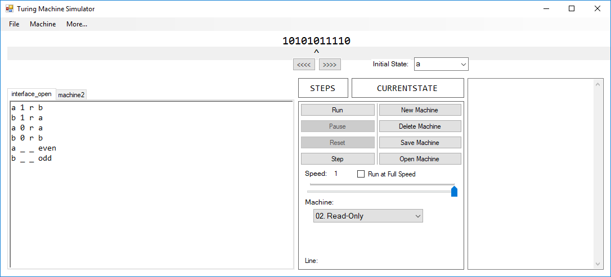

When changing tabs, the information in each field changes according to the current machine selected. No values have been changed in the first machine after switching to the next one.

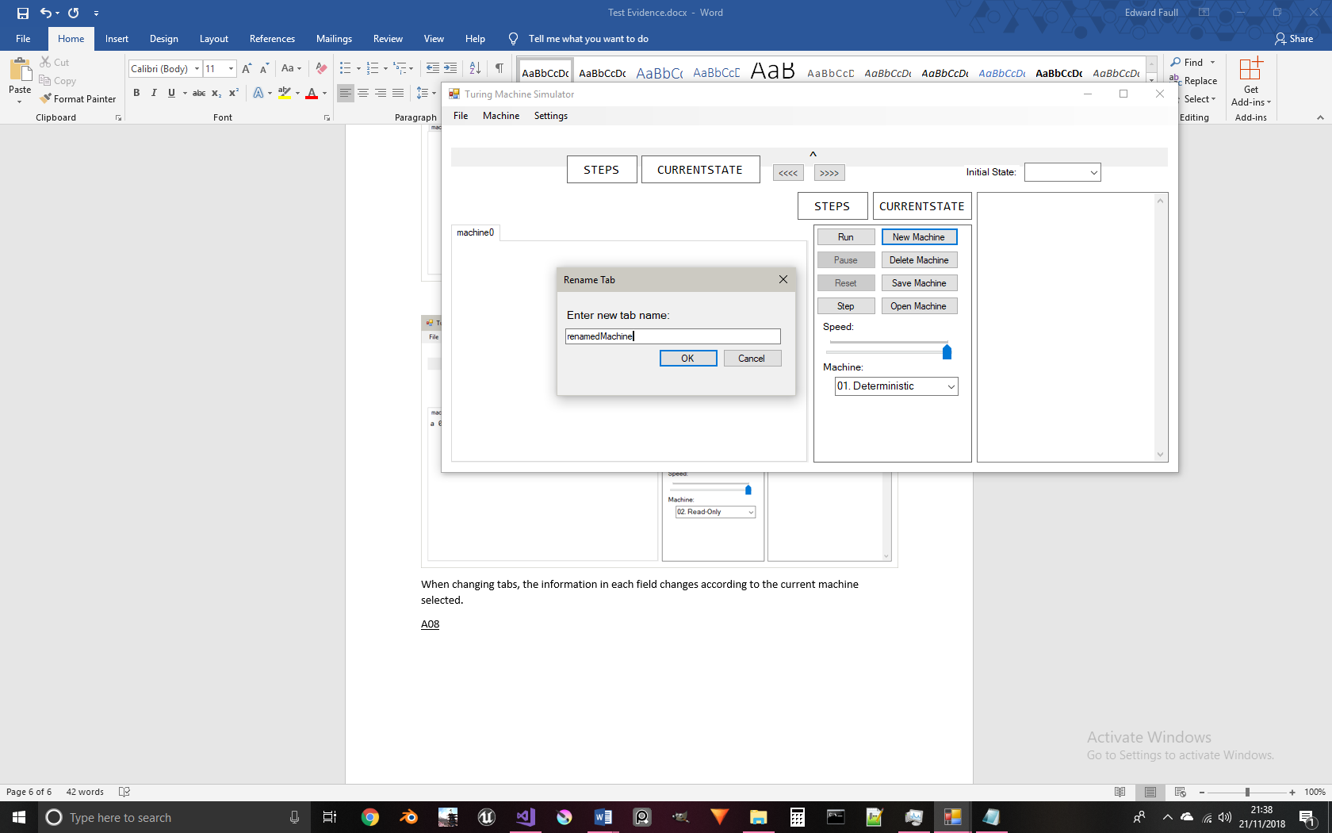

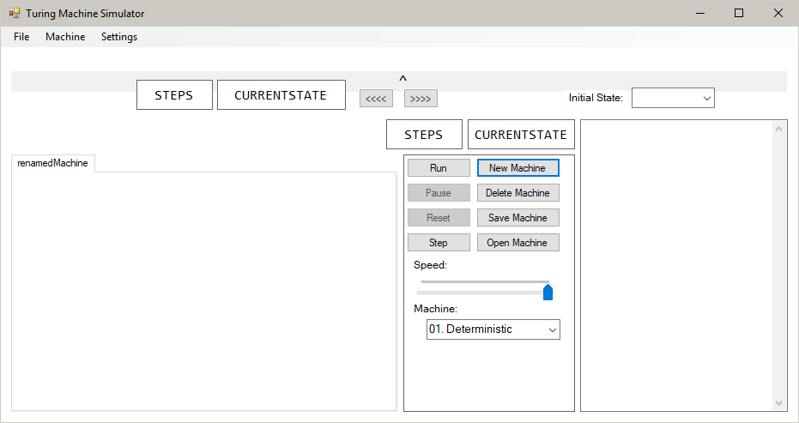

The new name of the machine is set as its tab’s label on the text editor.

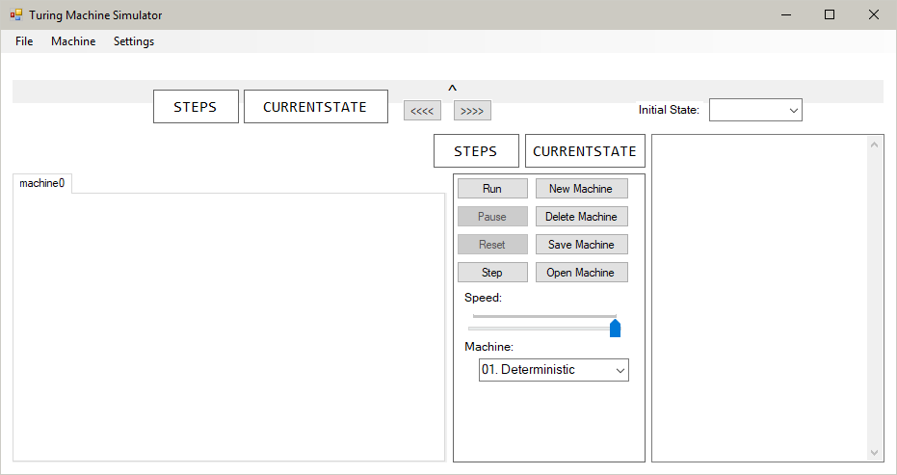

After pressing Ctrl+N, a new machine is created, identically to test 02.

The other shortcut options in the program are implemented in the same way to this one. As such, this test shows that all of the other shortcuts work as well.

This button is pressed:

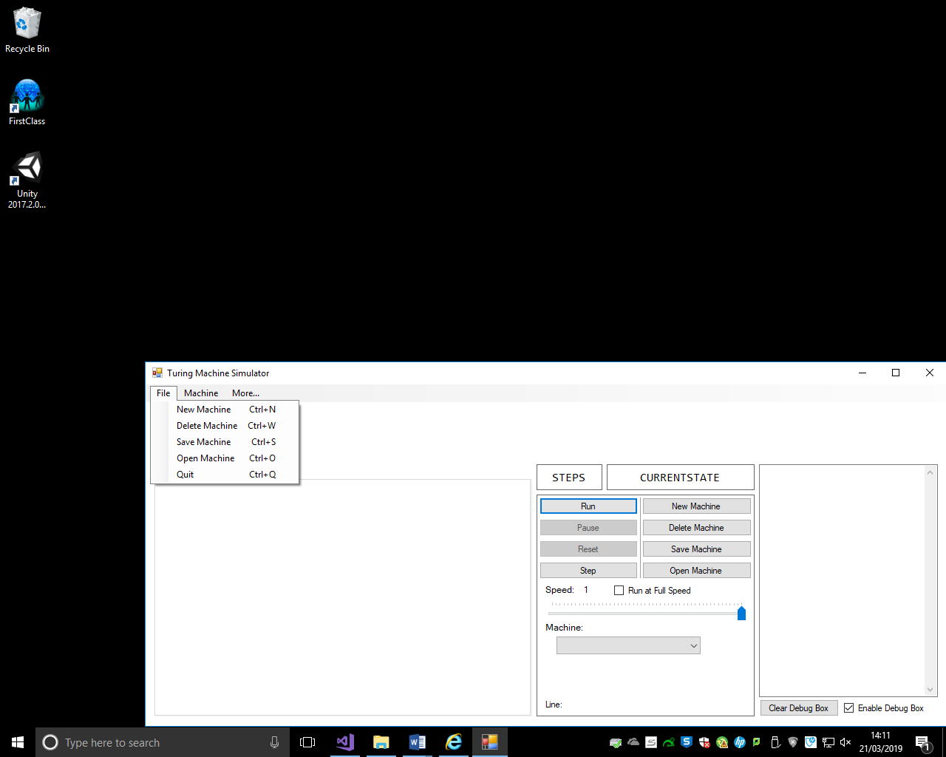

After pressing the button, the program is closed. This is shown by the fact that its icon has been removed from the taskbar:



This test has video evidence submitted alongside it: <https://www.youtube.com/watch?v=38SHbtvm1QU&t=0>

The video shows a key-logger in the backgorund that shows that when Ctrl and Q are pressed, the program closes.

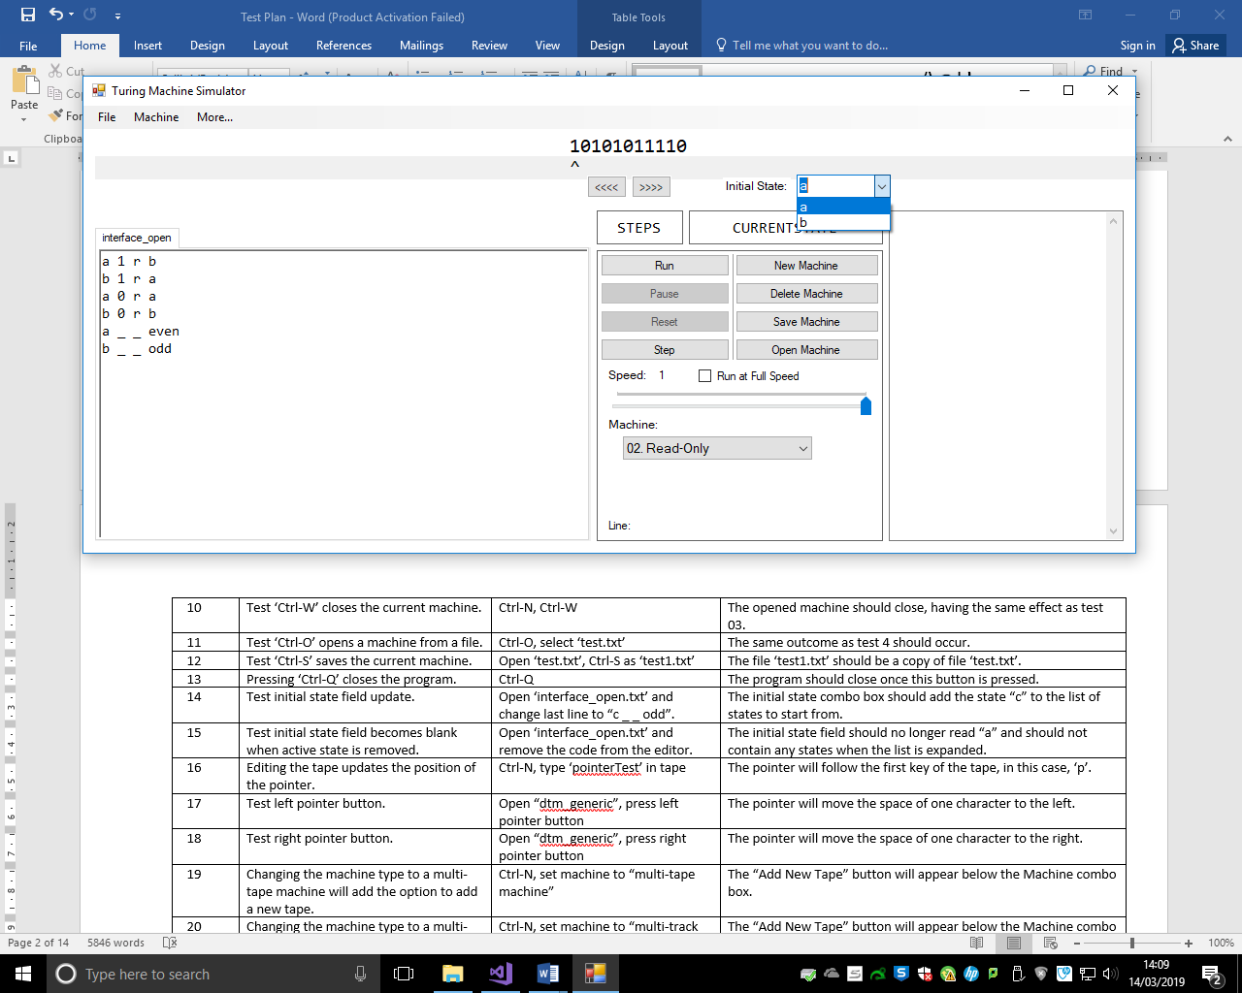

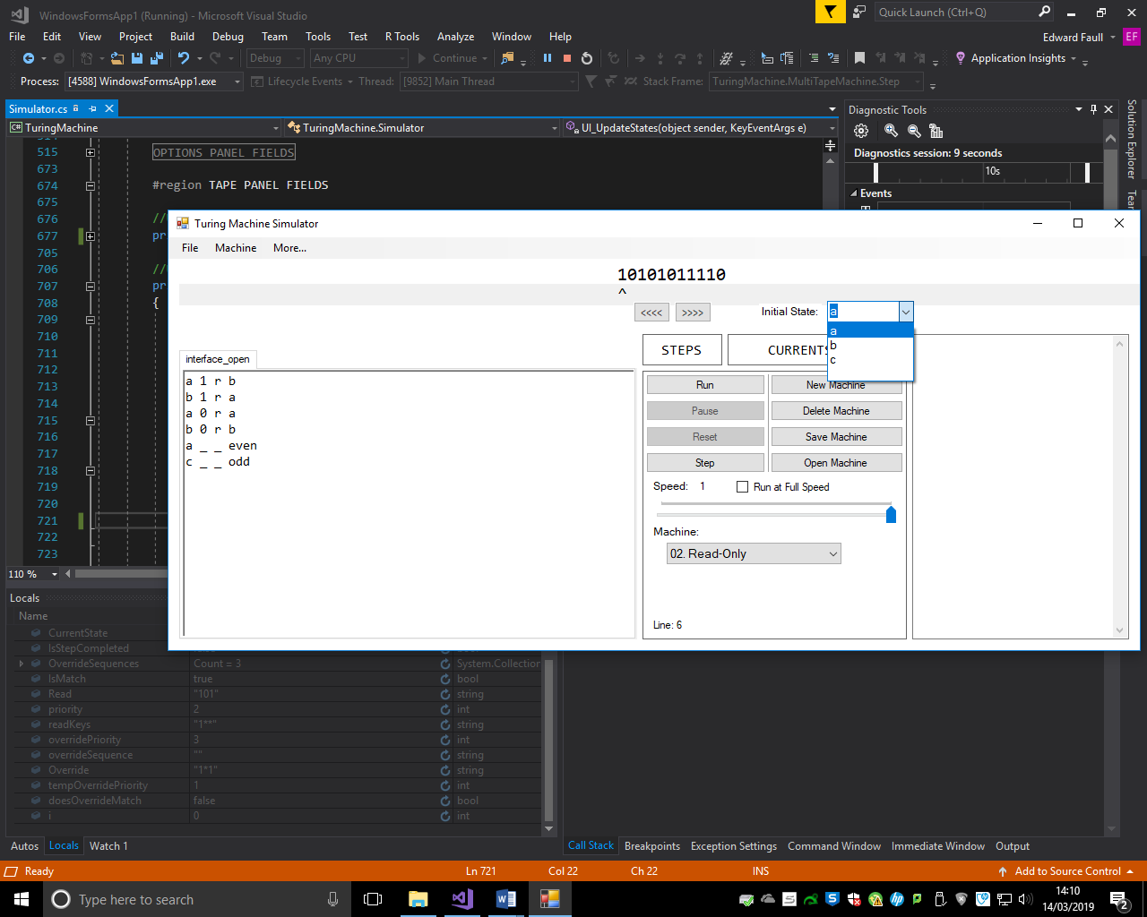

The state “c” is added to the list of states.



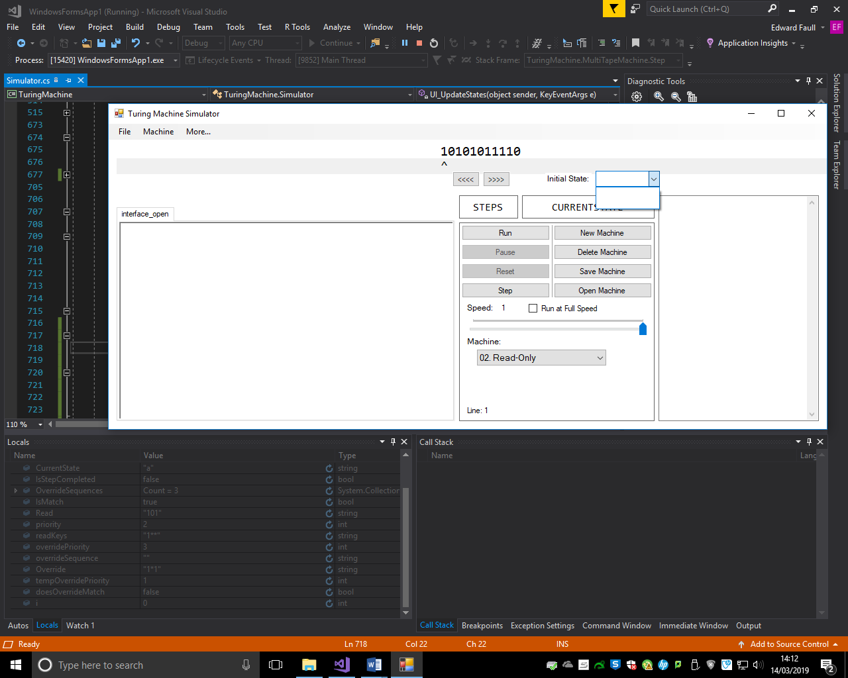

Removing the code from the text editor removes the states that could have previously been selected.

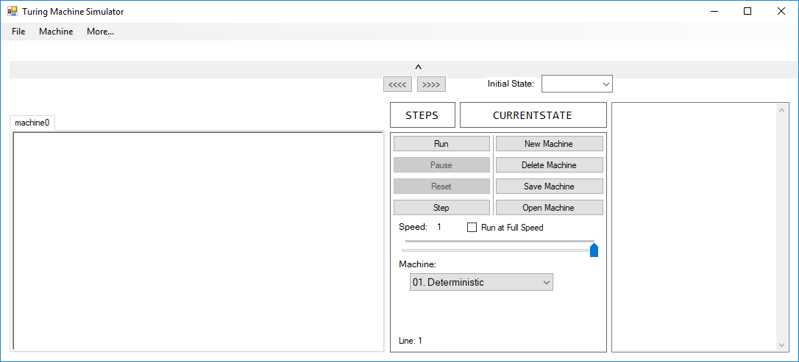

To start with, the read/write head points to the centre of the tape when it its blank. When it is written to, it stays with the first character in the tape:

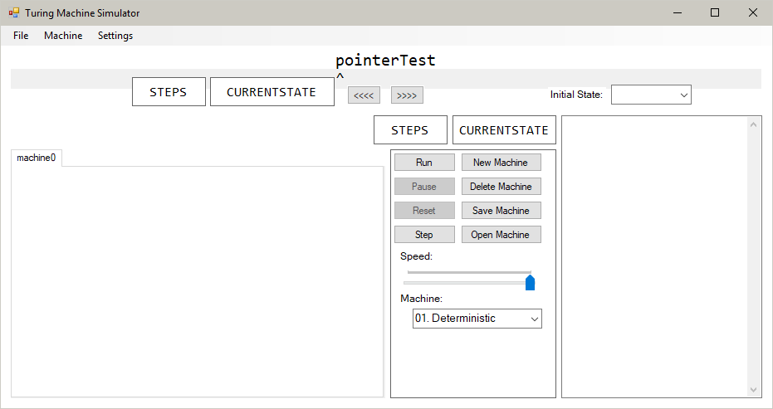

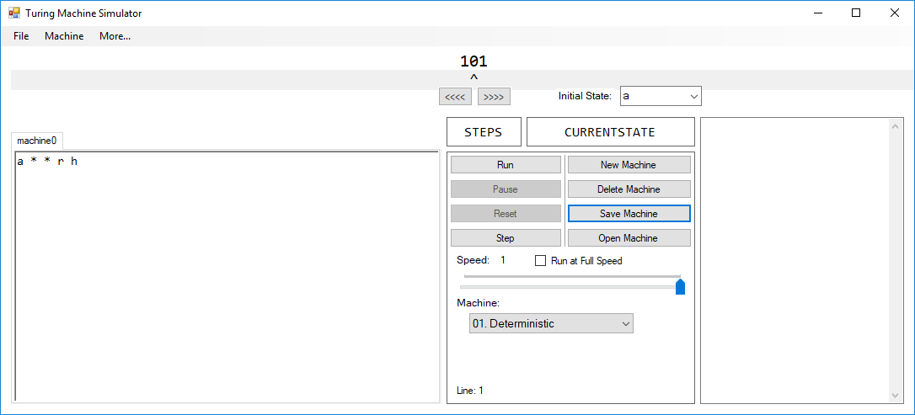

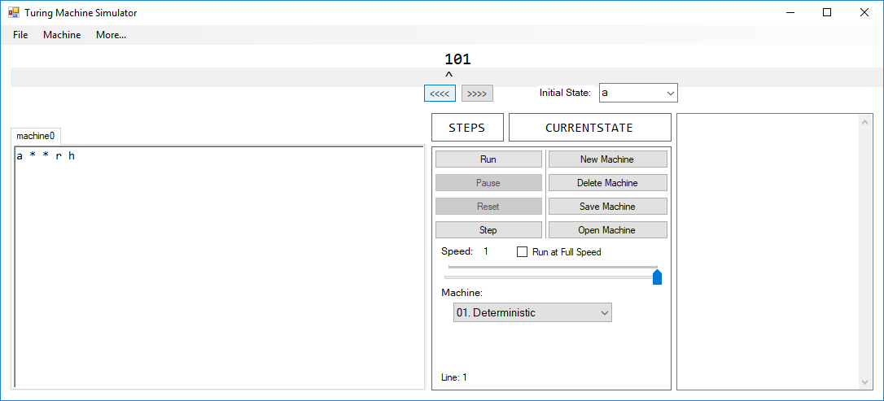

Pressing the left pointer button moves the read/write head one character to the left.



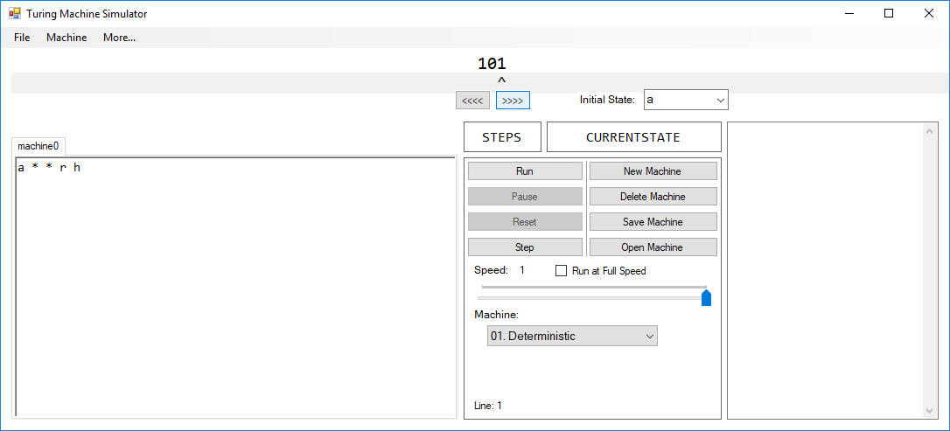

Pressing the right pointer button moves the read/write head one character to the right.

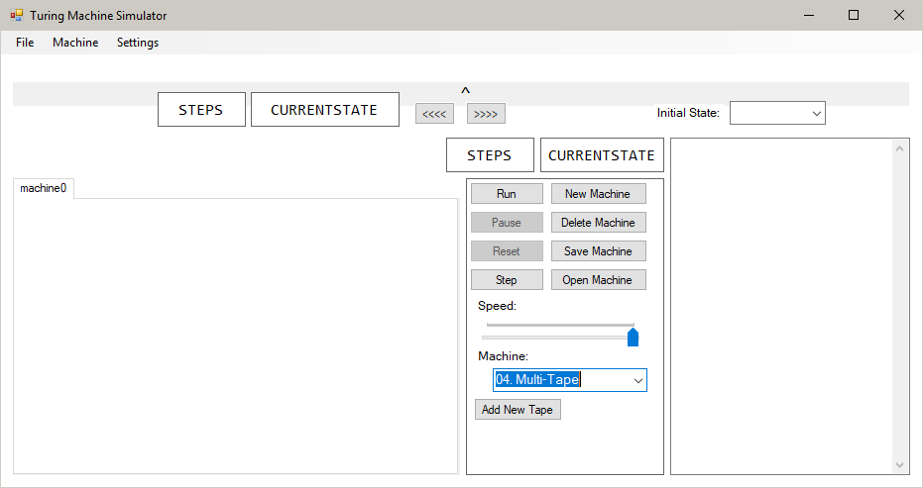

Below the machine selection box, the new button has appeared.

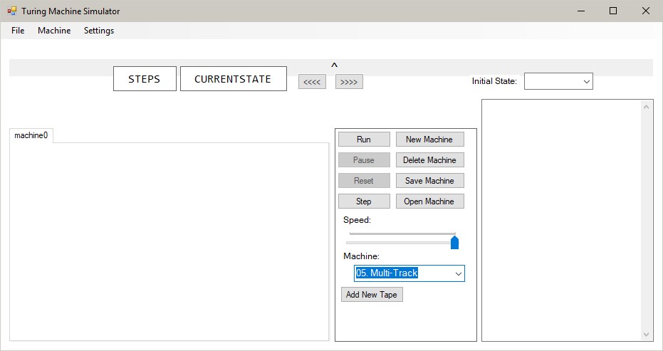

Below the machine selection box, the new button has appeared.



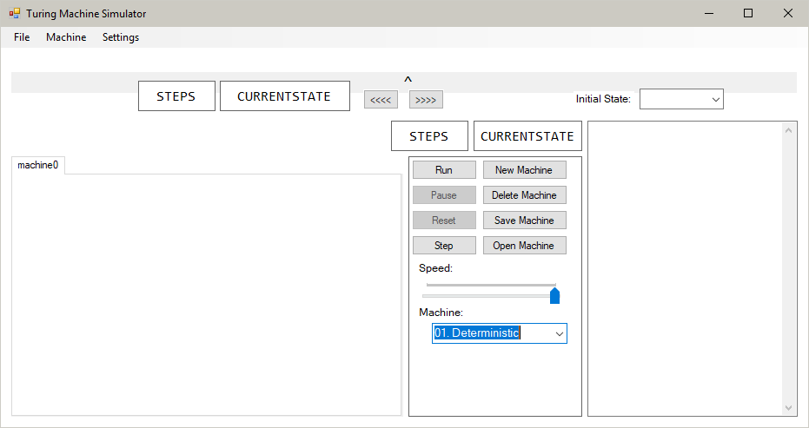

When the machine is set back to 1, the option to add a new tape is removed from the options pane.

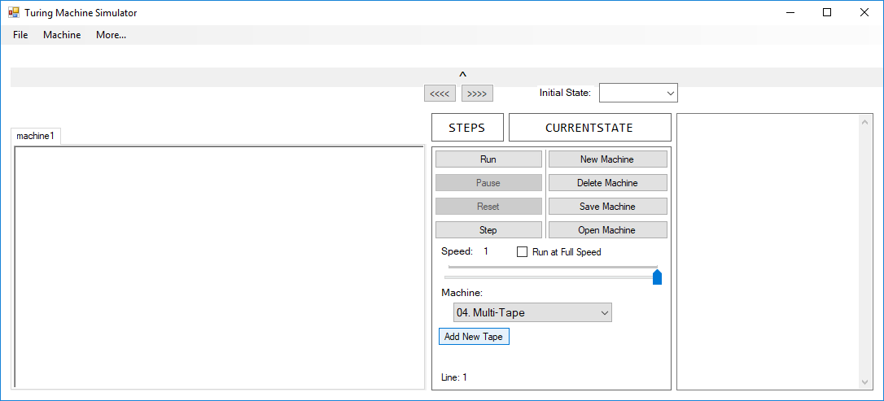

Before pressing “Add New Tape”, one tape exists in the machine. After:

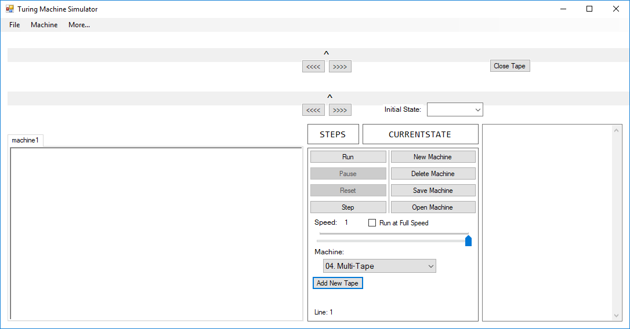

Another tape is produced, with blank values and the option to close it is visible.

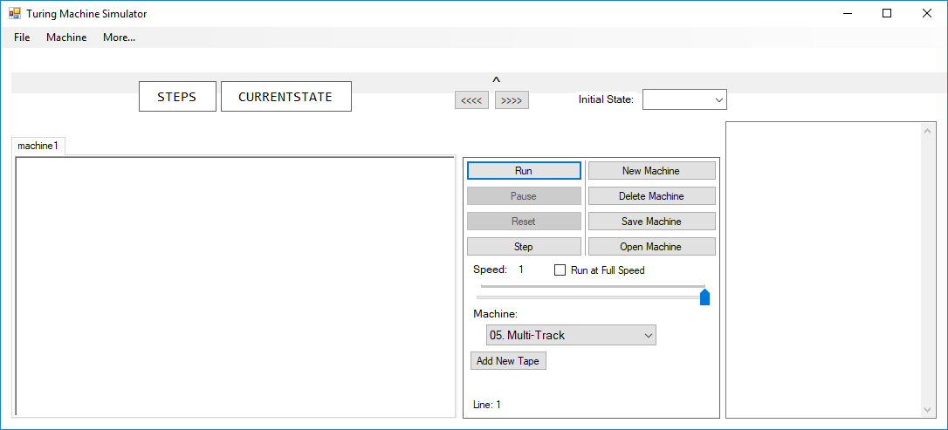

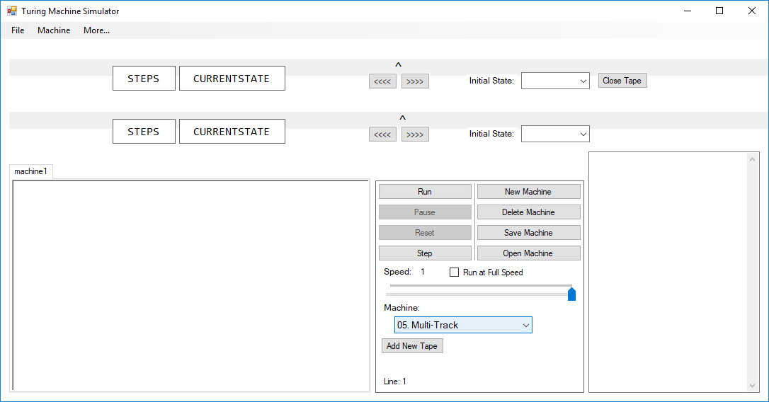

The new tape has all of the options of the tape enabled, including the tape-specific initial state box, labels to identify the tape’s state and count and the button to close the tape.

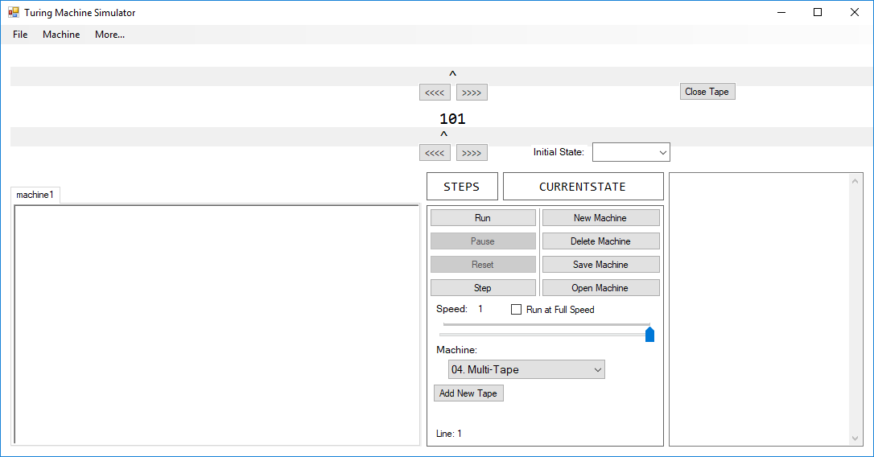

After adding information to the first tape, the tape at the top is still blank. After editing the second tape:

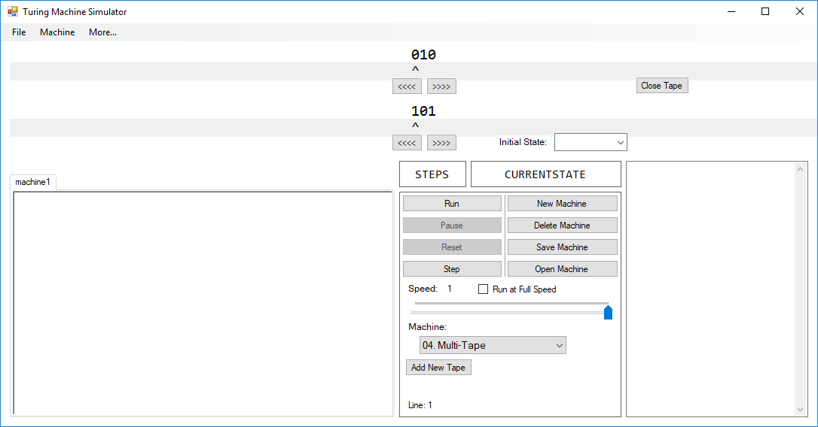

The second tape’s contents are updated and the first tape’s values are unchanged.

Initial tape appearance:

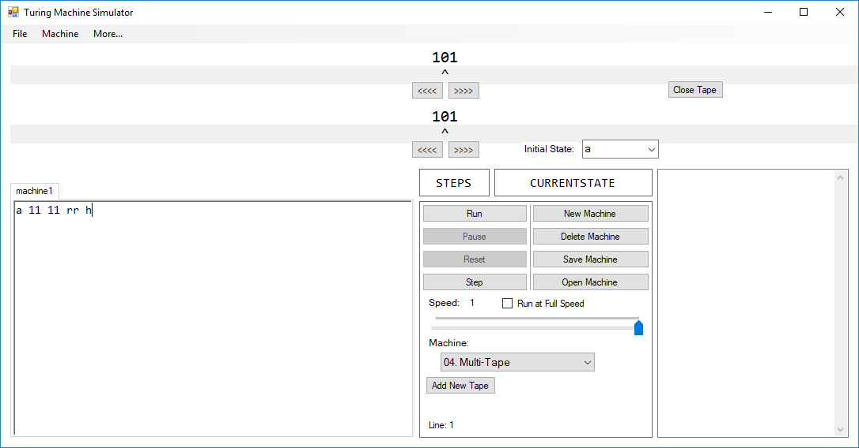

Pressing the left button on the first tape moves the read/write head of that tape one character to the left. The second tape’s pointer is unchanged.

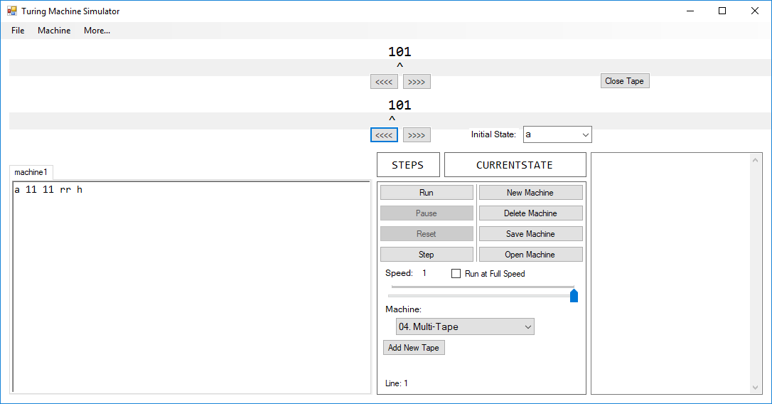

Pressing the right button on the second tape moves the read/write head of that tape one character to the right. The first tape’s pointer stays where it is.

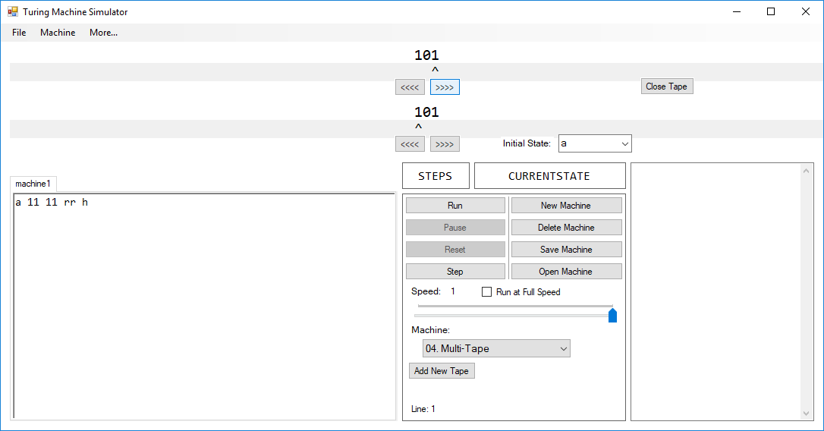

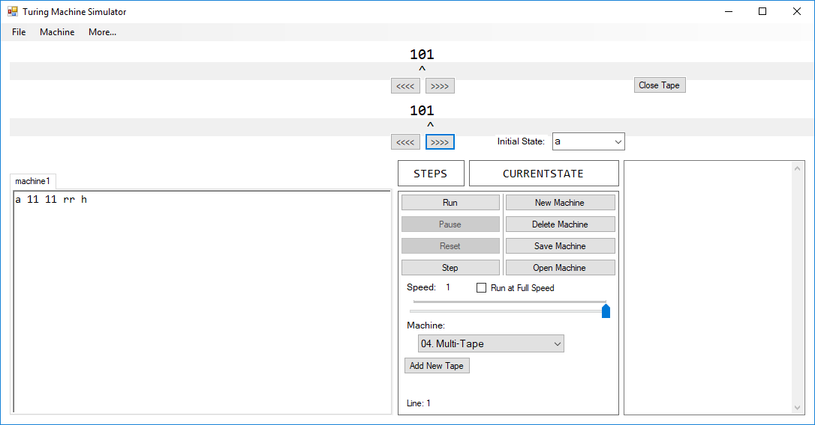

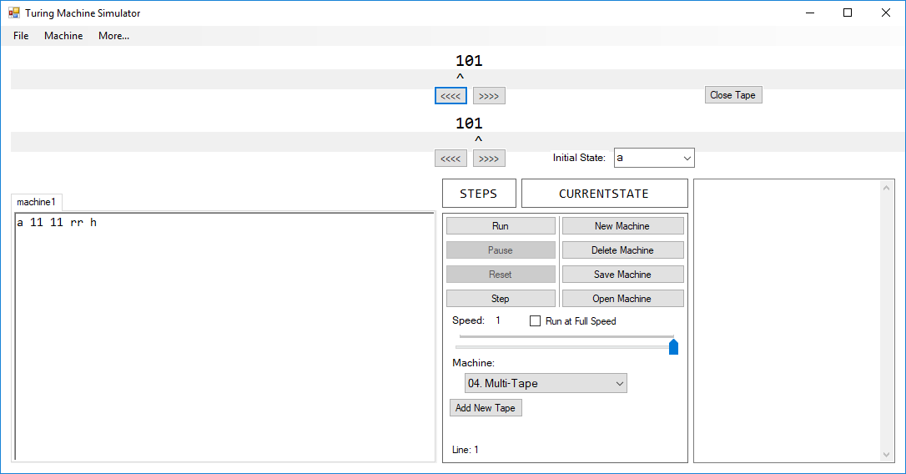

When the two read/write heads are moved, the position of the other read/write head does not change.

Initially, the first tape’s state is “a” and the second’s is “b”.

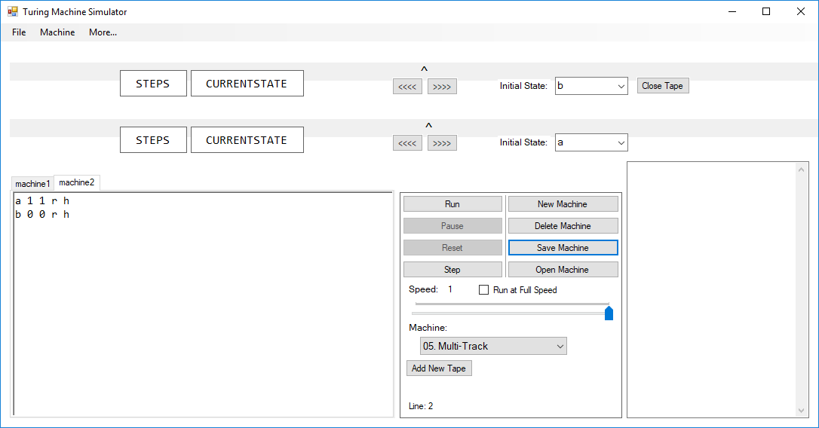

When changing the first tape’s state to “b”, the second tape’s state remains unchanged:

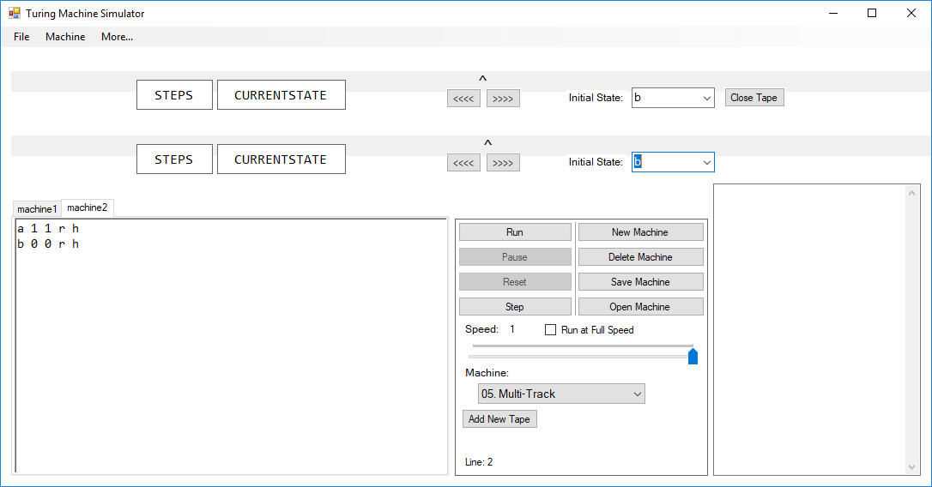

When changing the second tape’s state to “a”, the first tape’s state remains the same:

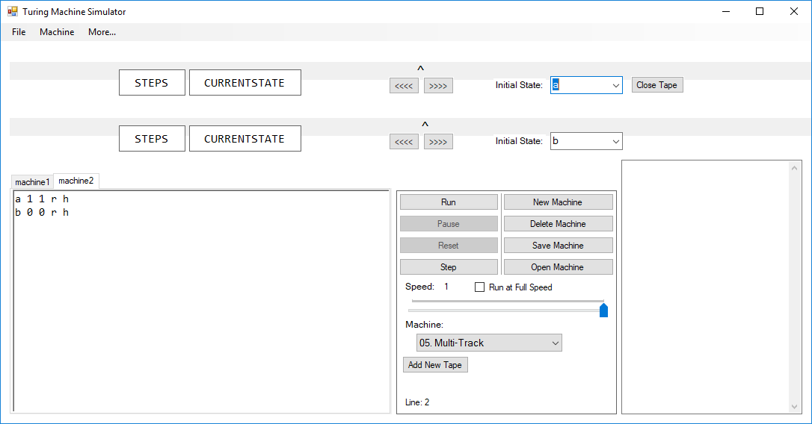

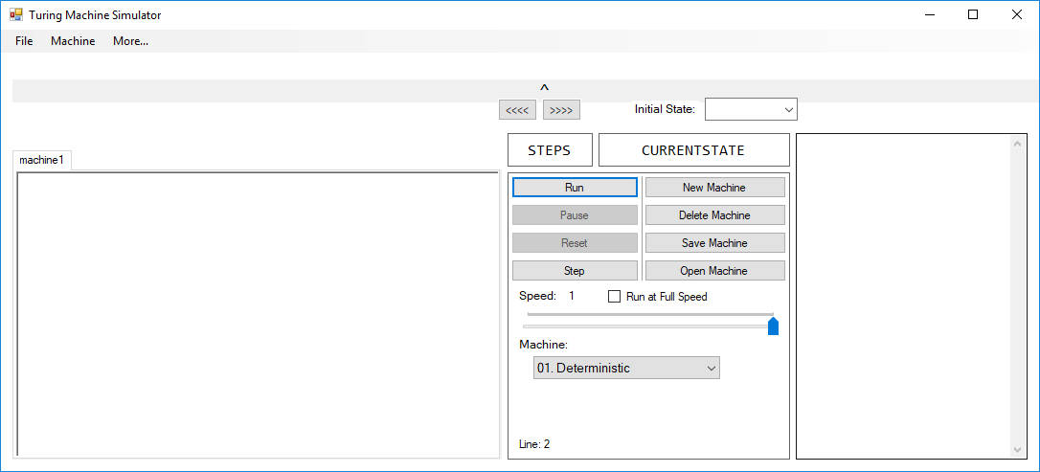

When changing to a multi-track machine, the standard set of labels disappear:

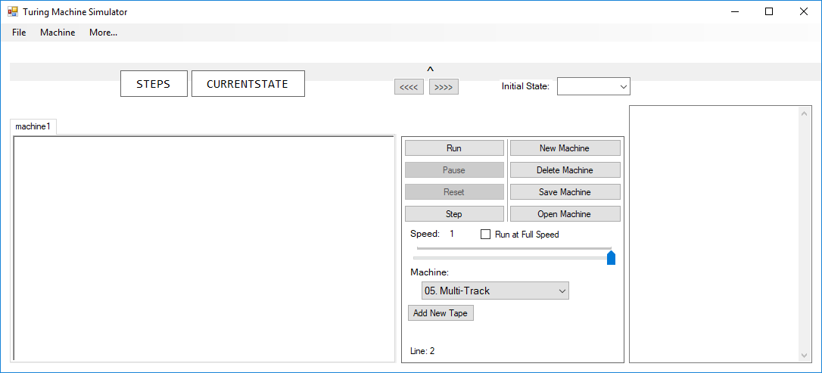

A set of labels appear next to the tape on the machine. When adding another tape to the machine:

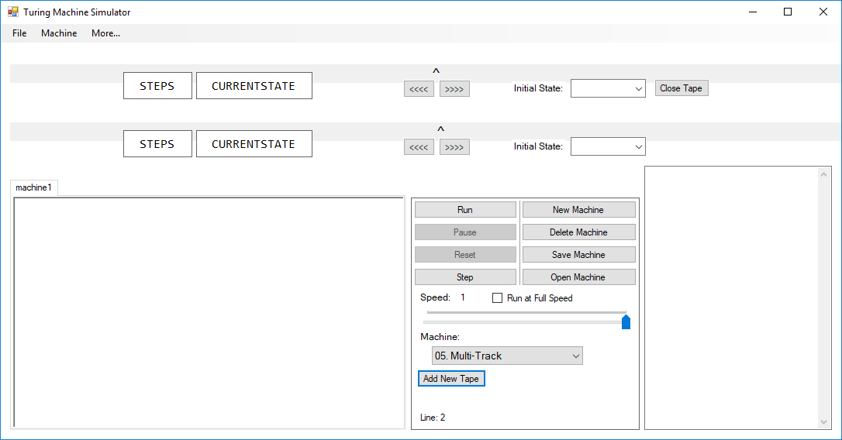

Both tapes in the multi-track machine has its own pair of labels.

In a multi-track machine, the labels are visible next to the tapes, and the standard set of labels are not visible:



After changing to a multi-tape machine, the individual tape labels disappear and the whole machine labels return:

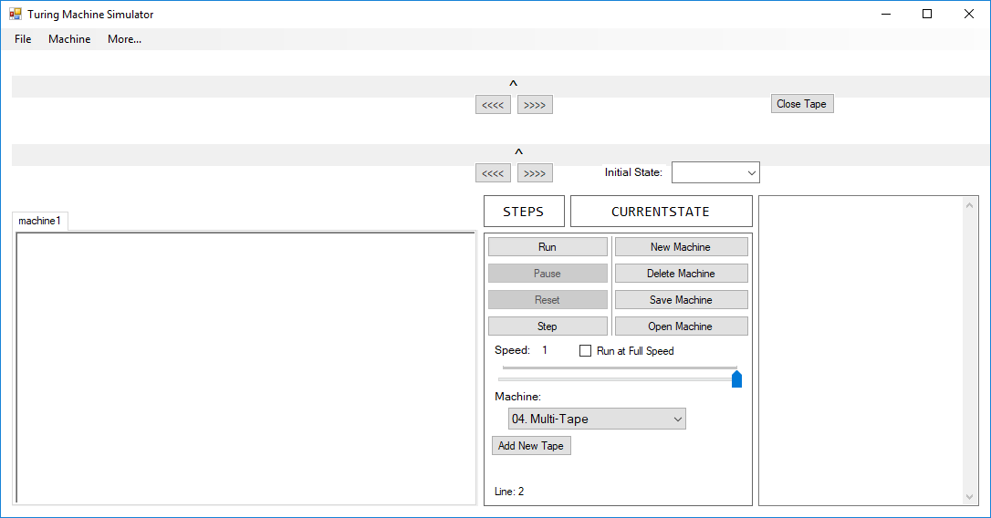

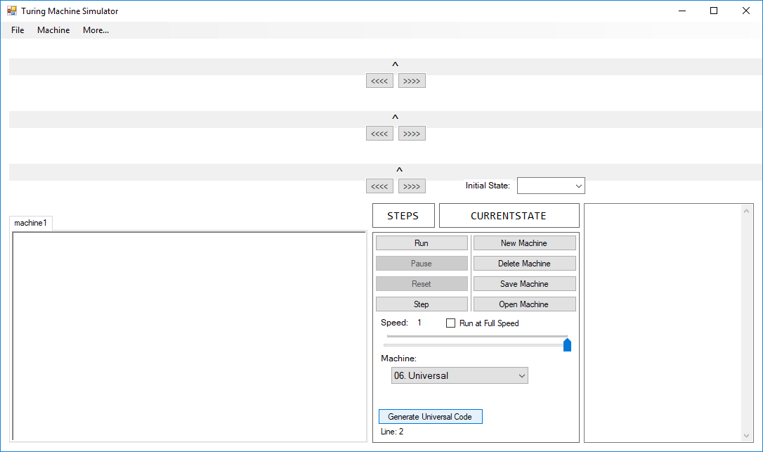

Making the machine variant “Universal” makes the “Generate Universal Code” button visible.

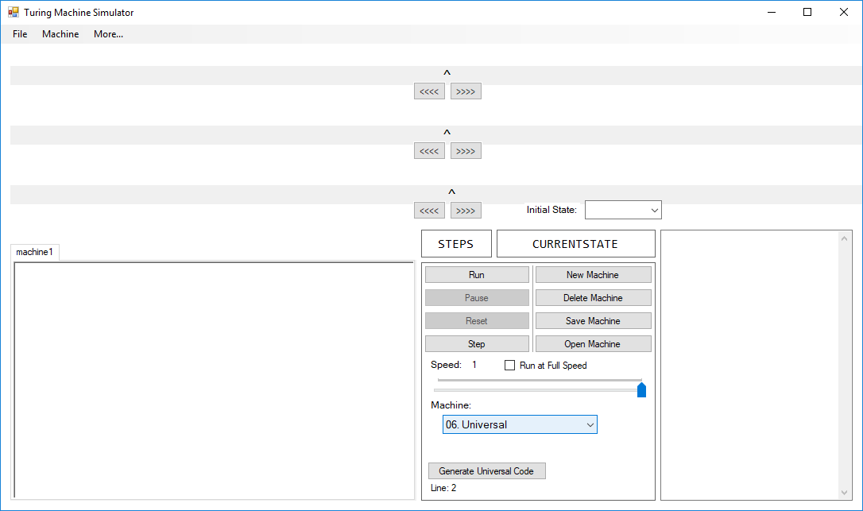

There are three tapes, with no option to close them and no tape specific labels. The only tape with the initial state drop-down box visible is the first tape.

The following selection is copied to the clipboard:



When attempting to paste this into the text editor, the image selected is removed:

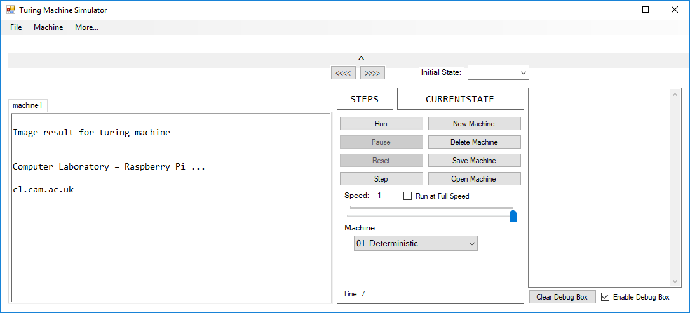

Before pressing the Undo shortcut, the text editor contains:

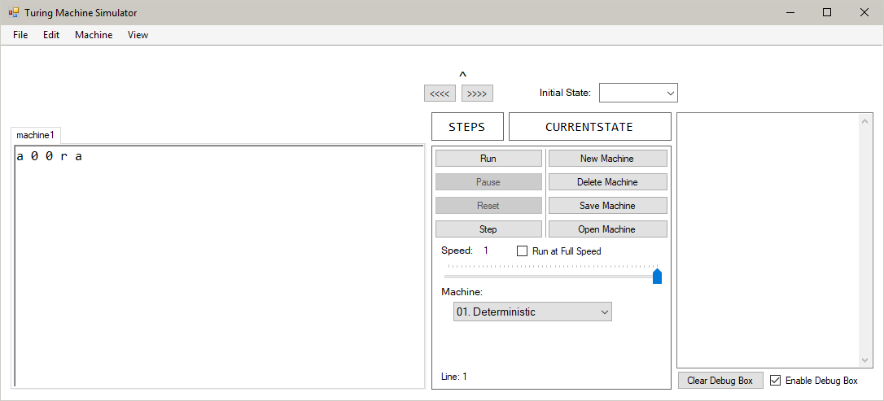

Pressing Ctrl-Z removes the addition to the text editor:

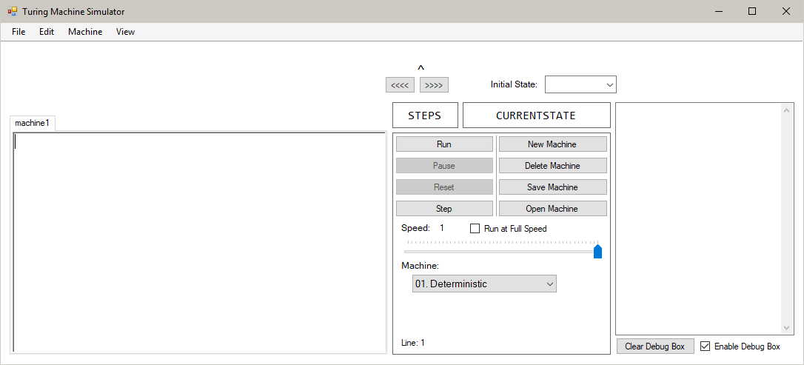

Pressing Ctrl-Y returns the edited contents to the editor:



The tape’s initial contents is:

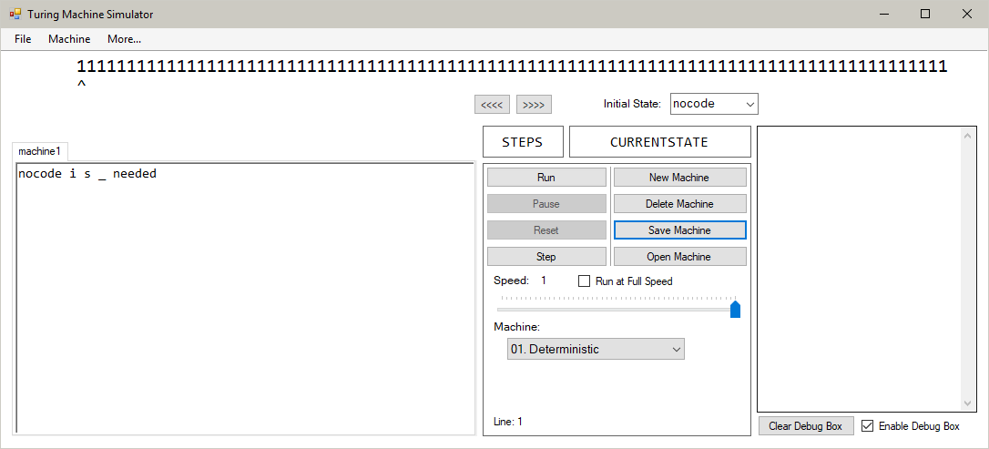

After adding the first character, the font size of the tape is reduced to fit it onto the tape. The font size of the read/write head has also reduced to line itself up with the tape:

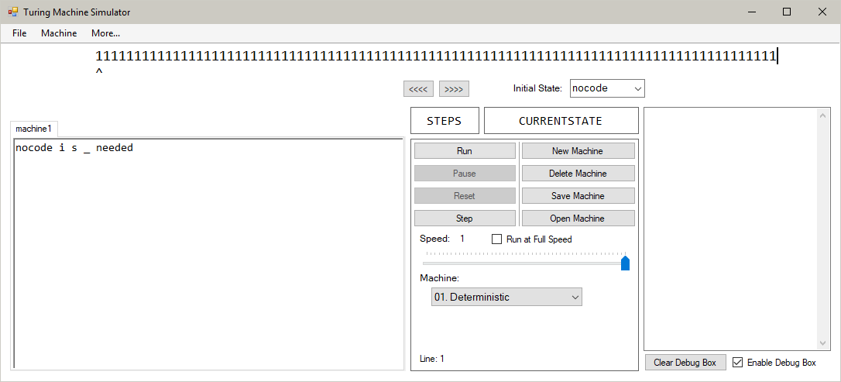

The next four characters are added normally, as they do not reach the ‘maximum’ size for the tape:

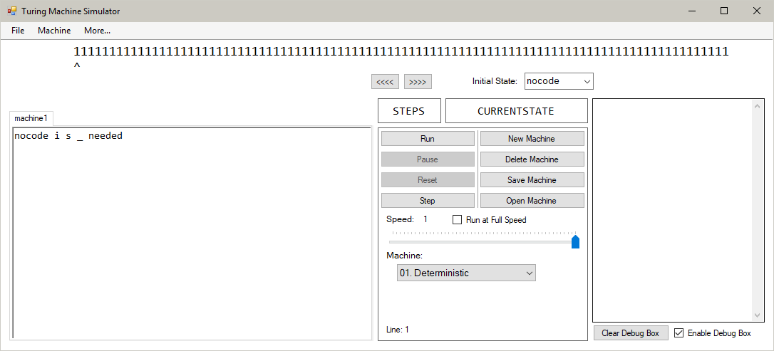

The tape currently reads:



After removing the first 4 characters, the tape’s font size is the same. This is because, if the tape’s font size were to be increased, it would exceed the maximum width set for the tape:

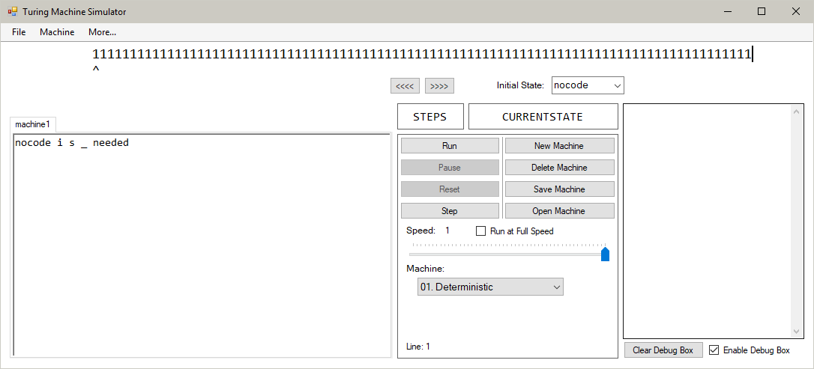

Removing one more character means that the tape, when increased in size, is within the maximum tape width. Therefore, the tape’s font size is increased:

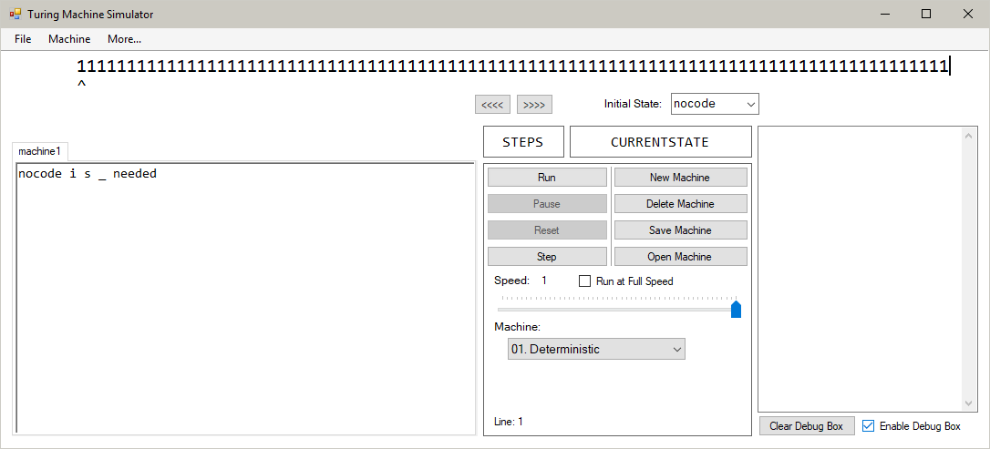

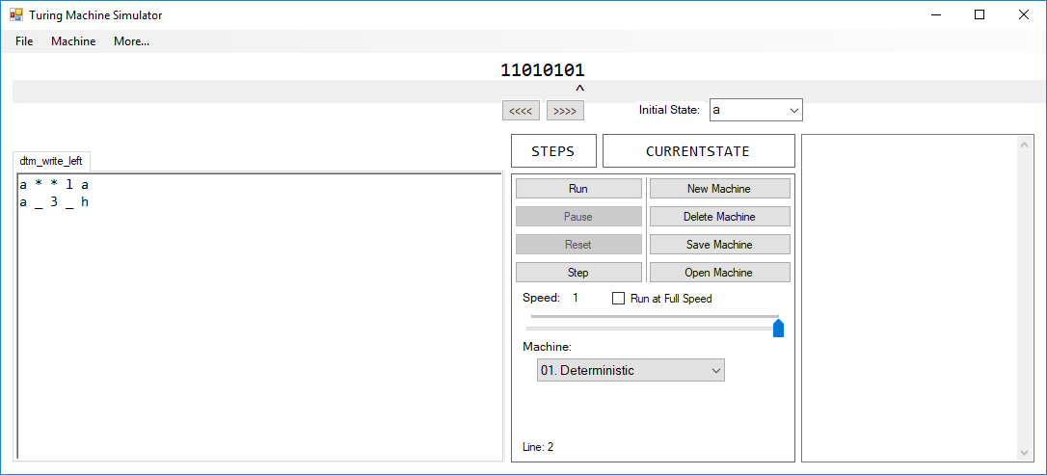

After running the machine, the final tape looks like:

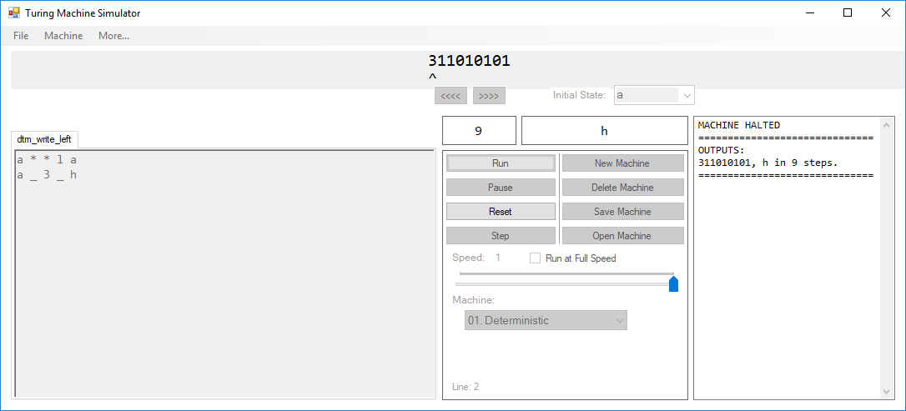

The character ‘3’ has been added to the left end of the tape and the machine has halted.

Before running the machine:

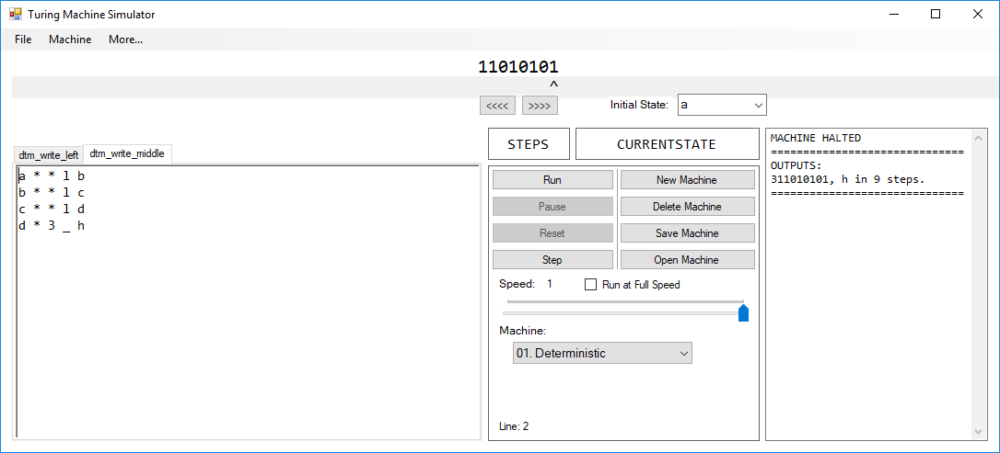

After running the machine:

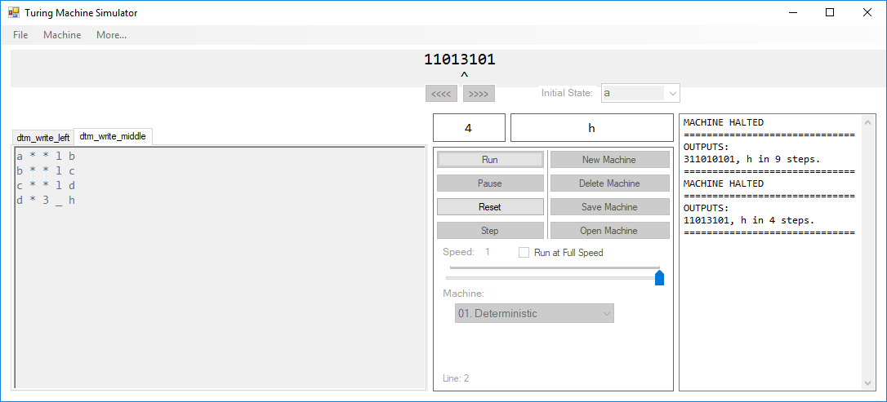

The character ‘3’ has been inserted into the tape after the read/write head has moved three spaces to the left.

Before running the machine:

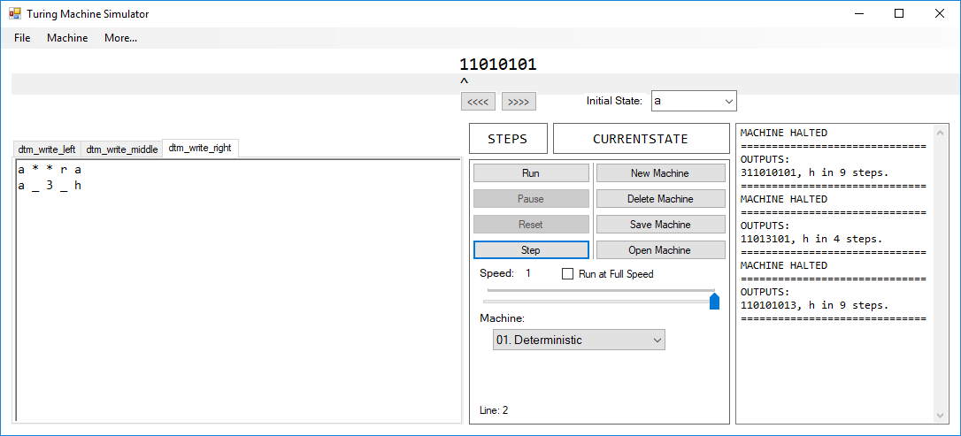

After running the machine:

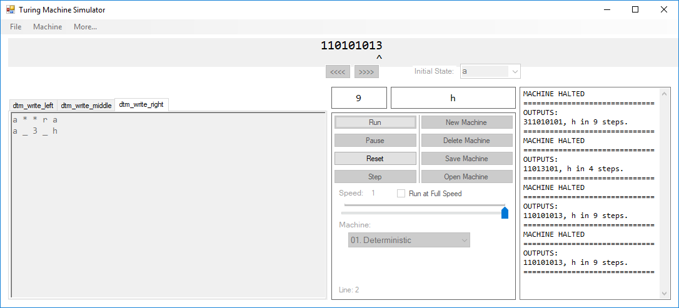

The tape has had a ‘3’ added to the right end of it. No other characters have been edited.

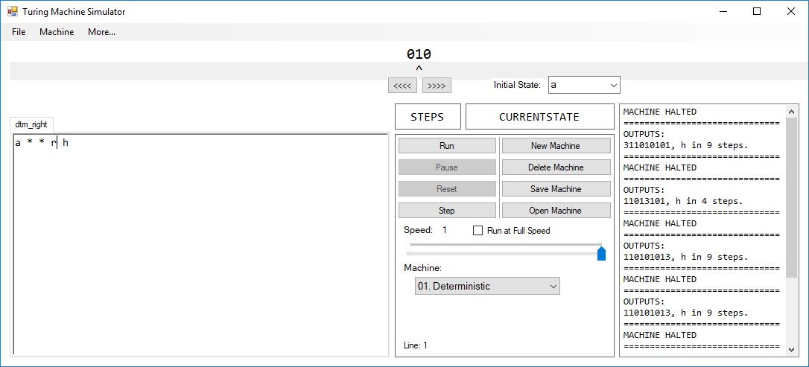

Running the machine moves the read/write head one space to the right of its initial position (at the 1).

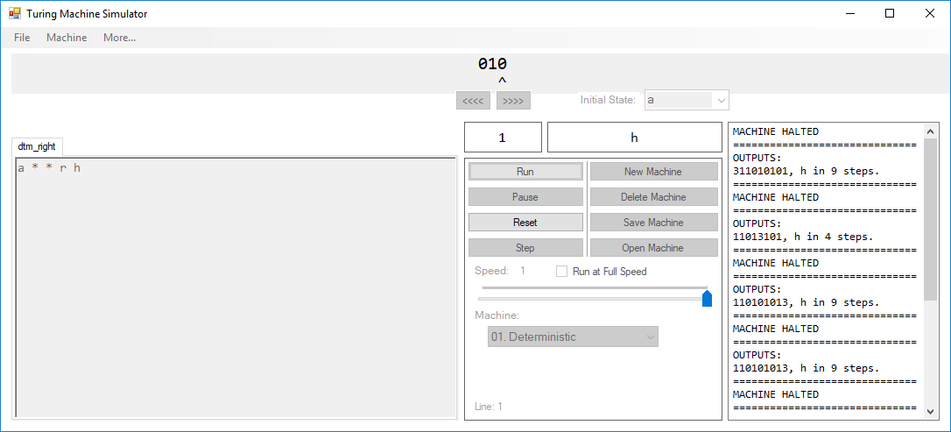

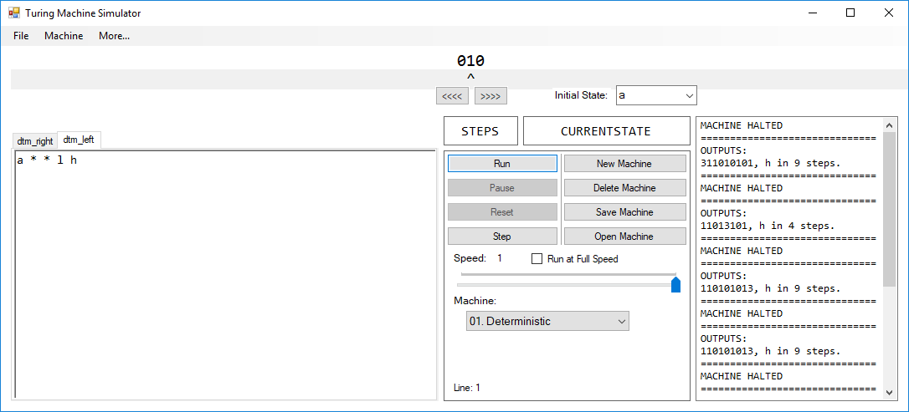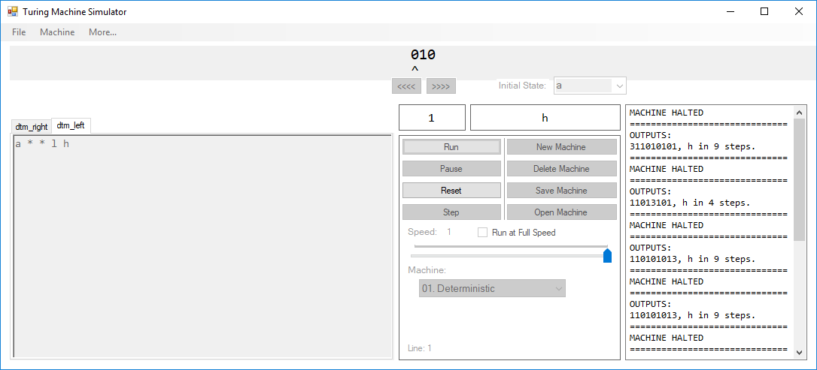

After running the machine, the read/write head has moved from the ‘1’ to the ‘0’ one character to the left of it.

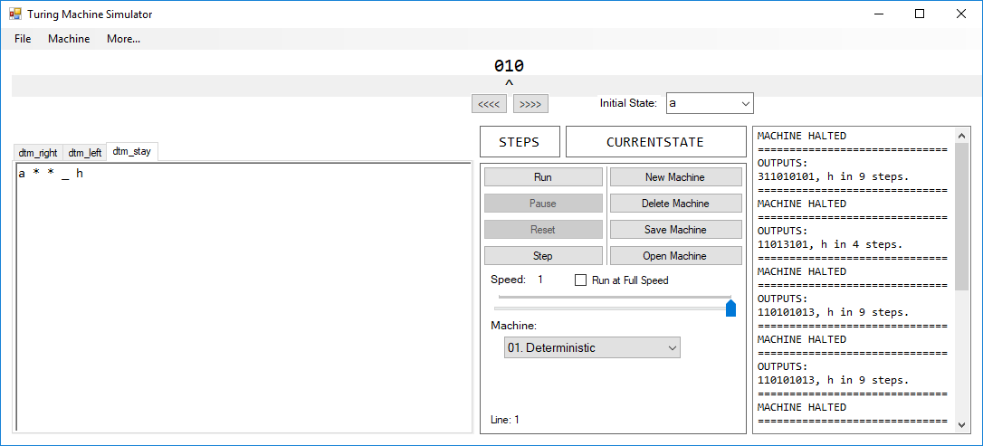

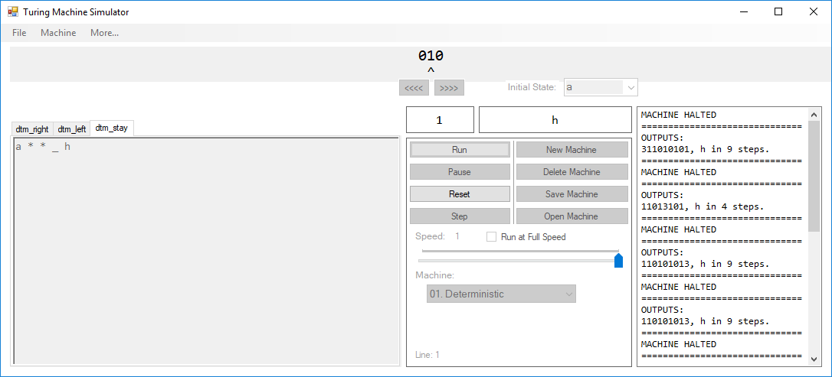

After running, the read/write head has stayed where it is.

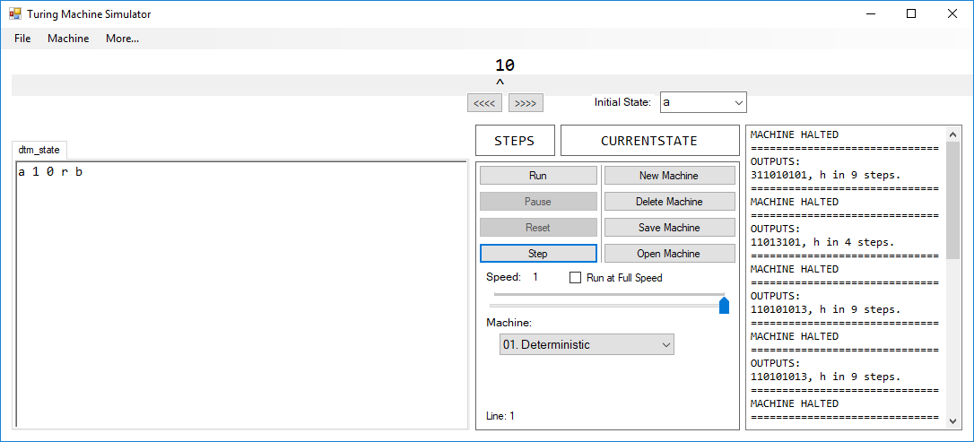

After running, the program ends in state ‘b’, which is consistent with the final state specified by the transition function in the text editor.

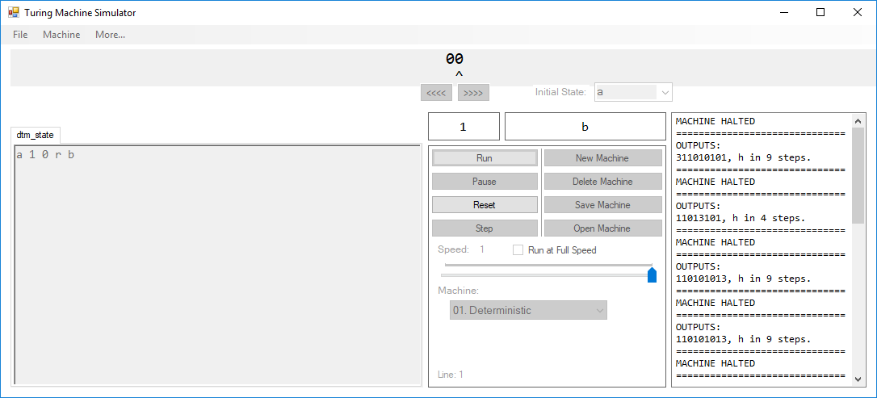

The initial appearance of the machine looks like:

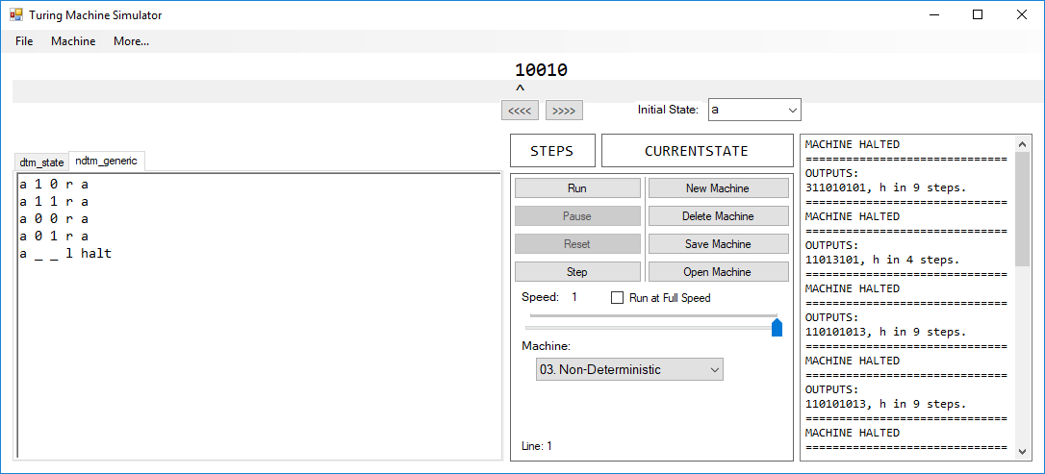

After each reset of the machine, the machine returns to this appearance. Importantly, the tape does not change in between each running of the machine.

Run 1:

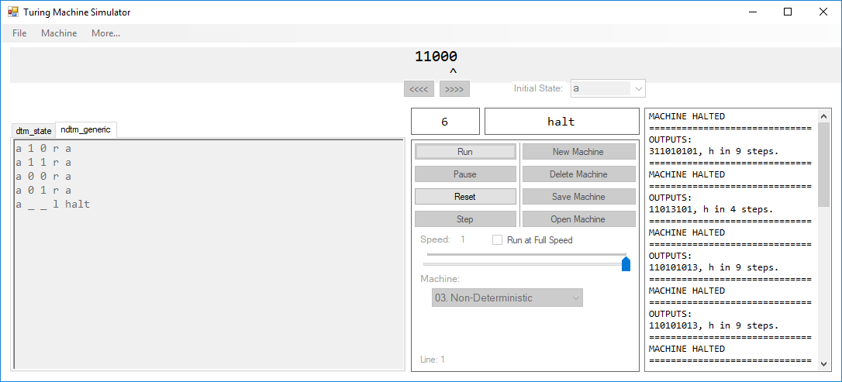

Run 2:

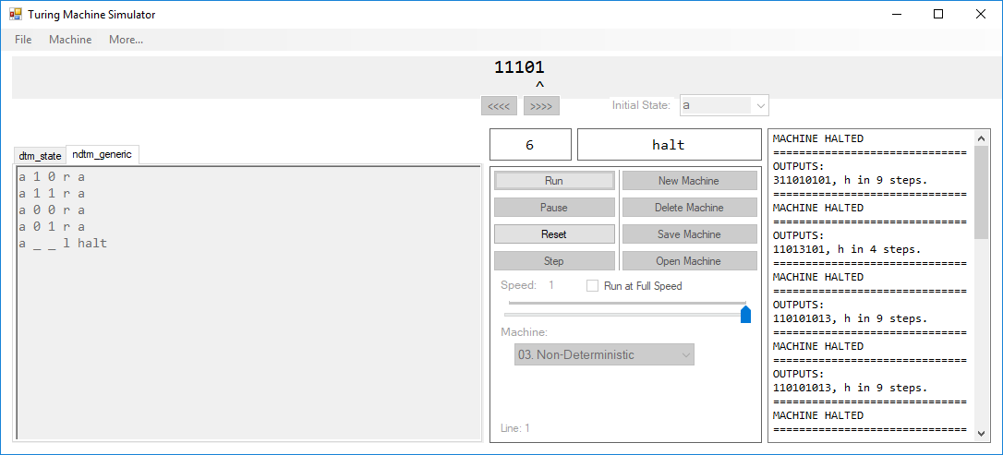

Run 3:

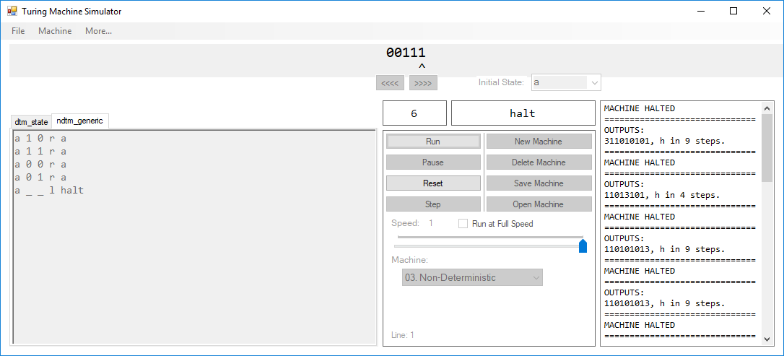

Run 4:

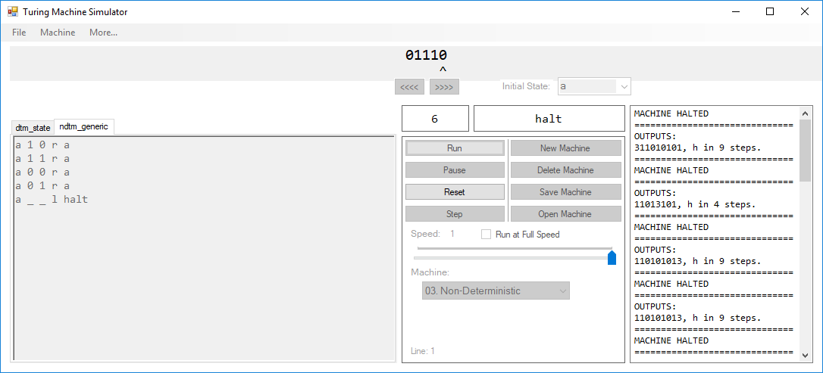

Run 5:

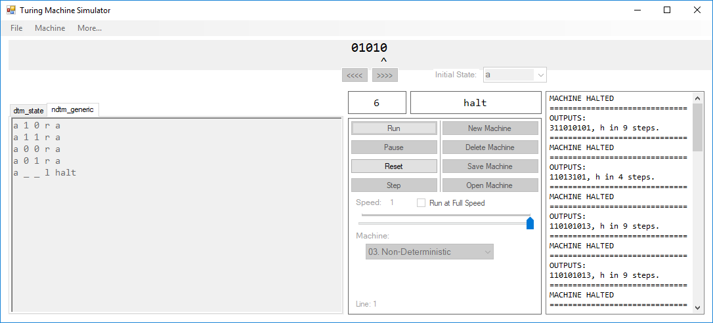

After running the program five times with the same transition function set and the same tape, five different results were found. This shows that each time the machine performs a step, it randomly chooses whether to write a one or a zero to the tape.

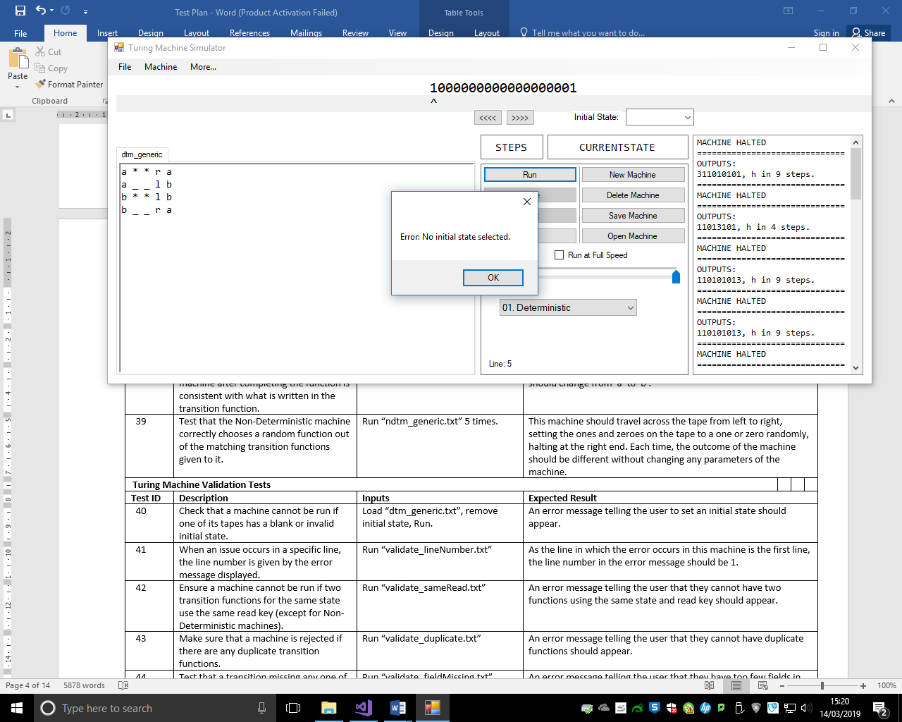

The initial state box is blank. When the ‘Run’ button is pressed, the error window appears and the machine does not run.

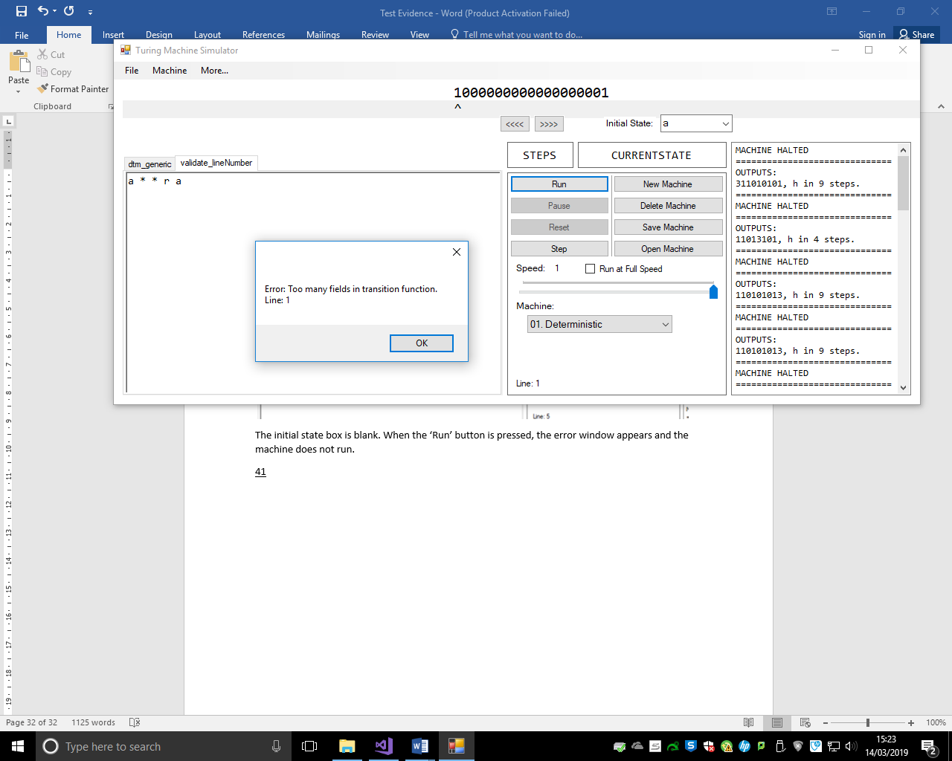

When an error is found in the code (in this case, an extra space has been added at the end of the line), the line number is specified in the error message.

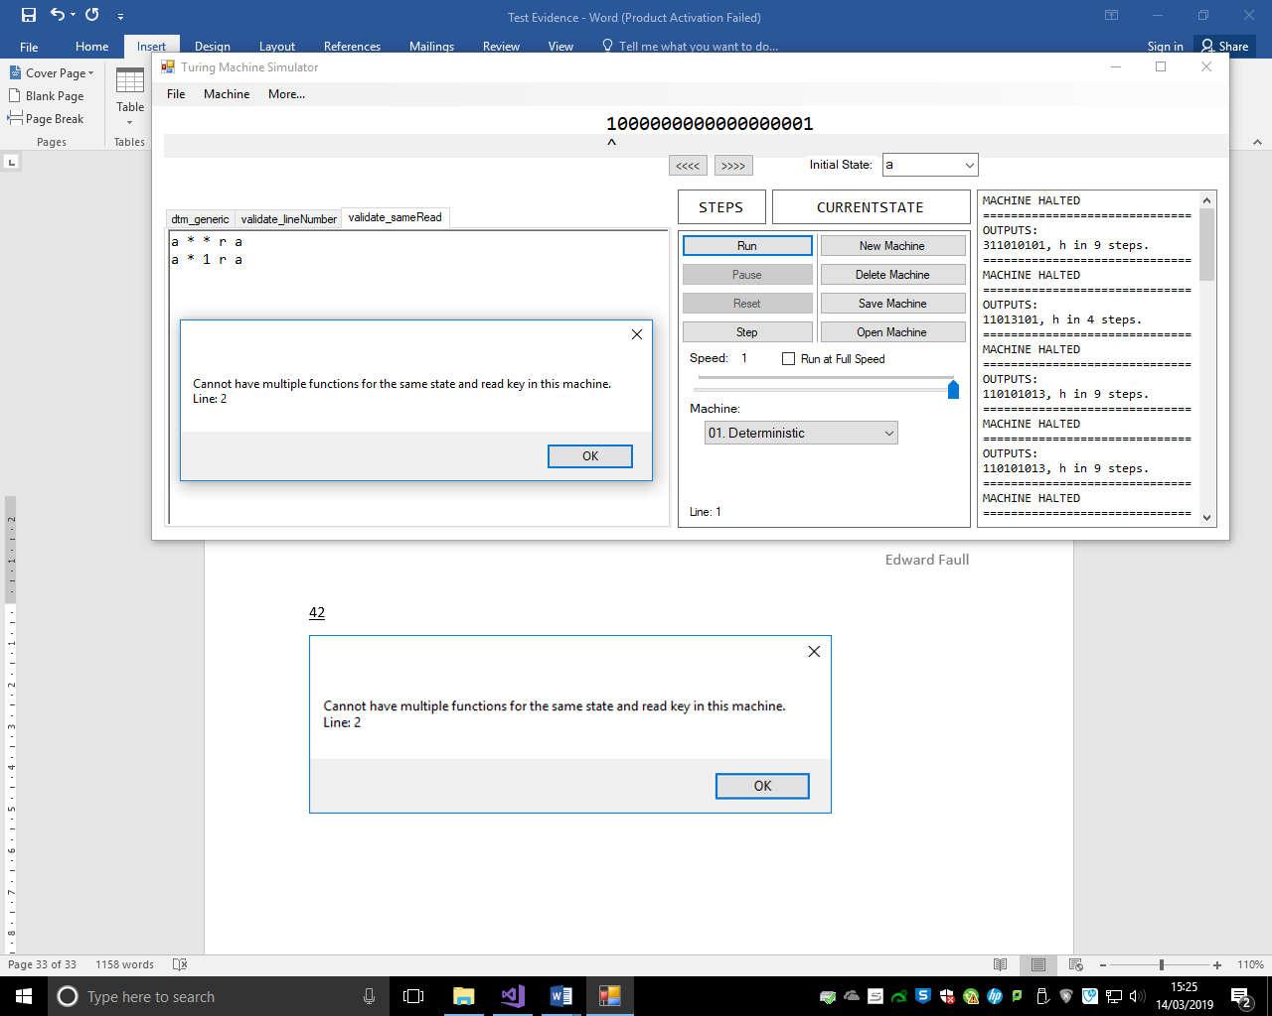

Running the program with two functions with the same state and read key produces an appropriate error. The line number specifies the second occurrence of the repeated function.

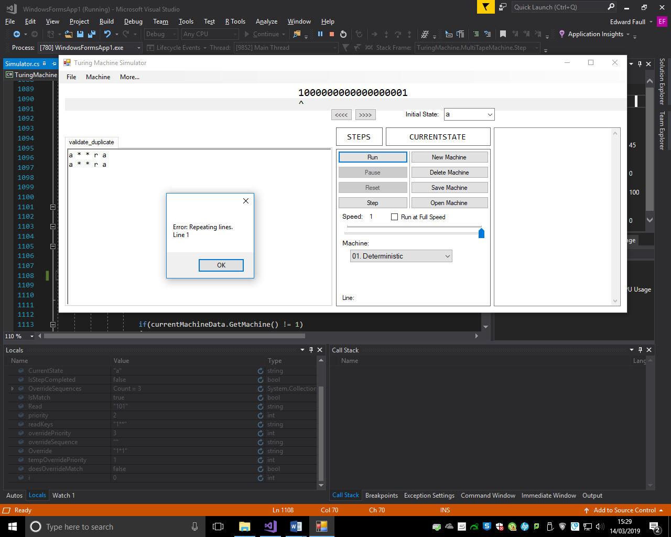

If there are duplicated lines, an error message will be produced saying so.

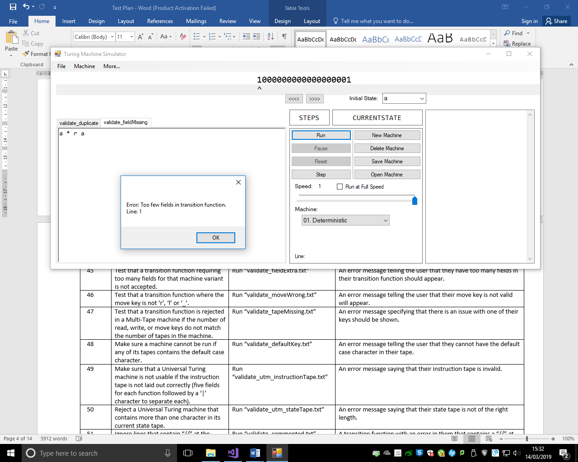

An appropriate error message is shown when the Turing machine does not contain enough necessary fields in a transition function. In this example, the machine variant is Deterministic, so is missing the write key field in the transition function in the text editor.

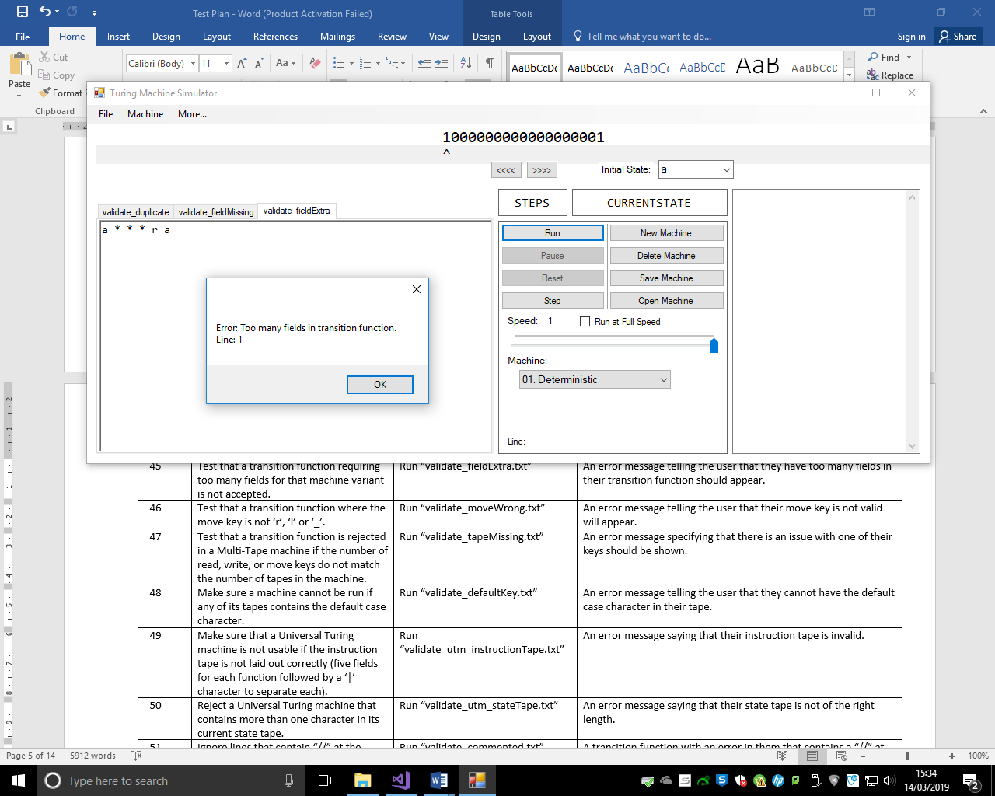

This transition function contains six fields. No machine can process that; so an error message is shown to indicate that there are too many fields in this function.

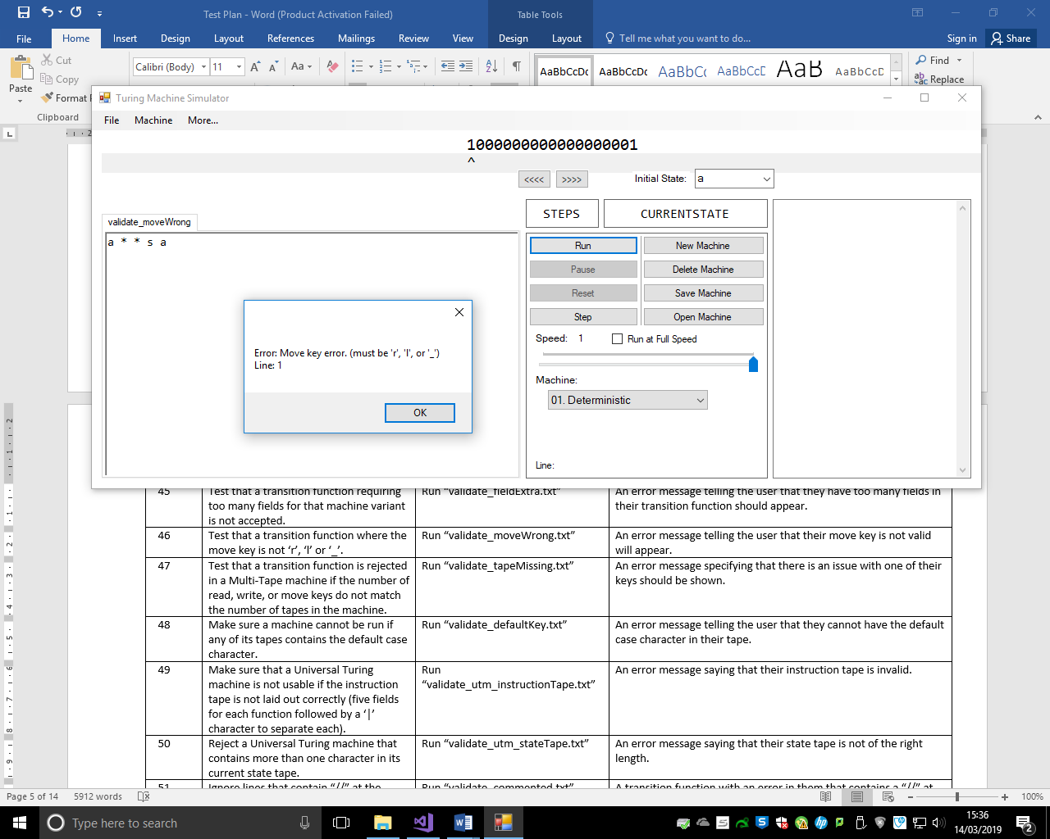

The move key in this transition function is wrong. When attempting to run the machine, an error message telling the user this is displayed. The error message also tells the user which keys can be used as a move key.

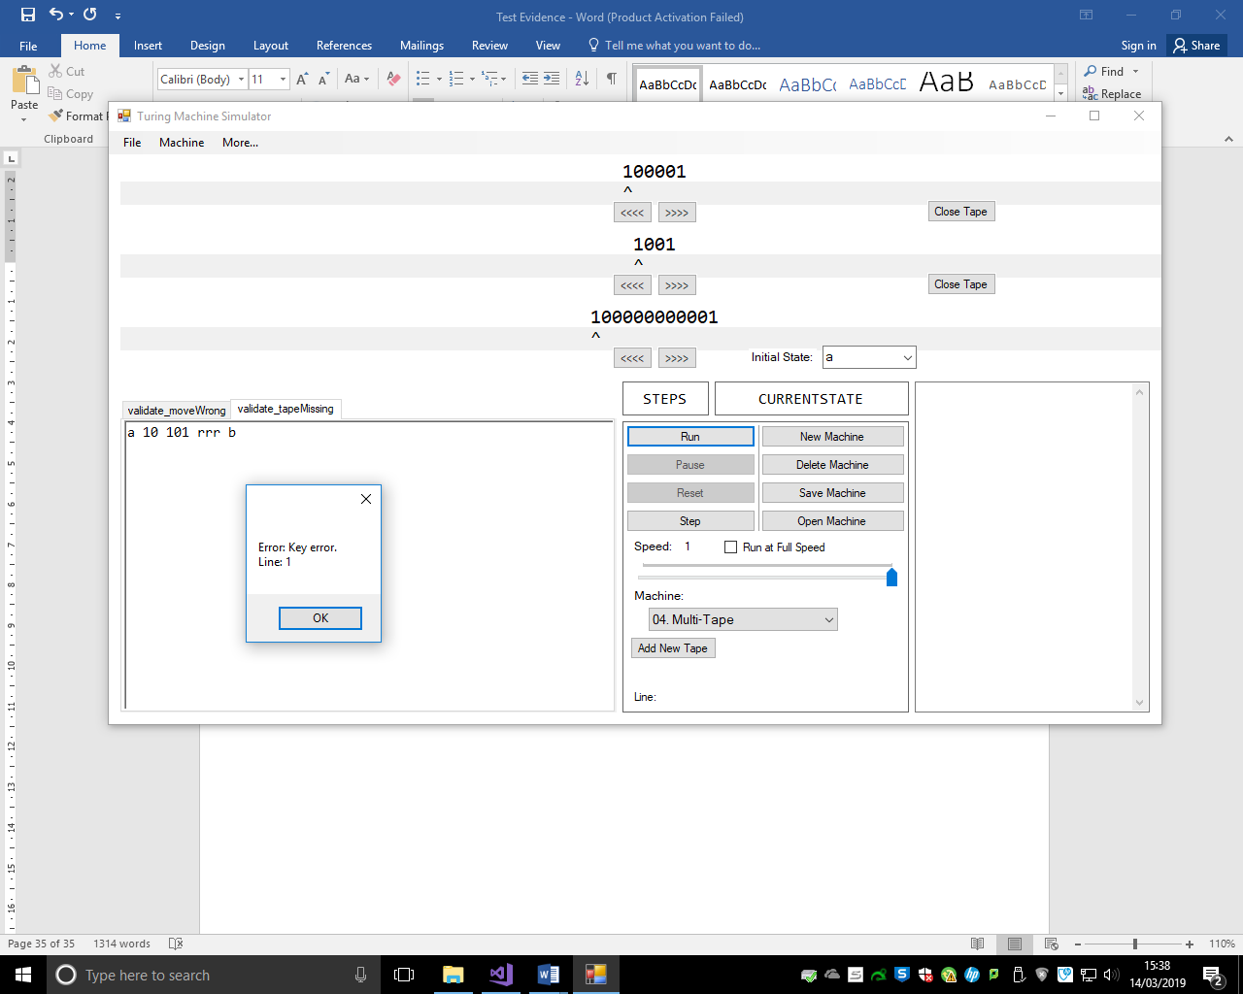

In this example, the read key of this function only contains a definition for two tapes, where there are three tapes in the machine. This gives an error when running the machine and the line number in which the error occurs is specified.

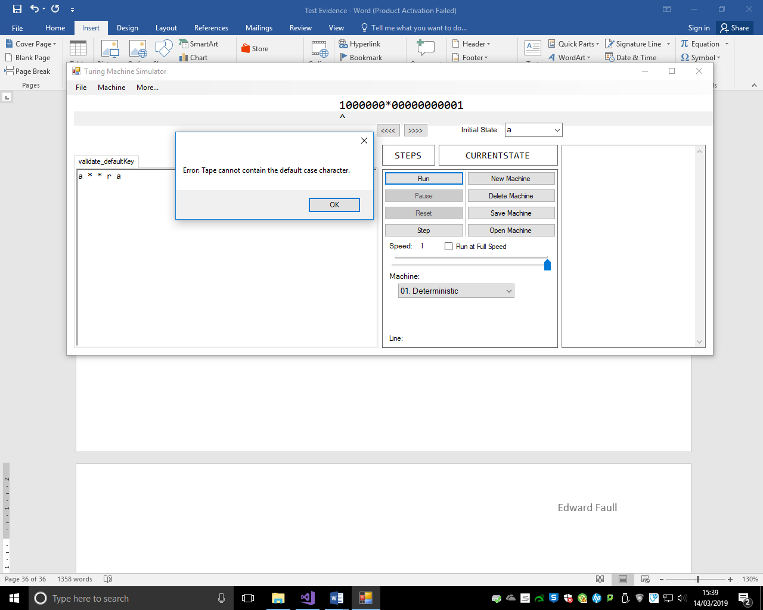

When trying to run a machine with the default case in the tape, an error is given by the program and the machine will not run.

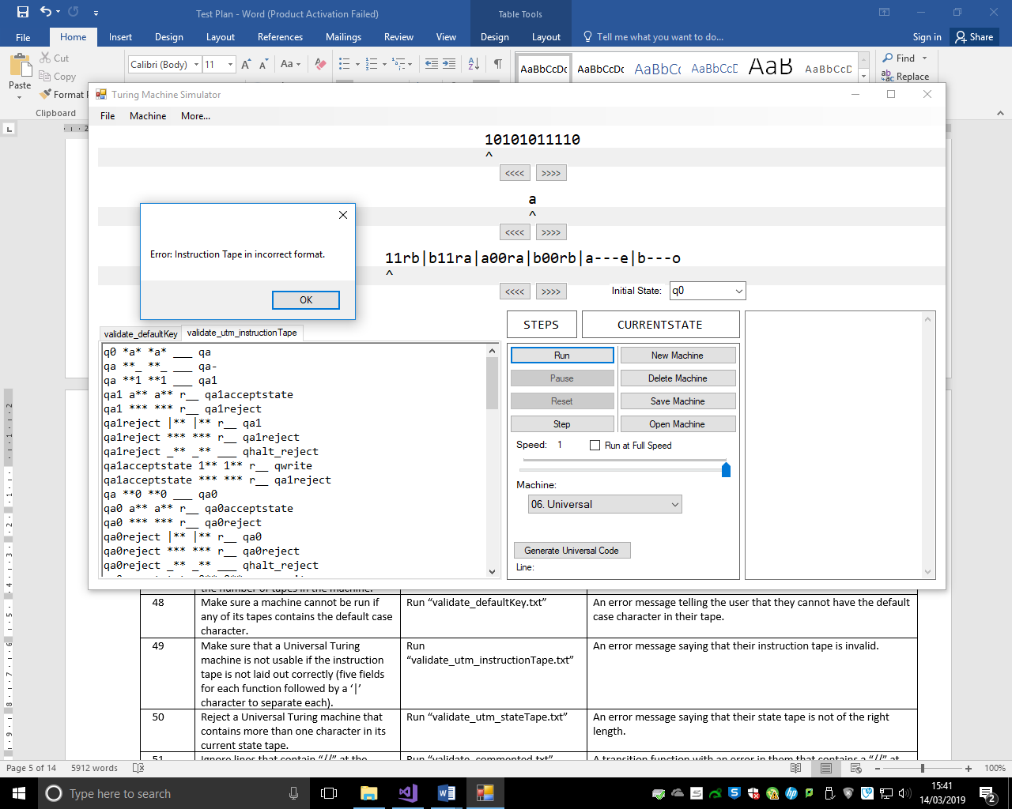

Here, the first instruction in the Instruction Tape is missing the initial state field. When this is validated, an error message is given telling the user that the Instruction Tape is incorrect.

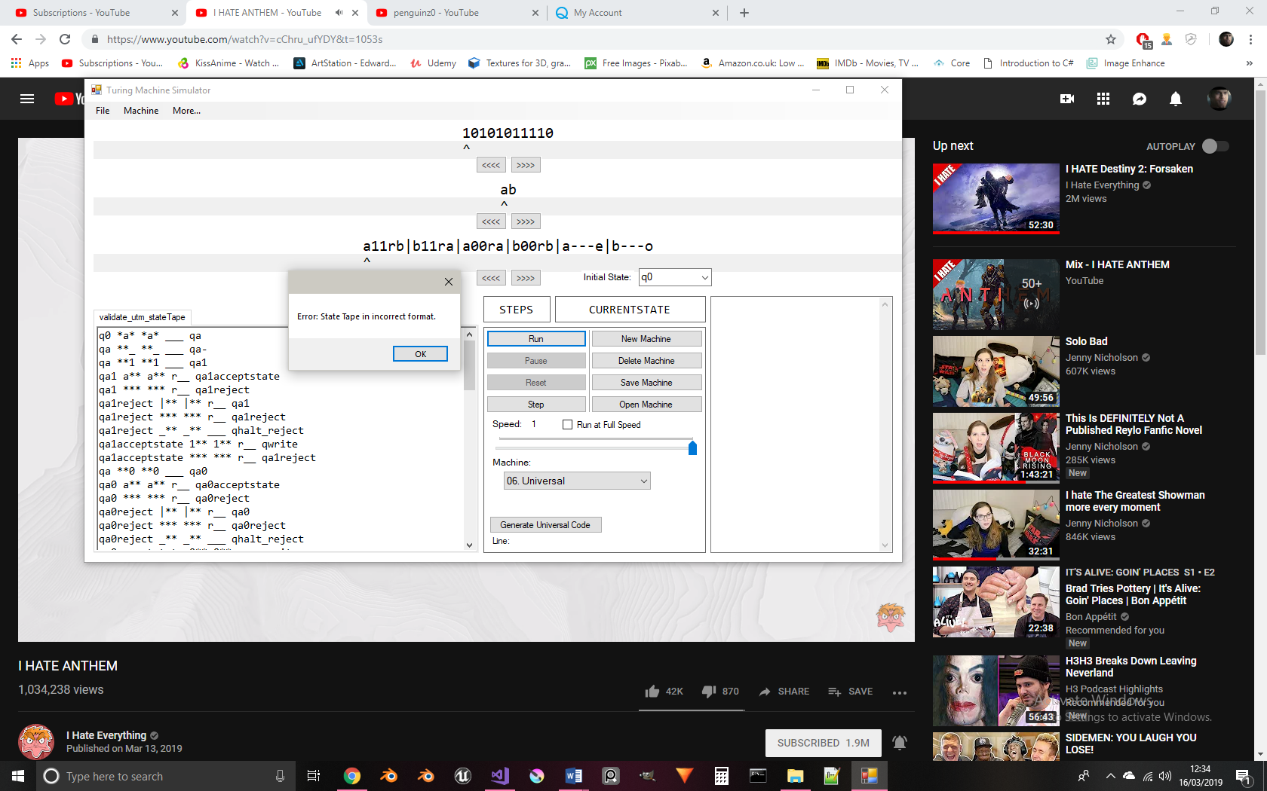

When the length of the state tape is greater than one, the error message above is shown.

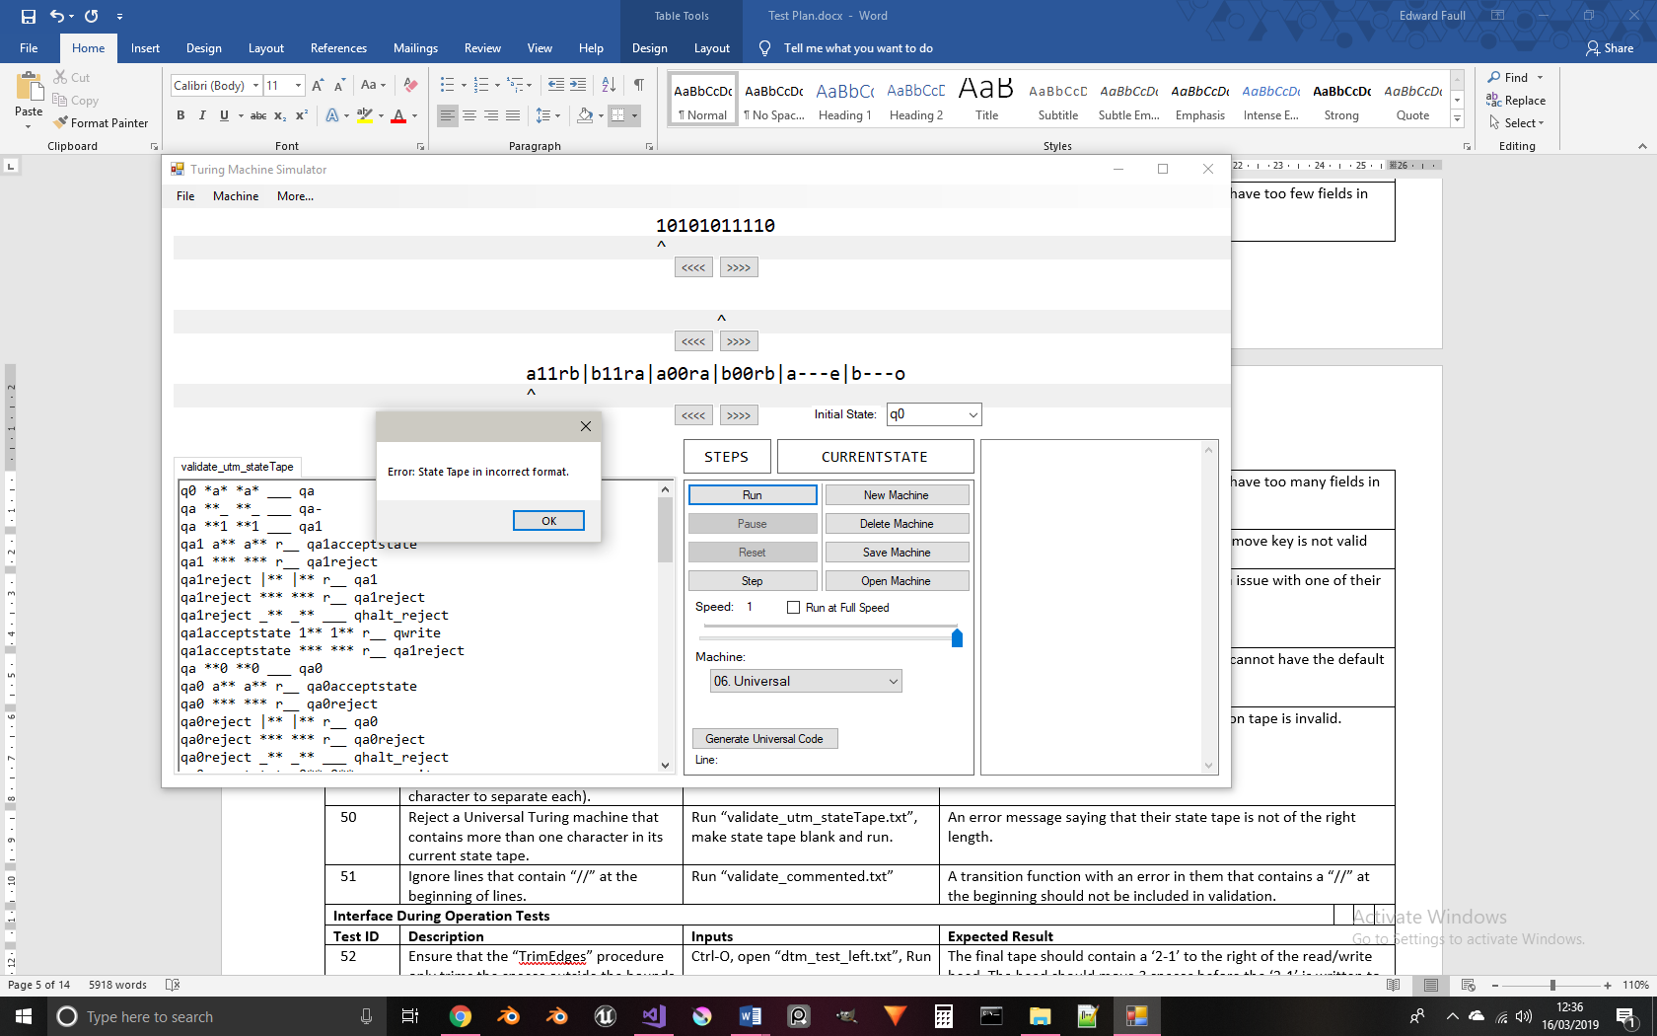

If the state tape’s length is less than one, and is therefore blank, the same error message is shown.

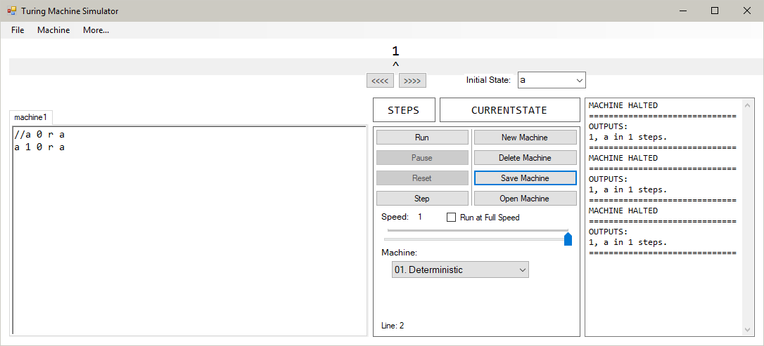

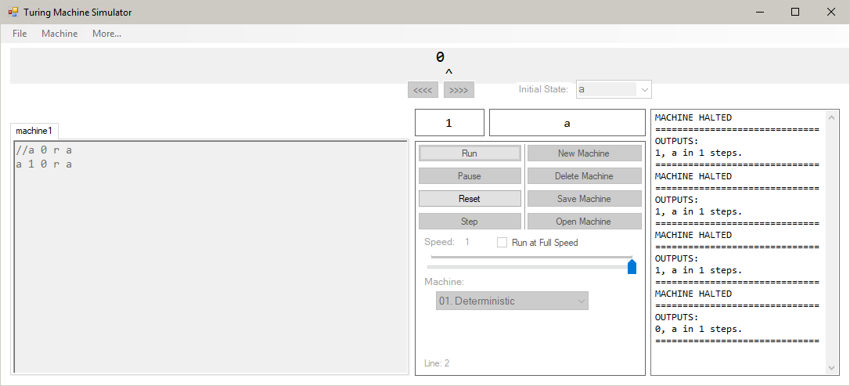

The top line of this code contains an error, as the machine is Deterministic and this line contains only four fields where it requires five. The ‘//’ excludes the transition function from being checked.

The ‘//’ marker also excludes transition functions from being run. Setting the tape to be ‘0’ before running the machine:

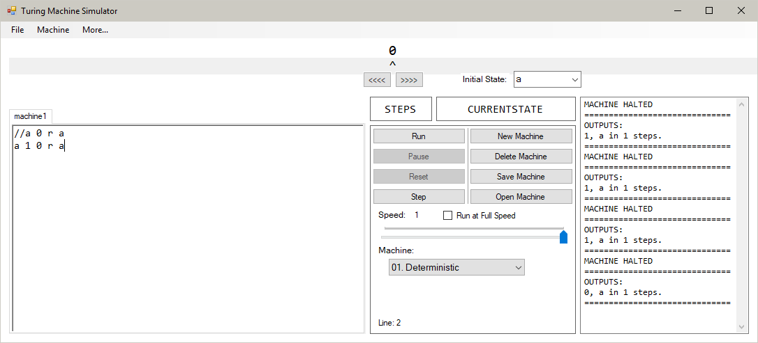

Running the machine halts it before it performs any instructions. This shows that the machine has ignored the commented transition function when compiling the machine, which shows this marker works as intended.

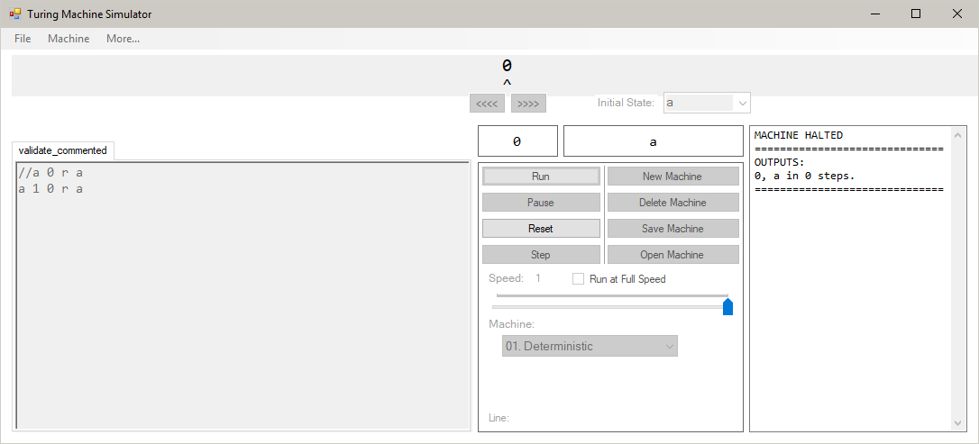

The machine can be verified as not having performed any instructions as the step count is 0.

The machine, when set to Deterministic, is:

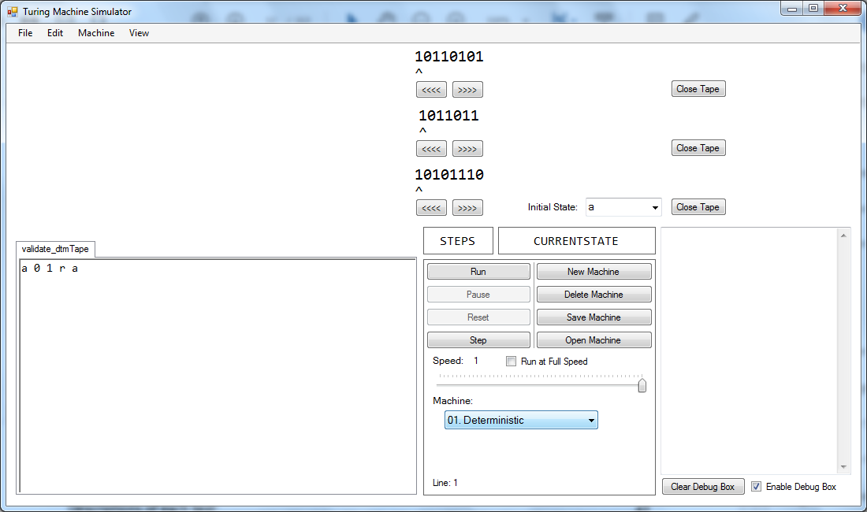

After pressing Run, the program produces this error message:

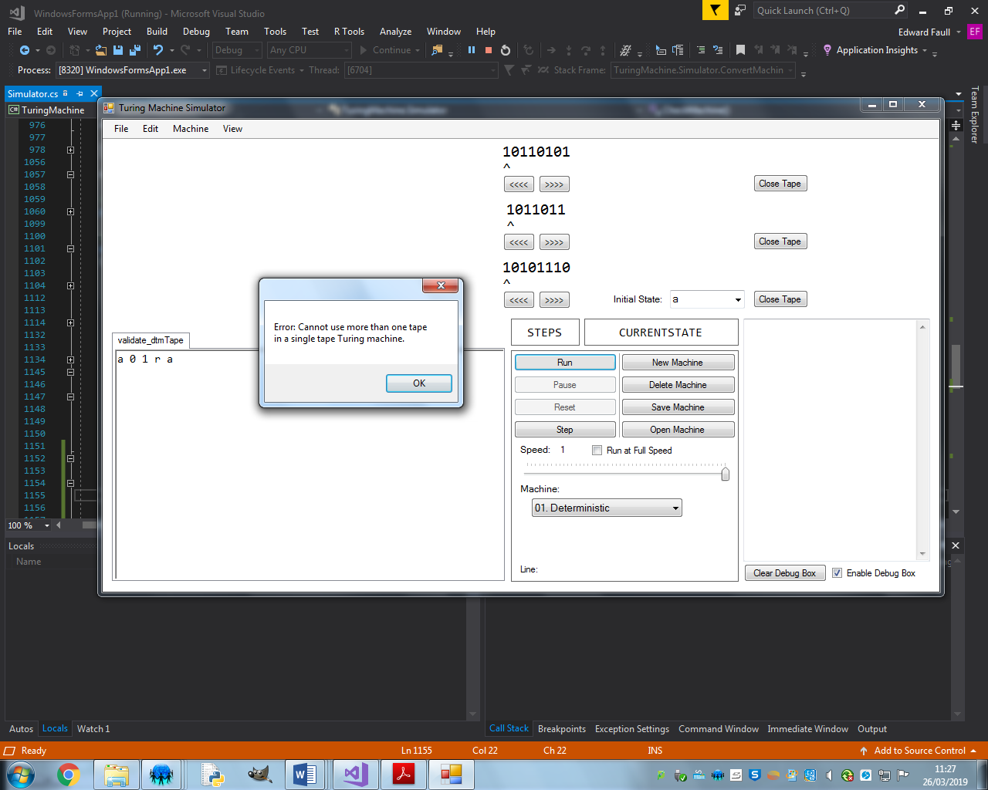

Before running, the read/write head is just inside the bounds of the tape: 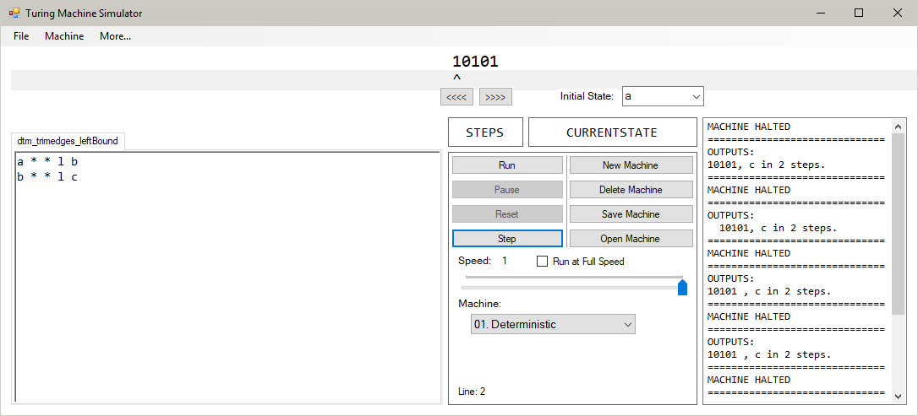

After running:

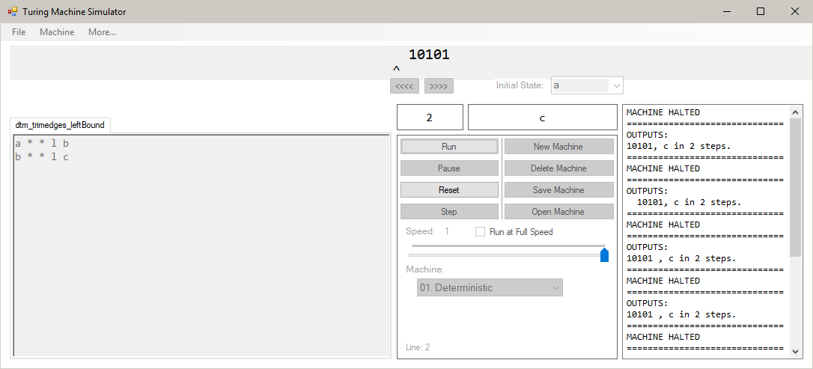

The pointer lies outside the bounds of the tape, but the additional spaces added onto the tape have not been deleted, as they lie inside the bounds of the pointer.

The halting message shows that the spaces have been preserved:

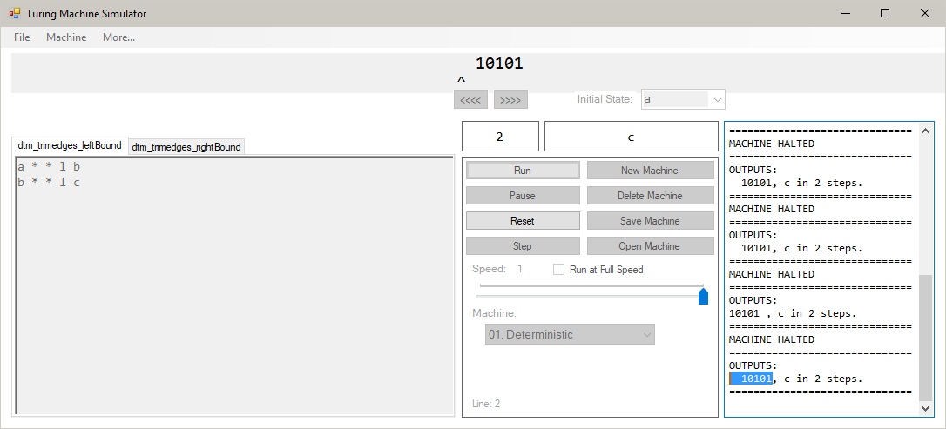

Before running, the read/write head is just inside the bounds of the tape:

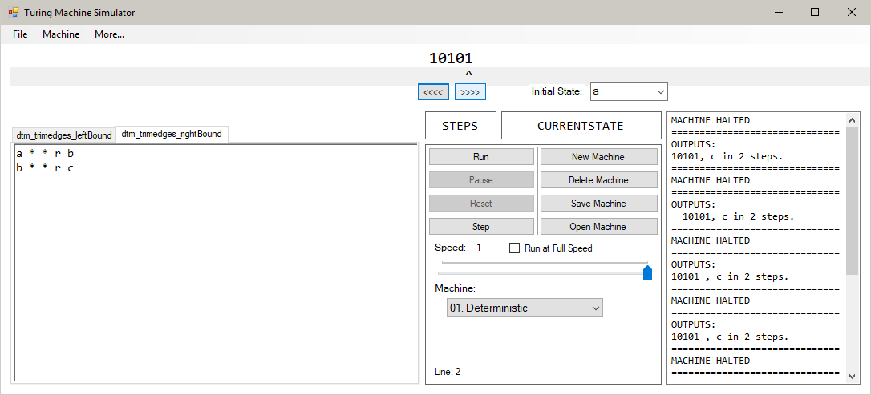

After running:

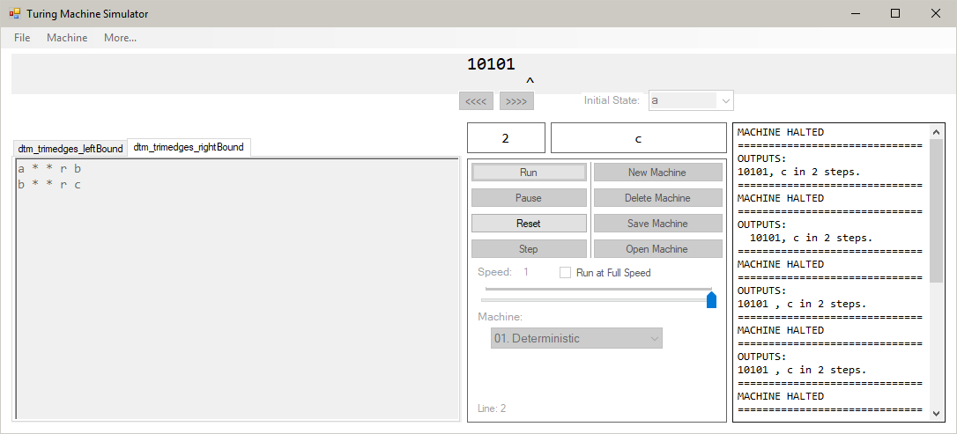

The halting message shows that the additional spaces added by the machine have been kept:

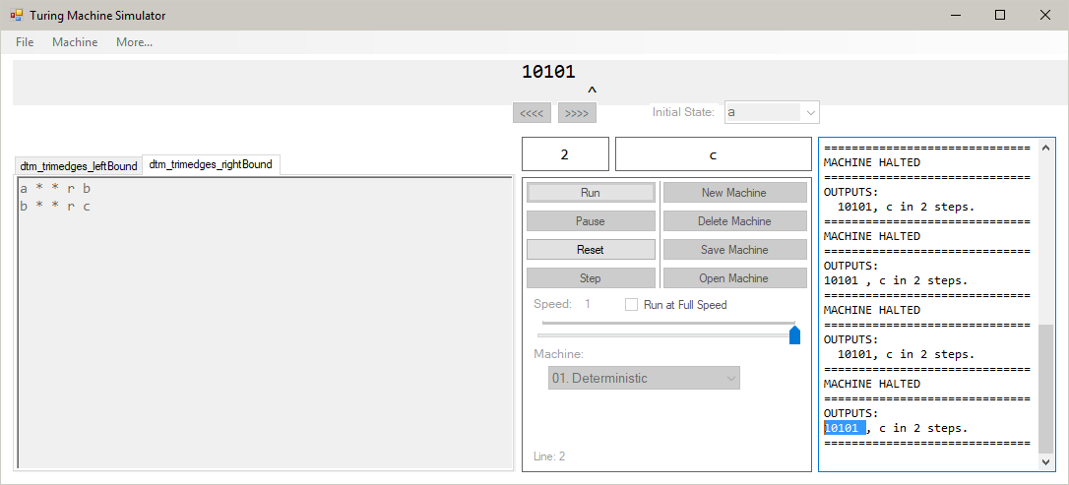

After the third step of the machine, an additional 1 has been added and the pointer is to the left of it:

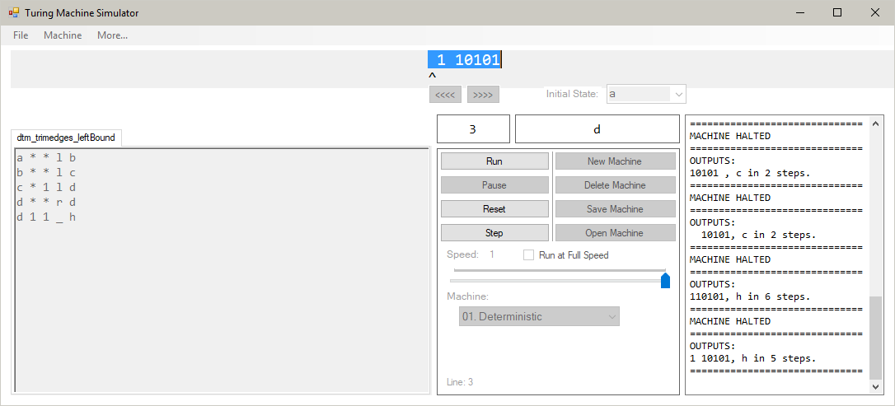

Also, there is a blank character added where the pointer now is. When the machine halts over the ‘1’, the space at the end is removed, as that character is no longer in the bounds of the pointer:

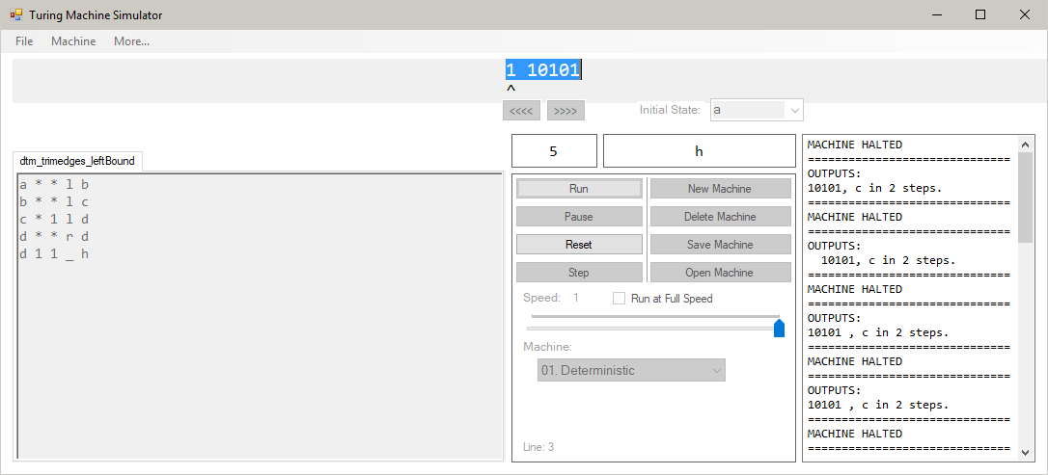

This shows that the program correctly identifies blank characters on the left which are not needed by the machine and are subsequently removed.

After the 4th step of the machine, an additional space has been added after the ‘1’ was added:

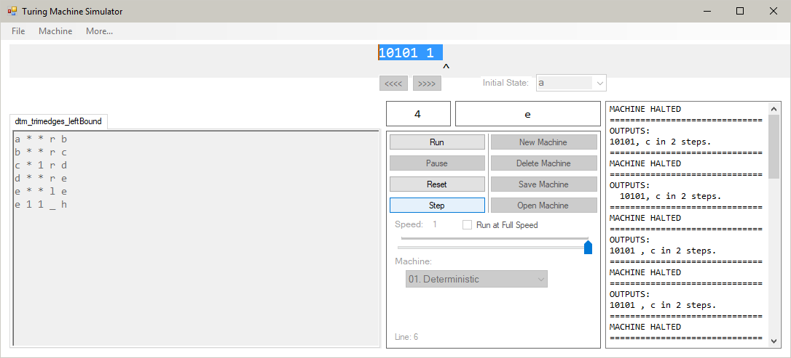

After the machine halts, this blank character is removed:

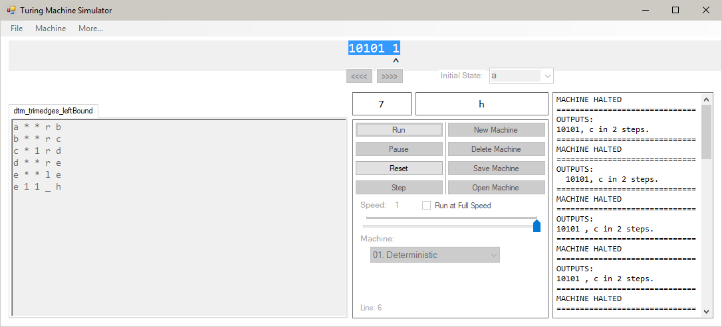

This shows that the program correctly identifies when a blank character is out of bounds on the right side of the read/write head.

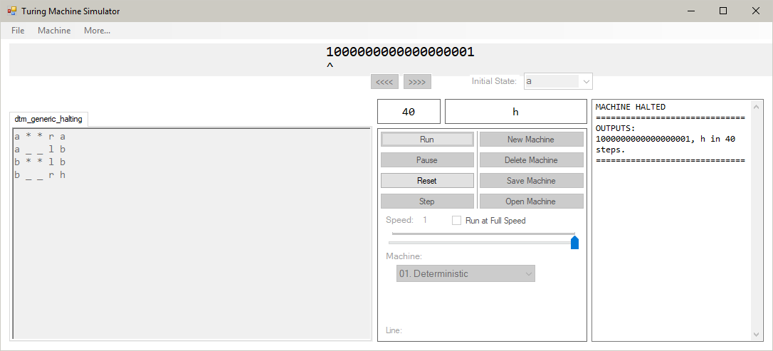

After the machine has halted, the ‘Run’, ‘Pause’ and ‘Step’ buttons are disabled. This means that the user cannot start the machine until the ‘Reset’ button is pressed, which enables them again:

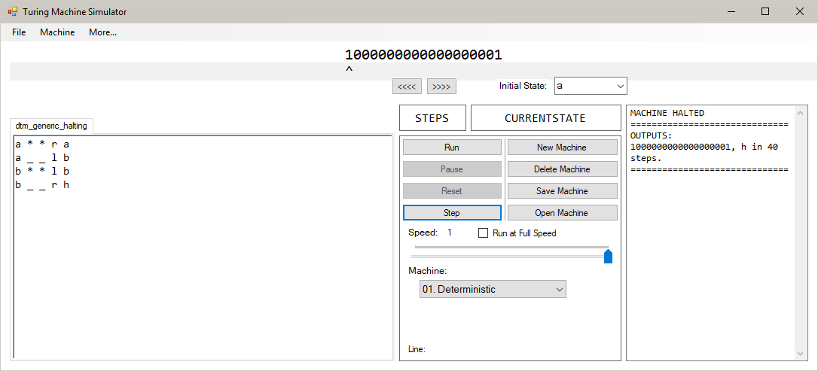

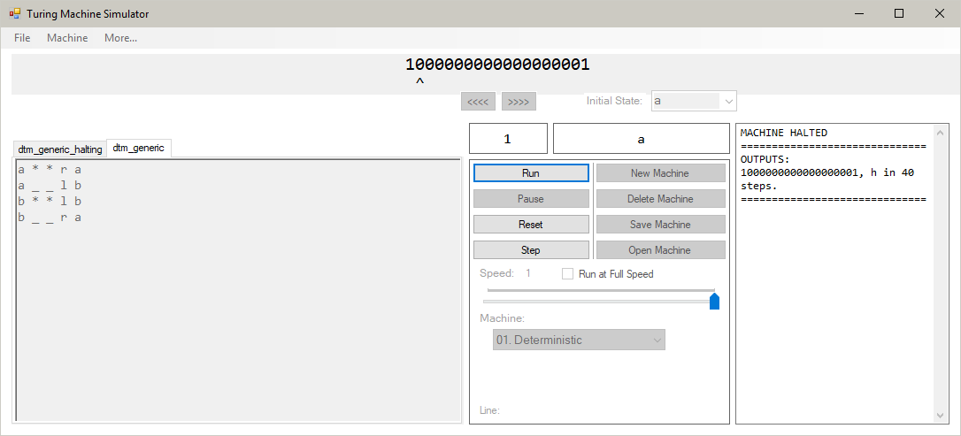

When the machine is compiled, all of the options aside from the options to run the machine are disabled. This is shown by them being greyed out and unusable. This shows that the machine cannot be edited if it is already compiled.

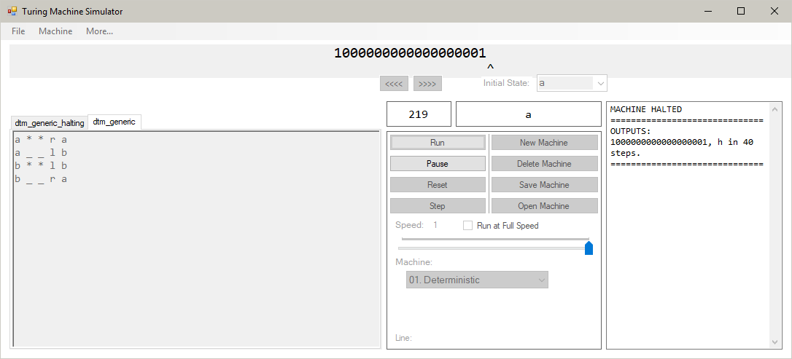

Here, the machine is running. This can be seen by the fact that only the “Pause” button is enabled. All of the controls used to edit the machine are not enabled and cannot be used. This shows that the machine cannot be edited when it is running.

This test’s evidence is in video form. This can be found at: <https://www.youtube.com/watch?v=38SHbtvm1QU&t=10>

The video shows that as the speed slider is moved, the program stops running the machine. When the slider’s value is not being adjusted, the program runs.

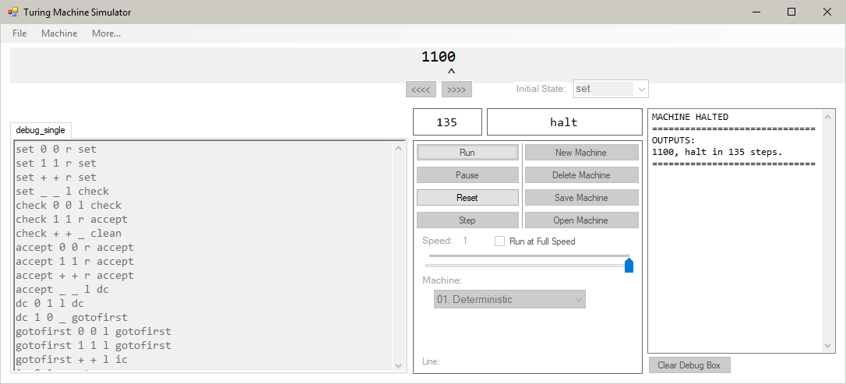

The program correctly transfers the final contents of the tape, the final state of the machine and the steps taken into the debug box. The format of the message is as specified in the Design Document.

The final contents of the tapes are:

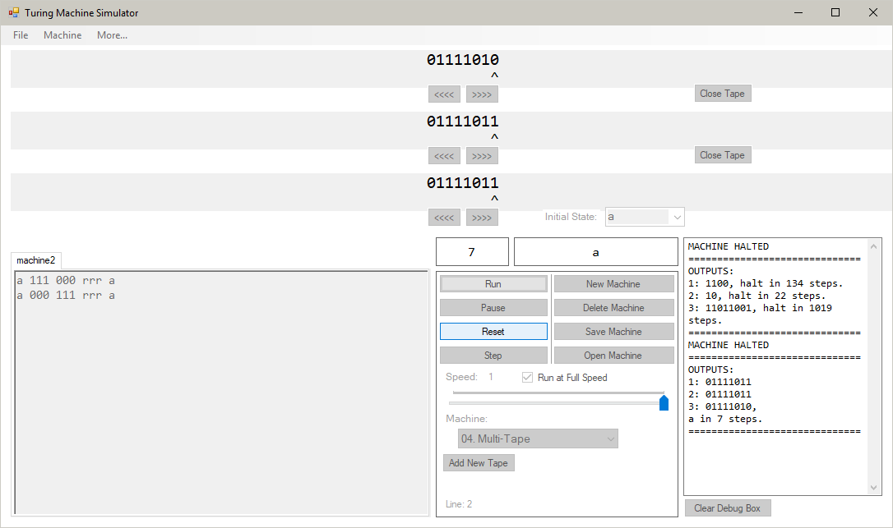

The debug message given is:

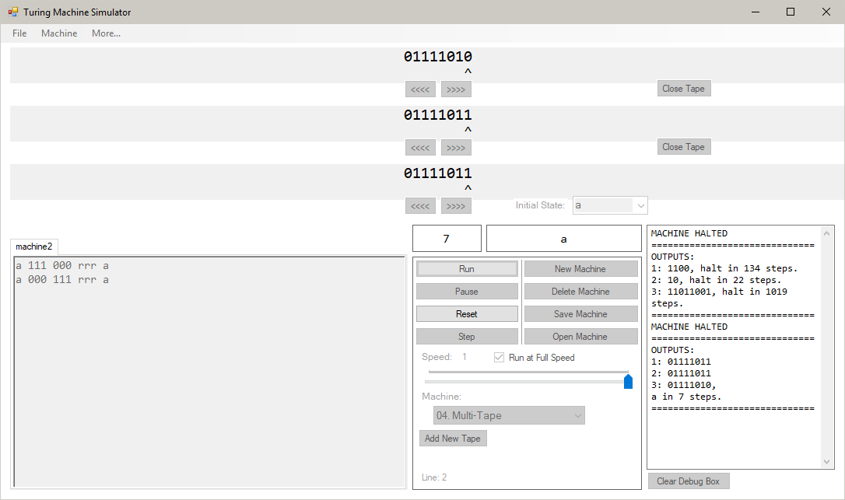

The program places the tapes in the right order (bottom to top), places the final state and step count at the end and formats the message correctly.

After running the machine, the tapes look like:

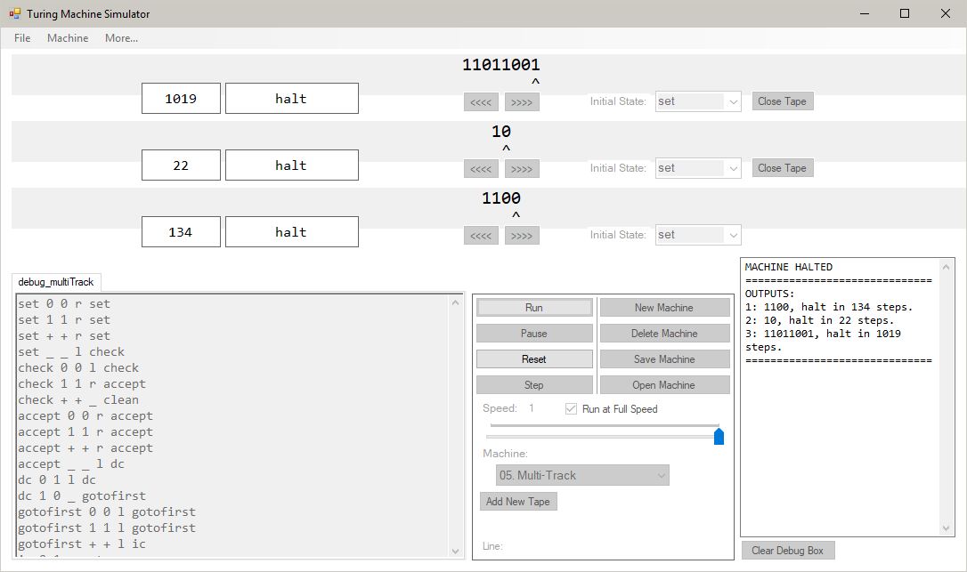

The debug message given after this is:

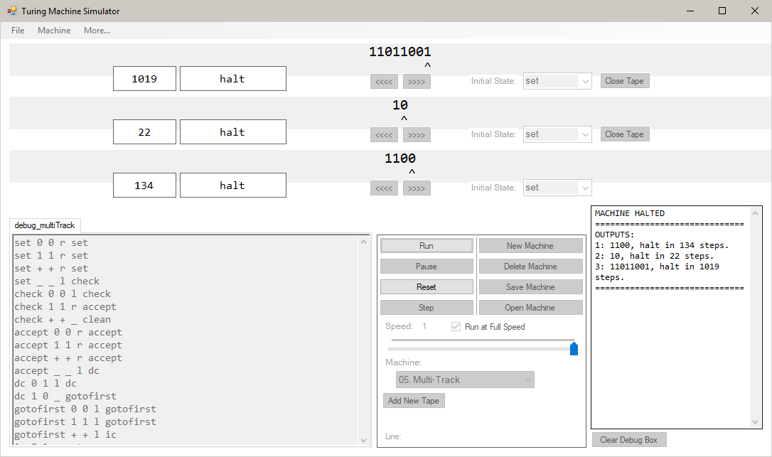

The program correctly transfers all of the data from the tapes into the message. Each tape has its own final state and step count next to it. They are ordered correctly (bottom to top), and the message is formatted correctly according to the Design Document.

The initial contents of the tape was:

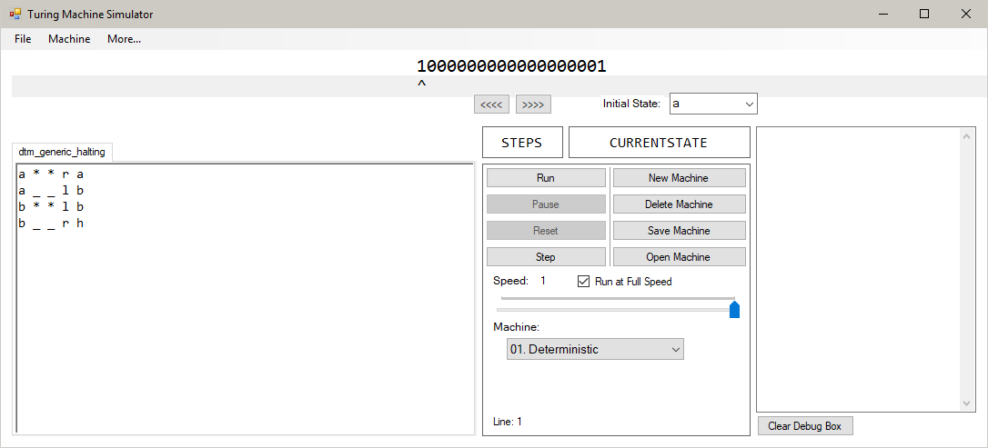

After running the machine, the tape’s contents were unchanged:

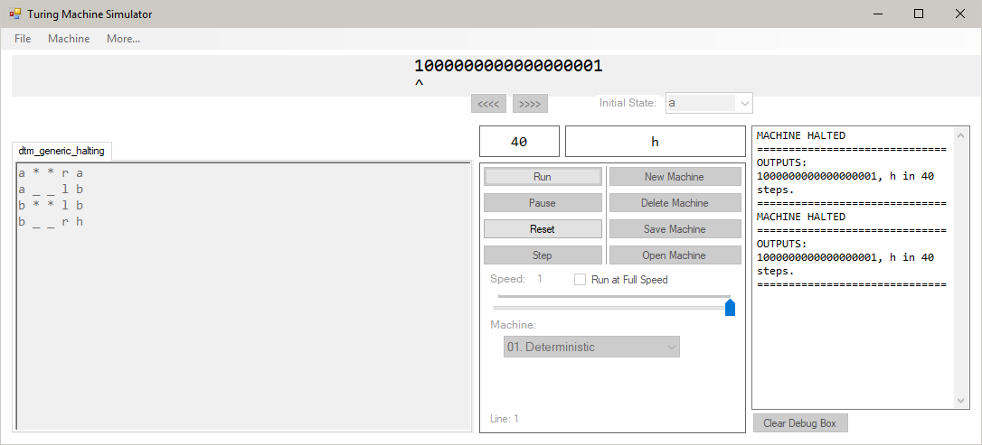

The algorithm for running the machine correctly recognised that using the default case character (‘*’ in this case) in the write key field means that the tape should not be written to.

All of the characters on the tape are different:

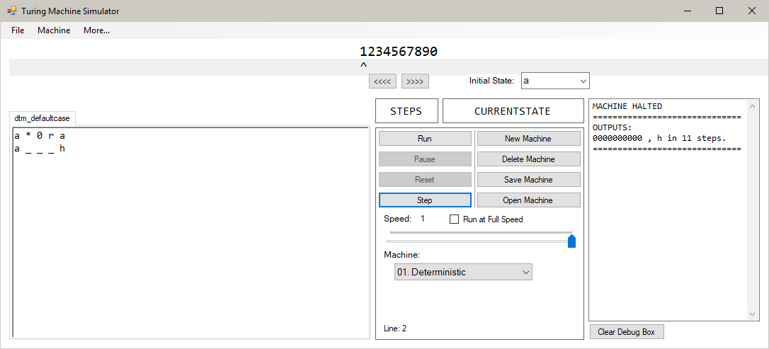

When read by the machine, all are matched with the default case function:

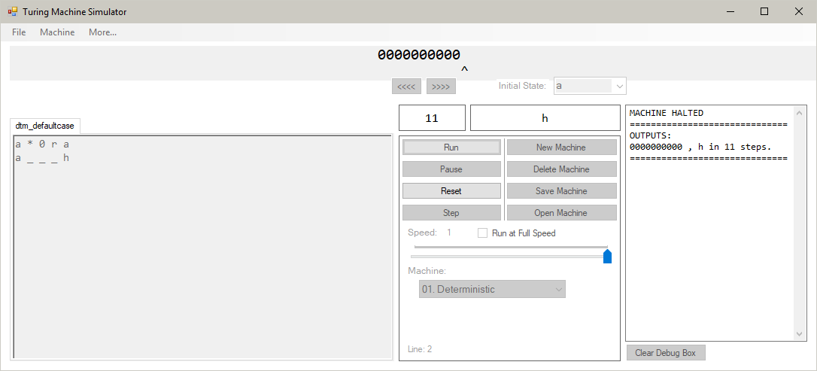

The contents of the tape before running are:



After running the machine, all of the characters that do not have a transition function written to them are matched with the default case function, and become ‘0’. The ‘4’, which does have a function written for it, follows that function and is not changed:

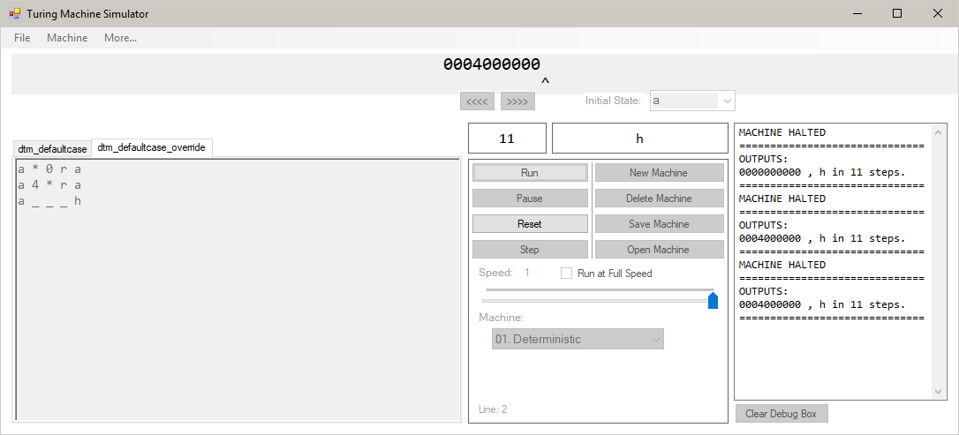

Before running, the tape reads:

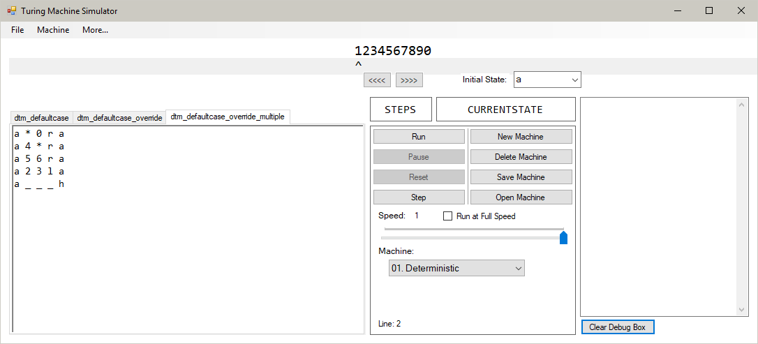

After running, the two characters, ‘4’ and ‘5’ that have transition functions defined for them, follow their own functions, and the other characters in the tape follow the default case function:

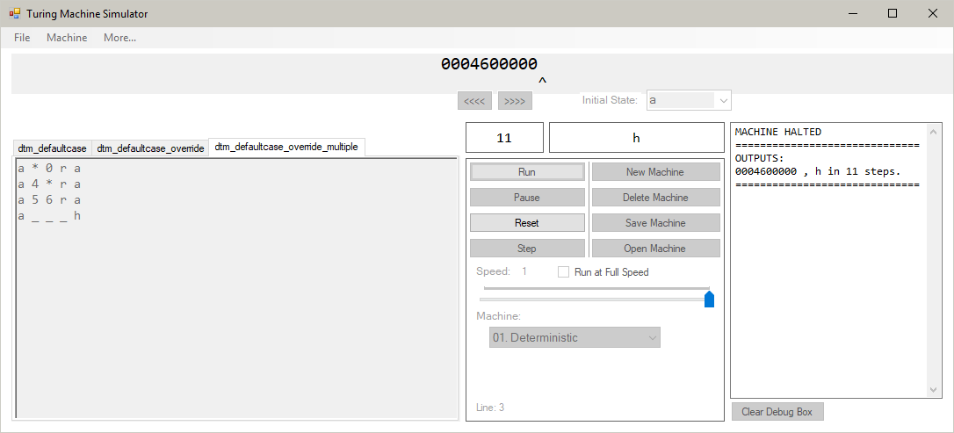

Each state in this machine have multiple functions with a higher priority than the default case function:

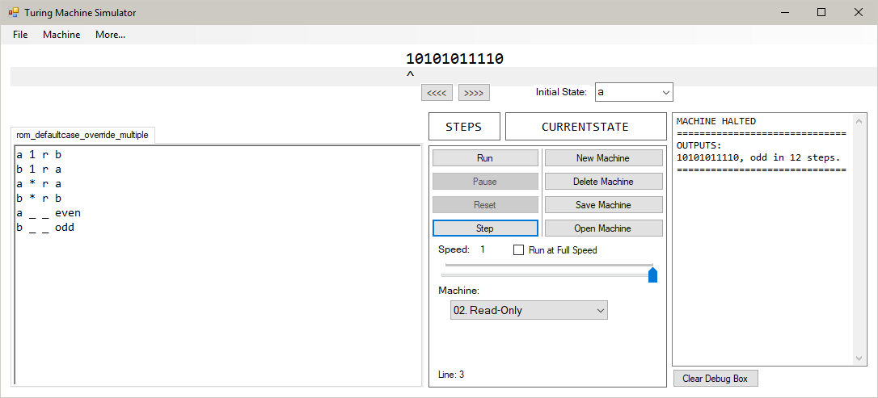

In the first step of the machine, the algorithm correctly chooses the matching function with the highest priority, the line “a 1 r b”:

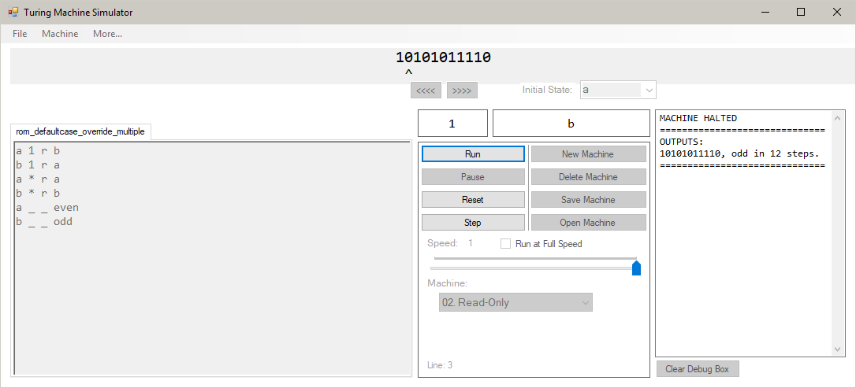

Because the next read in character does not match any fully defined function in state b, the default case function is carried out, and the machine stays in state b:

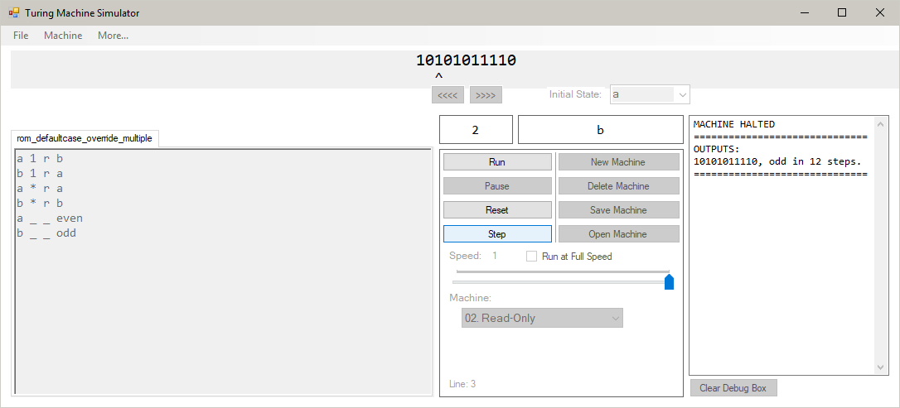

This process carries on until the parity of the binary integer is found:

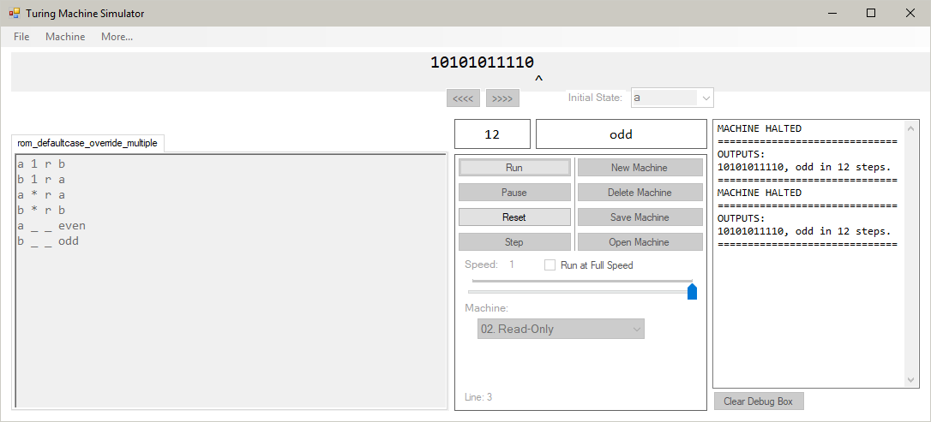

The contents of the tapes are initially:

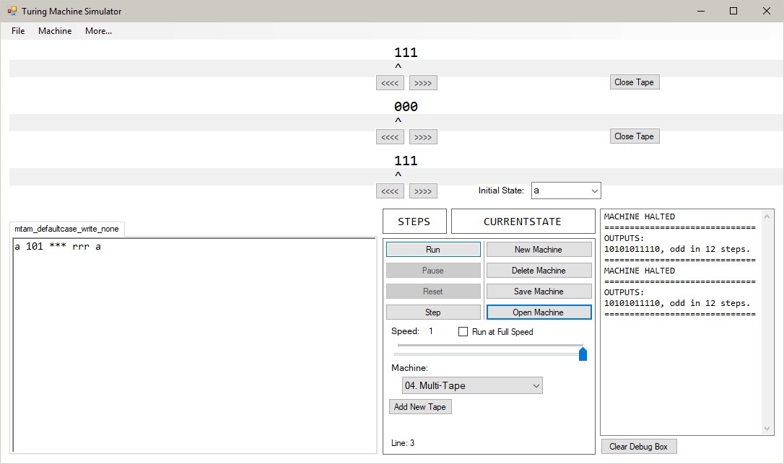

After running the machine, we can see that the write keys are successfully interpreted and the tapes are not written to:

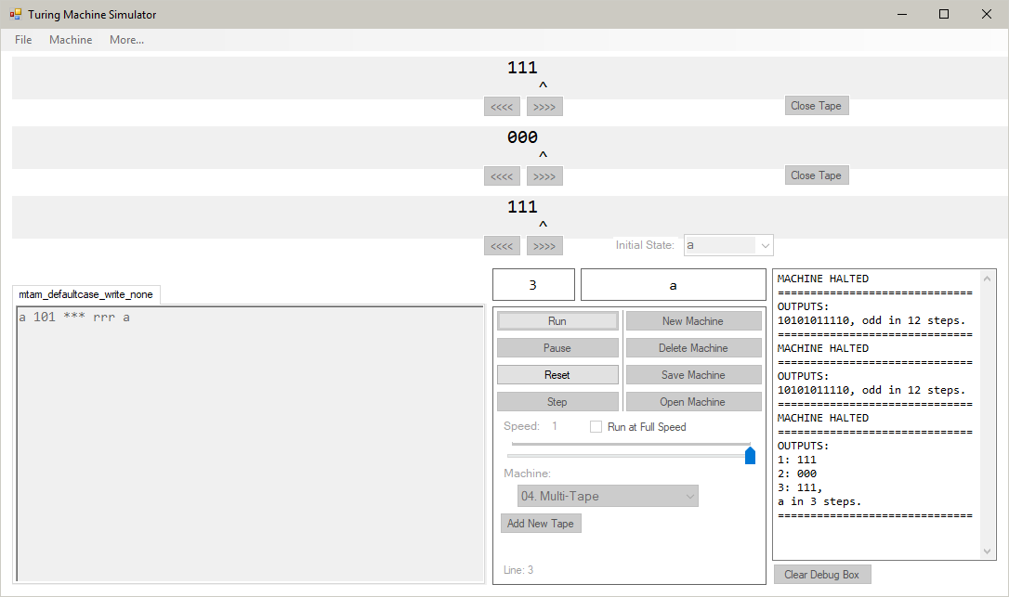

The contents of the tapes are initially:

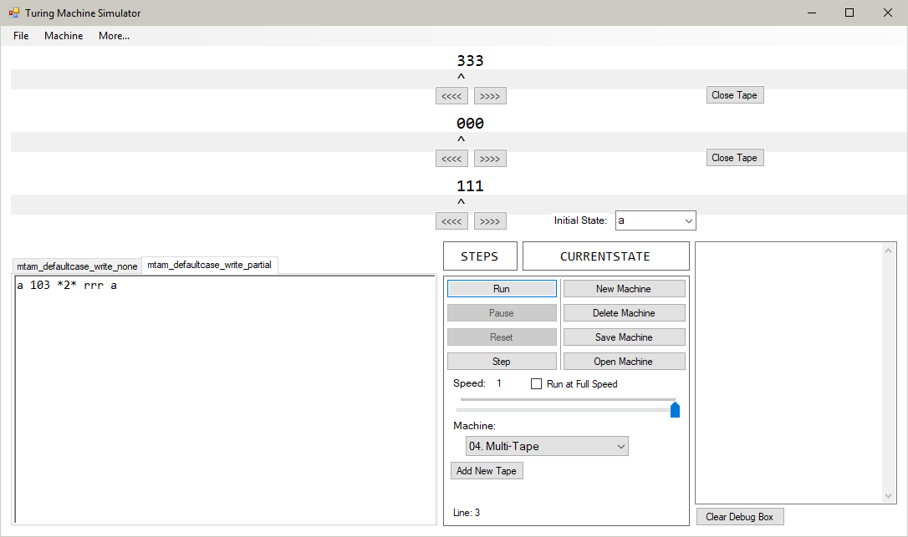

The transition function specifies that the top and bottom tapes are not written to, and the middle one has the character ‘2’ written to it. After running the machine, the final tapes are:

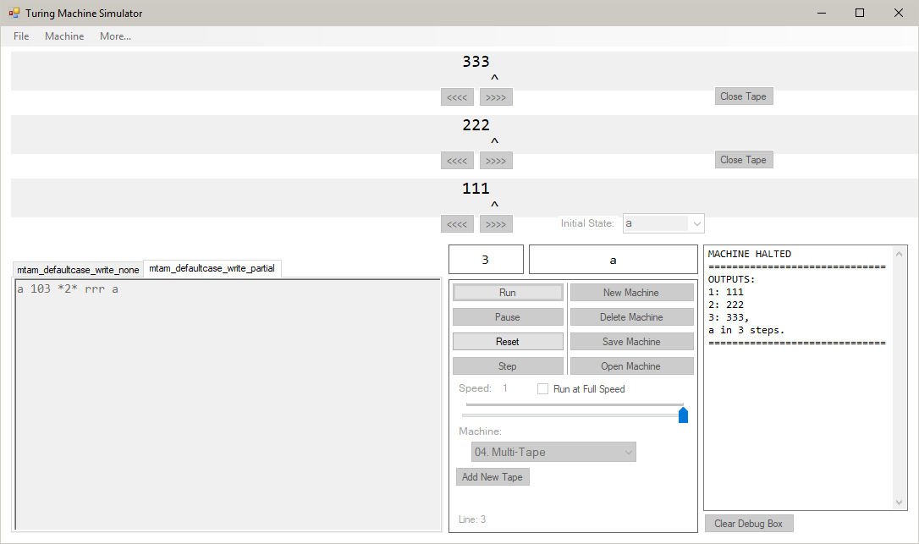

The program correctly identified which tape the ‘2’ should be written to and kept the contents of the top and bottom tapes unchanged while writing to the middle.

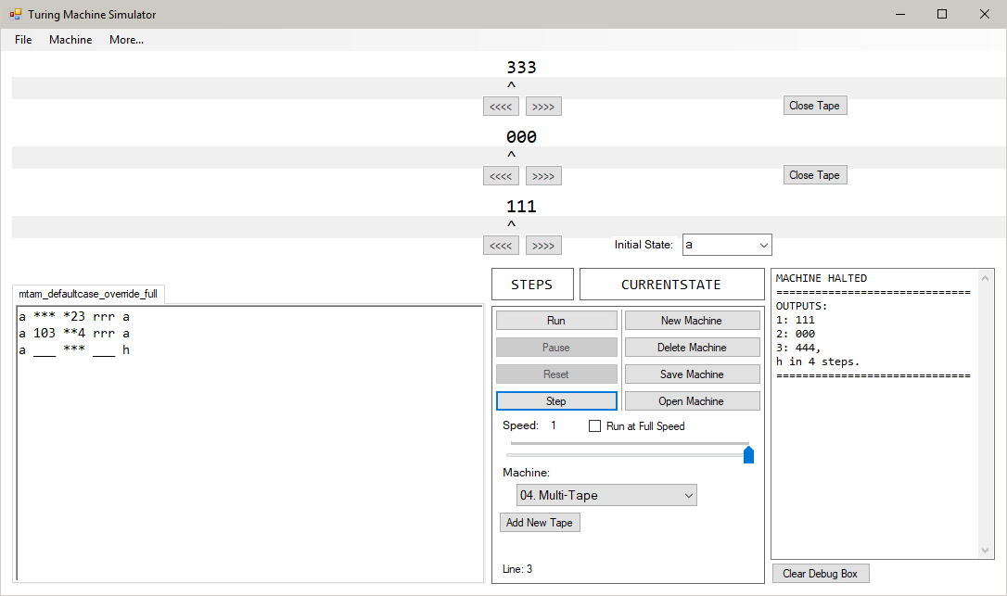

In this machine, both the default case function and the fully-defined function match. Because the fully-defined function has a higher priority, this is the function that is executed:

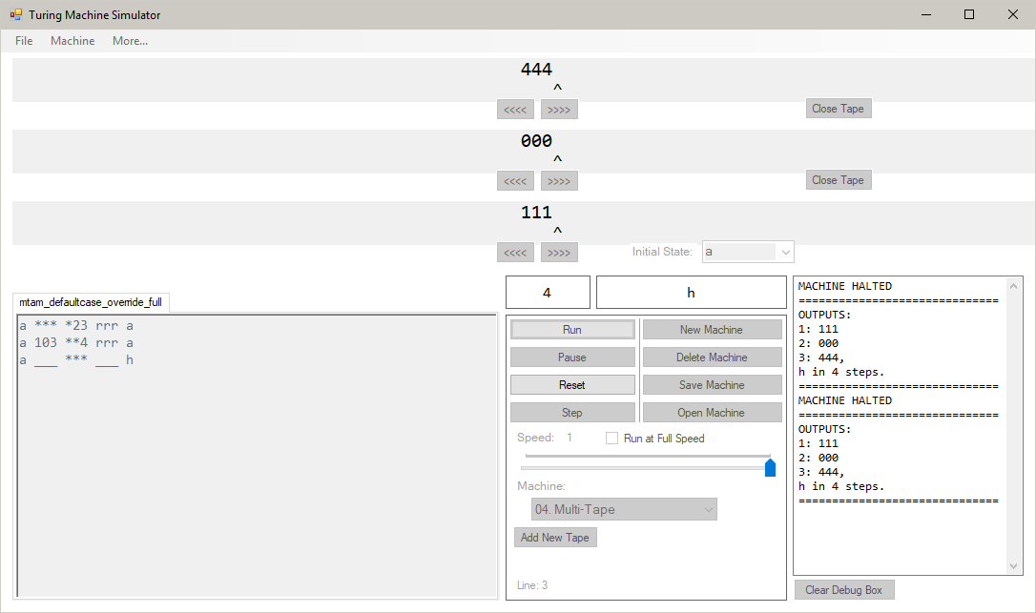

The program correctly identified that the fully-defined function has a higher priority than the default case function.

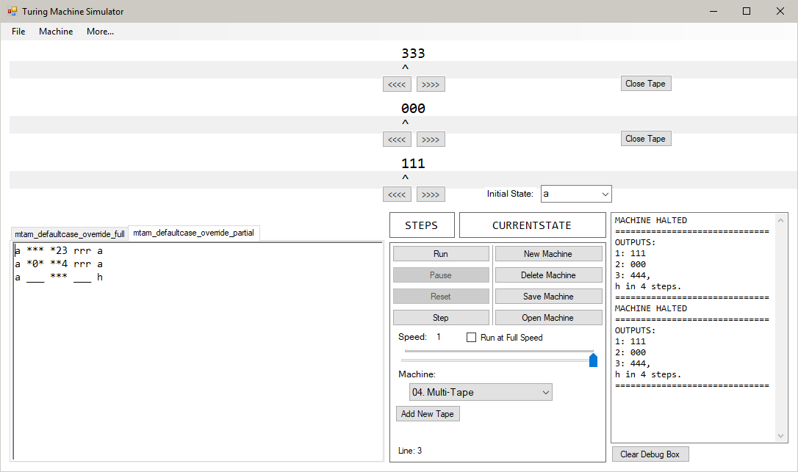

In this machine, both the partially-defined function and the default case function match the tape. Because the partially-defined function has a higher priority than the default case function, this is the function that is performed:

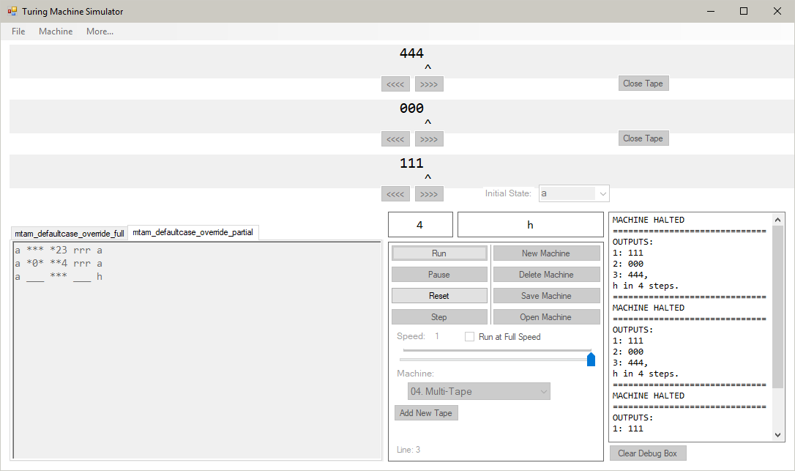

The rules of priority for Multi-Tape machines ensure that the most fully-defined matching function is the one that is executed. Here, there are two partially-defined function; one with two real characters and one with only one. The function with two real characters has the higher priority:

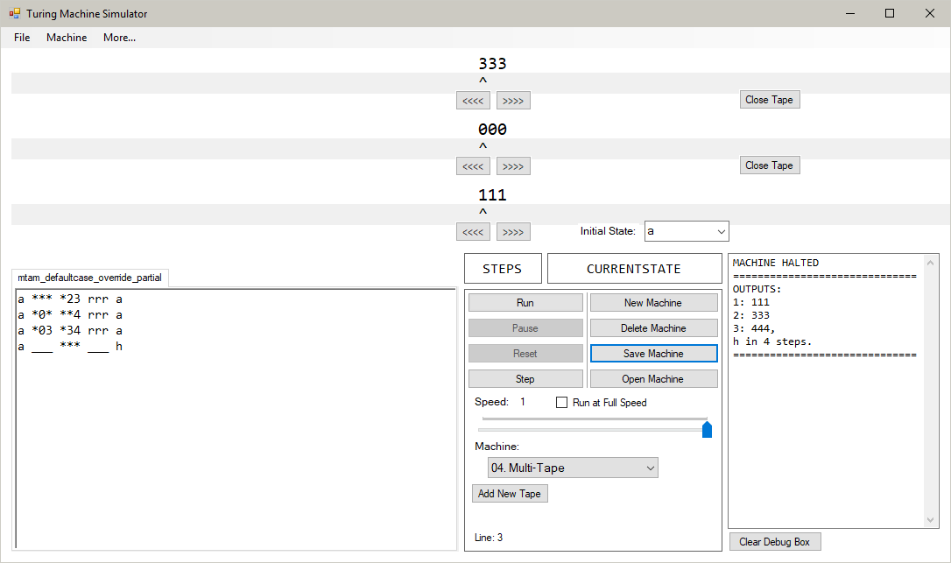

For each step of the machine, the algorithm chooses the third transition function:

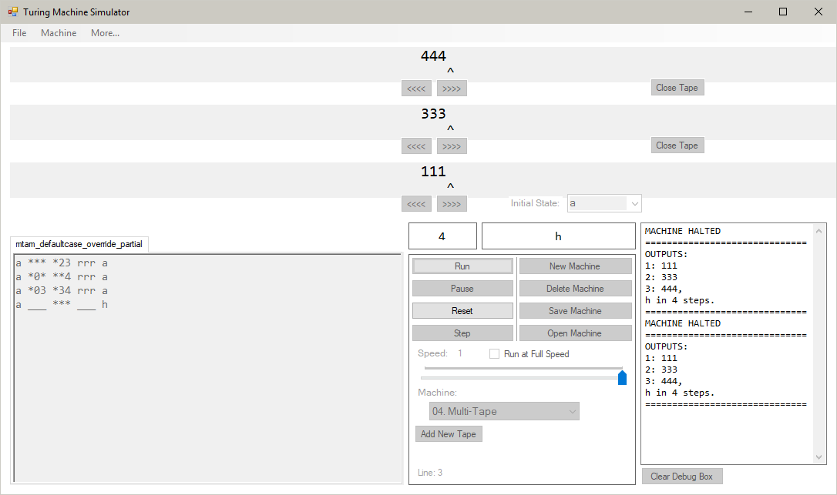

When using all three kinds of function, a fully-defined function has the highest priority, as it has the most real characters:

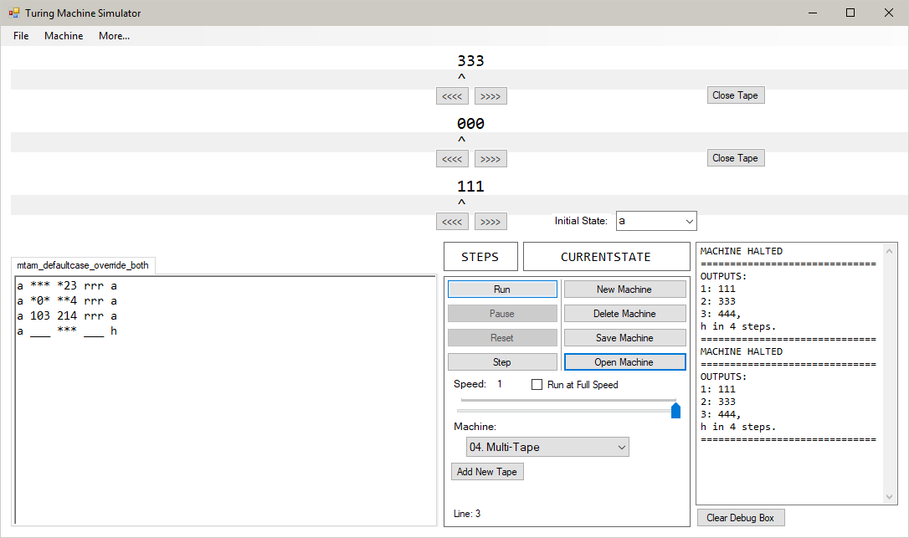

After running the machine, the final contents of the tapes match up with what is specified in the fully-defined function:

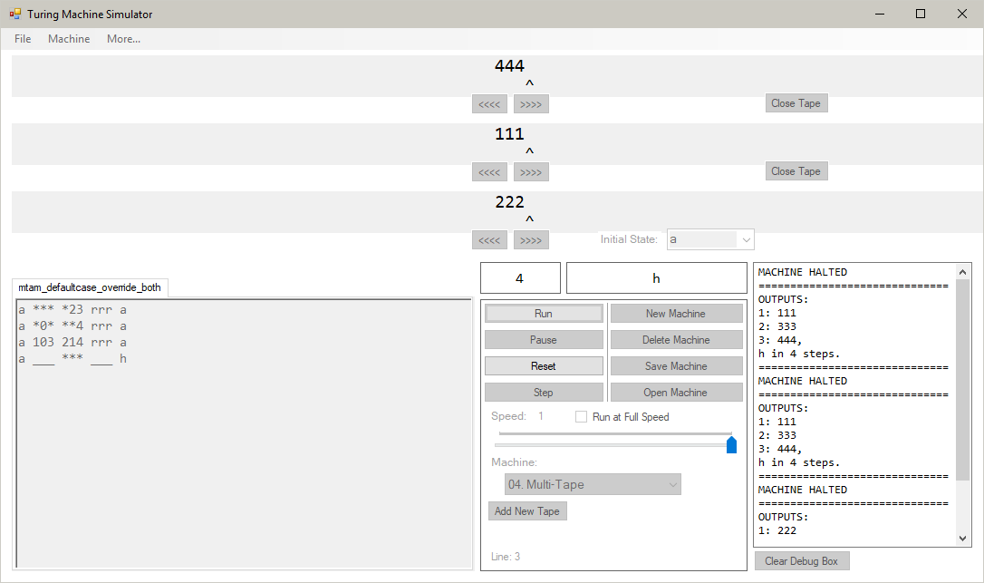

The tapes’ initial contents are:

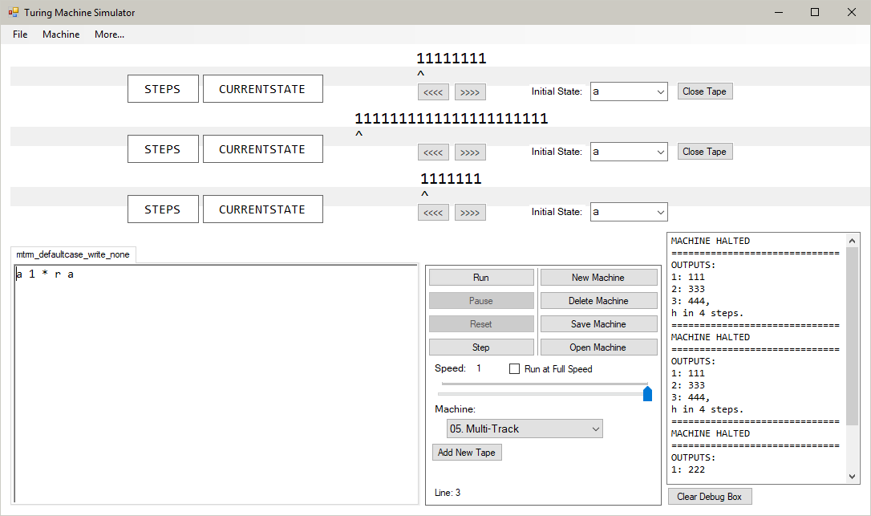

After running the machine, each tape follows the transition function correctly, and does not change the value of the ‘1’s as specified:

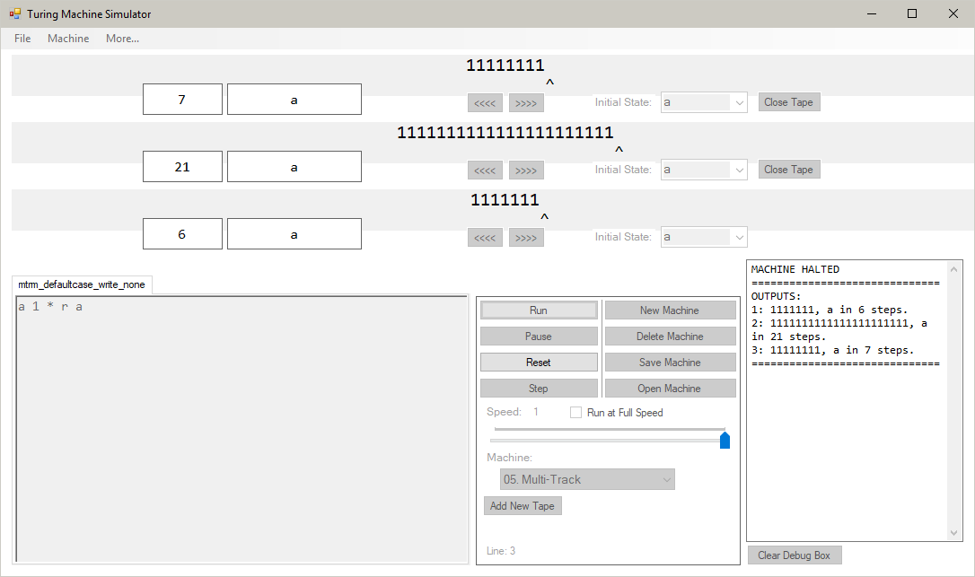

The machine’s initial values are:

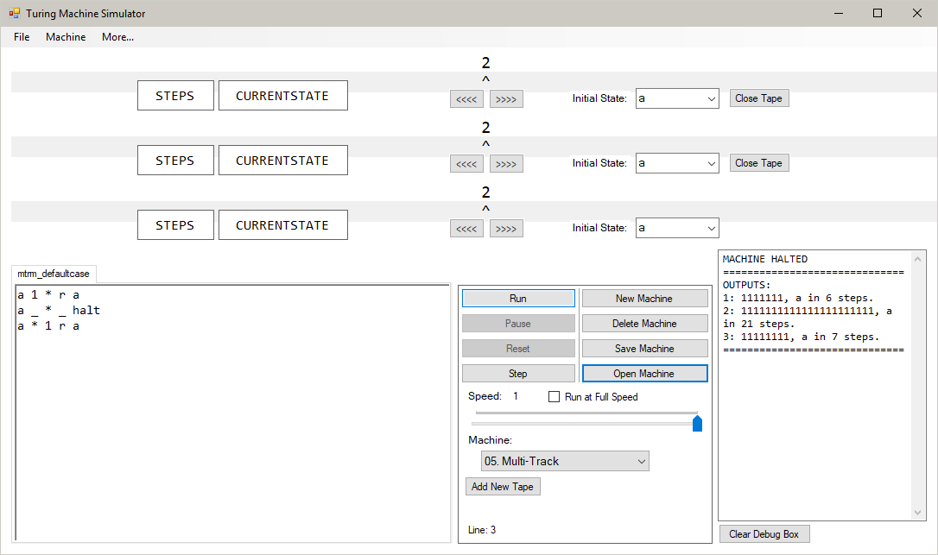

Because there is no matching defined function for the characters on the tape, the default function is performed on all tapes, setting their contents to ‘1’. They halt when encountering a blank space, following the second transition function:

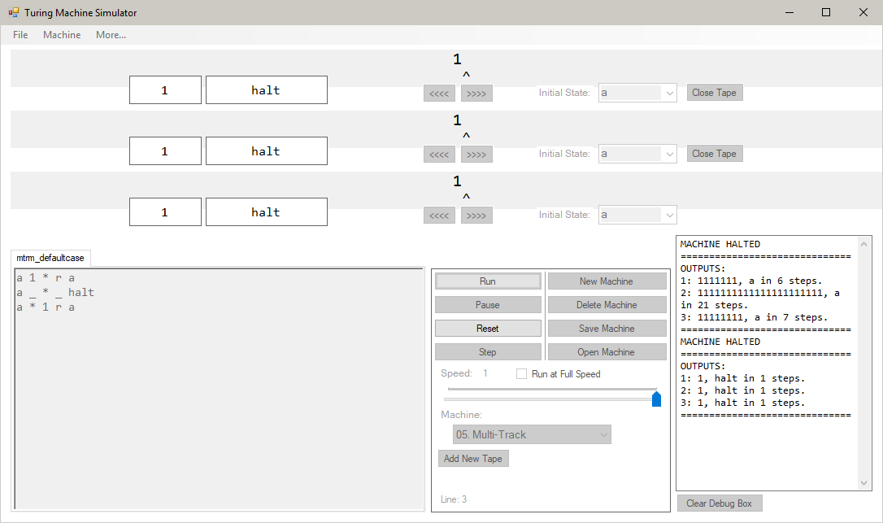

Each tape in this machine will perform differently:

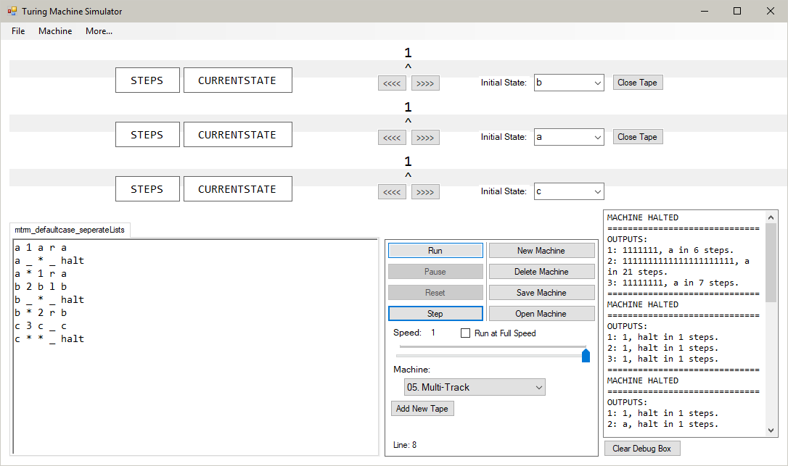

The top tape is in state ‘b’. This state does not have a defined function for ‘1’, whereas state ‘a’ does. Because it is in state ‘b’, it cannot use a state ‘a’ function so must resort to the default case:

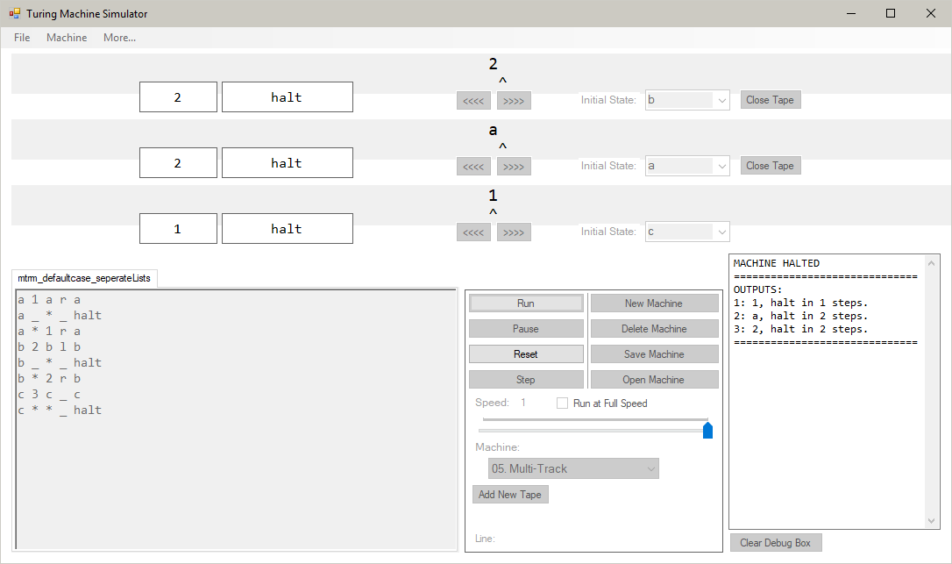

The middle tape matches the defined function on the first line. Because this is of the highest priority, it performs this function:



The bottom tape does not match the defined function for state ‘c’. Therefore, it resorts to the default case and halts:



This machine shows that the program correctly creates a set of override characters for each tape. This is because the top tape, in state ‘b’, will not accept the character ‘1’ as an override character, despite this being accepted as one in the middle tape, which is in state ‘a’. This is the same for the bottom tape, which is in state ‘c’, which will only accept the character ‘3’ to override the default case.

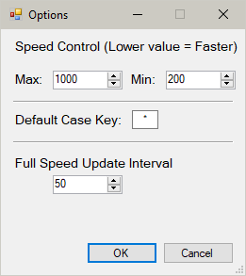

Setting the minimum speed value to 200 now updates the slider to use the scale 1000 to 200:

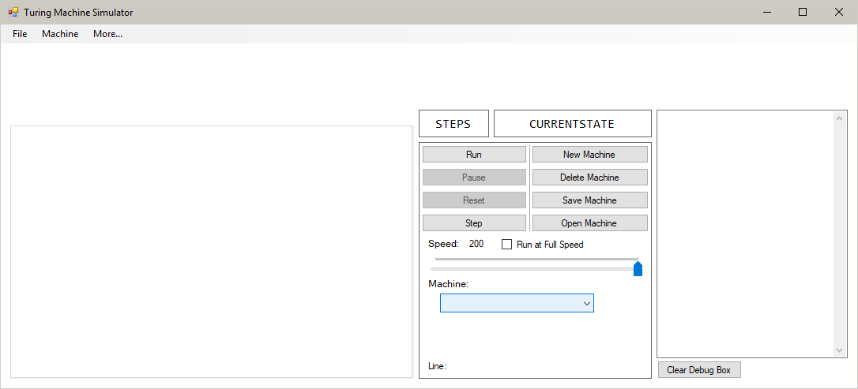

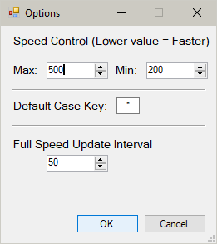

Making the maximum speed value 500 now makes the left-hand side of the slider the value 500:

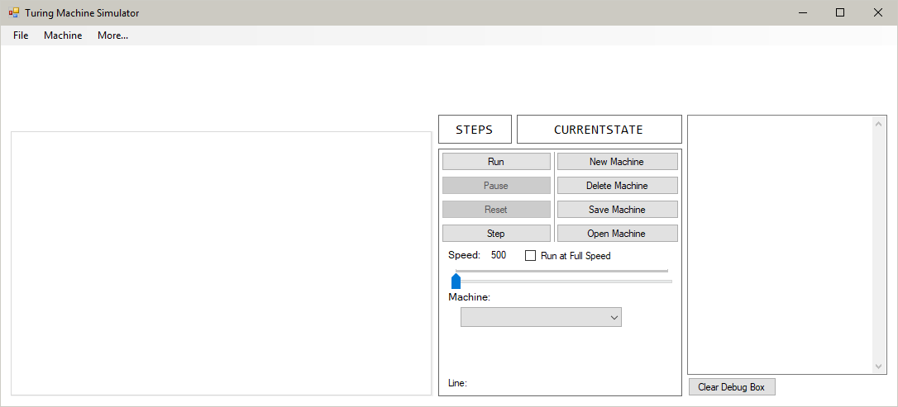

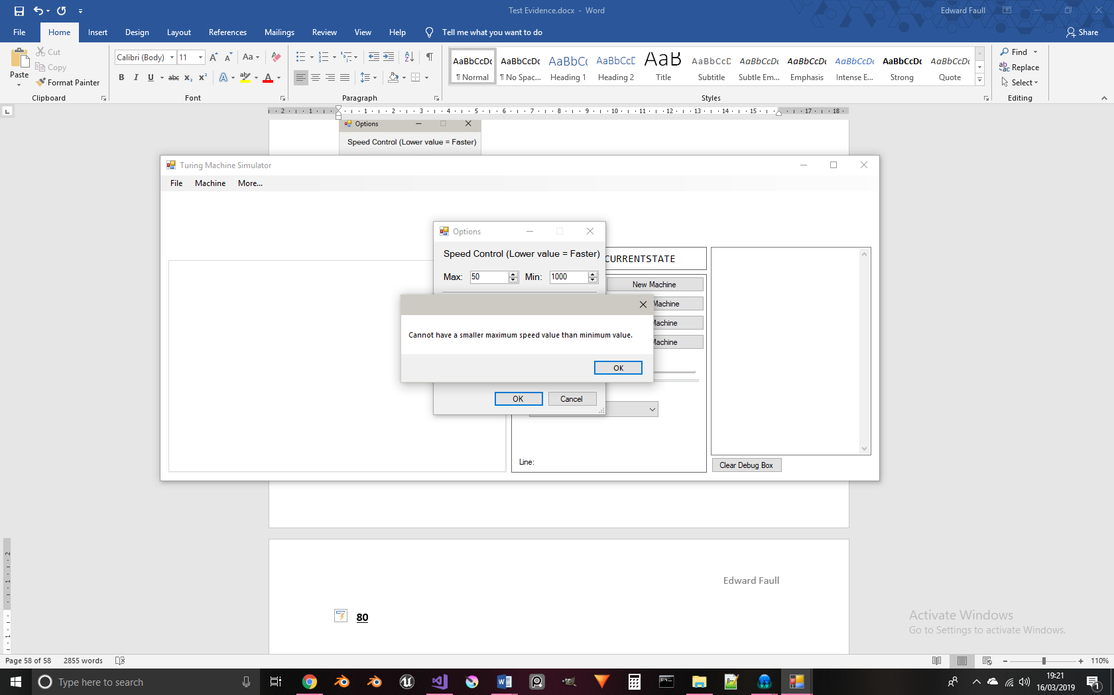

Attempting to use a maximum value smaller than the minimum value yields this error message. Pressing “OK” will close the message and keep the user in the settings menu:

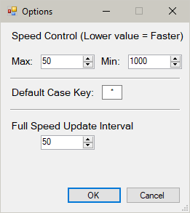

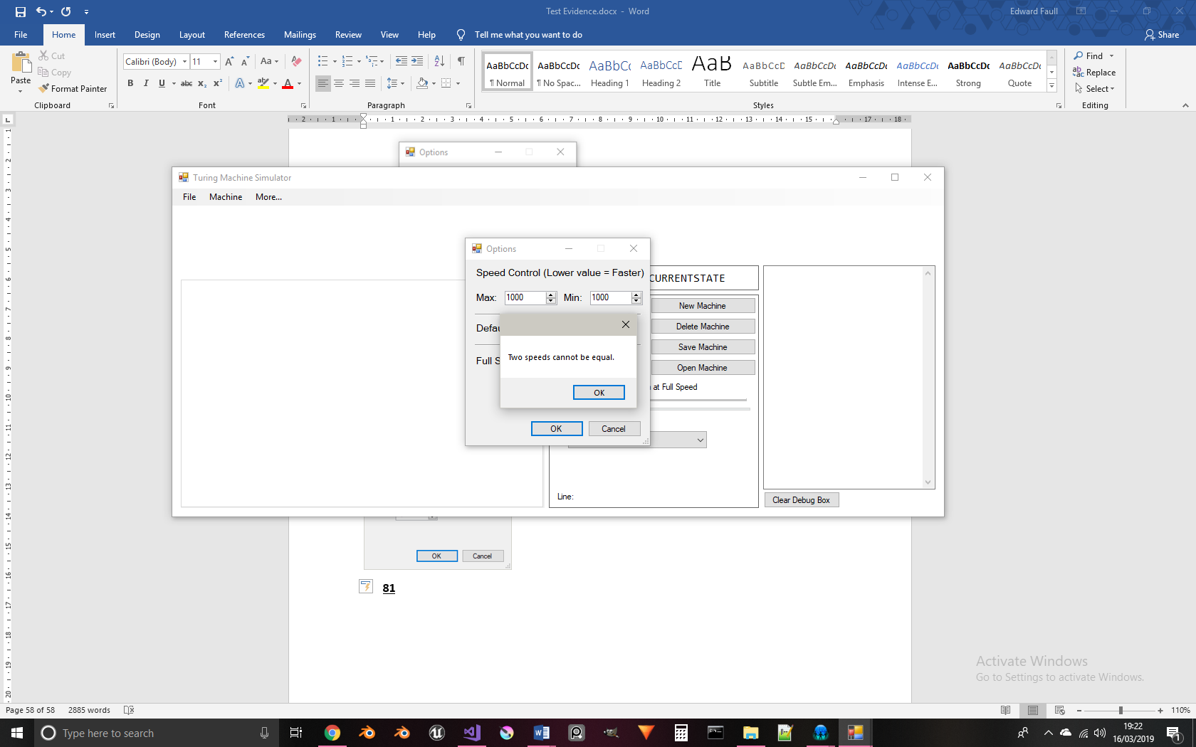

An error message appears when attempting to use the same value for both speed values. Pressing “OK” returns the user to the settings window:

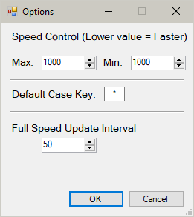

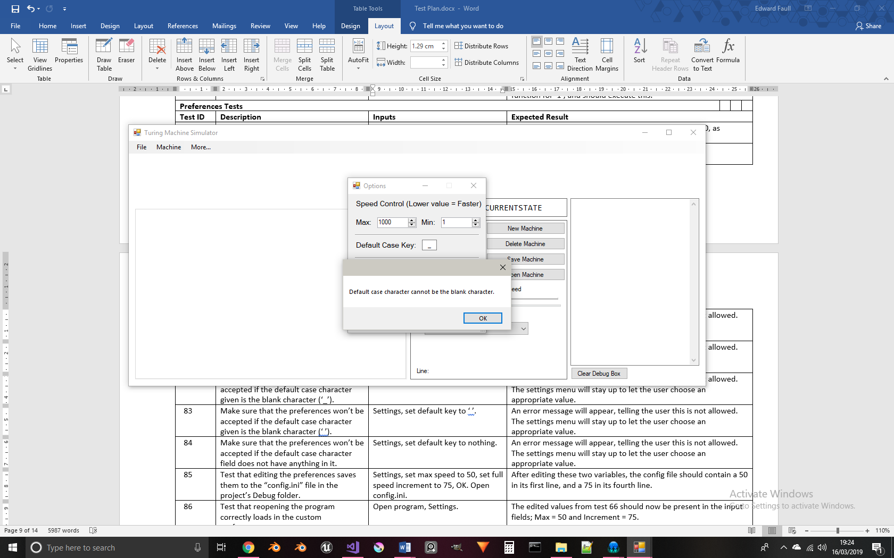

An error message telling the user that they cannot use that character is shown.

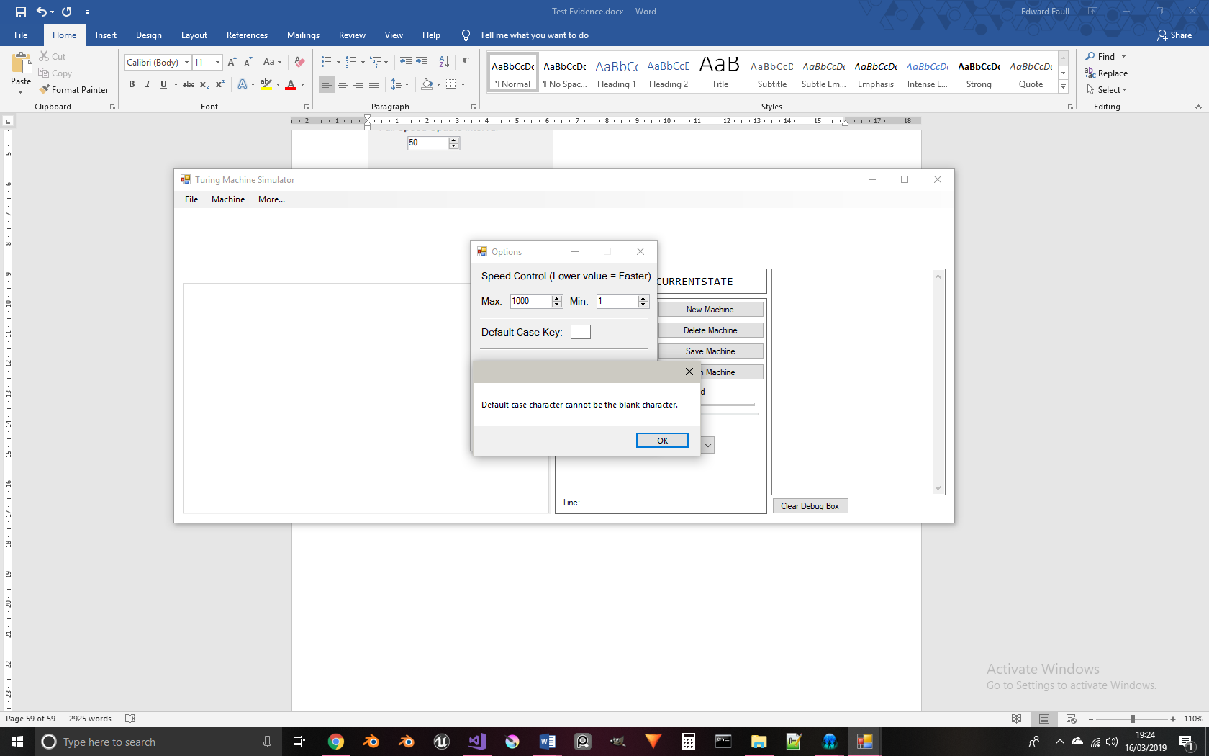

The same error message as in Test 82 is displayed when using a space instead of an underscore.

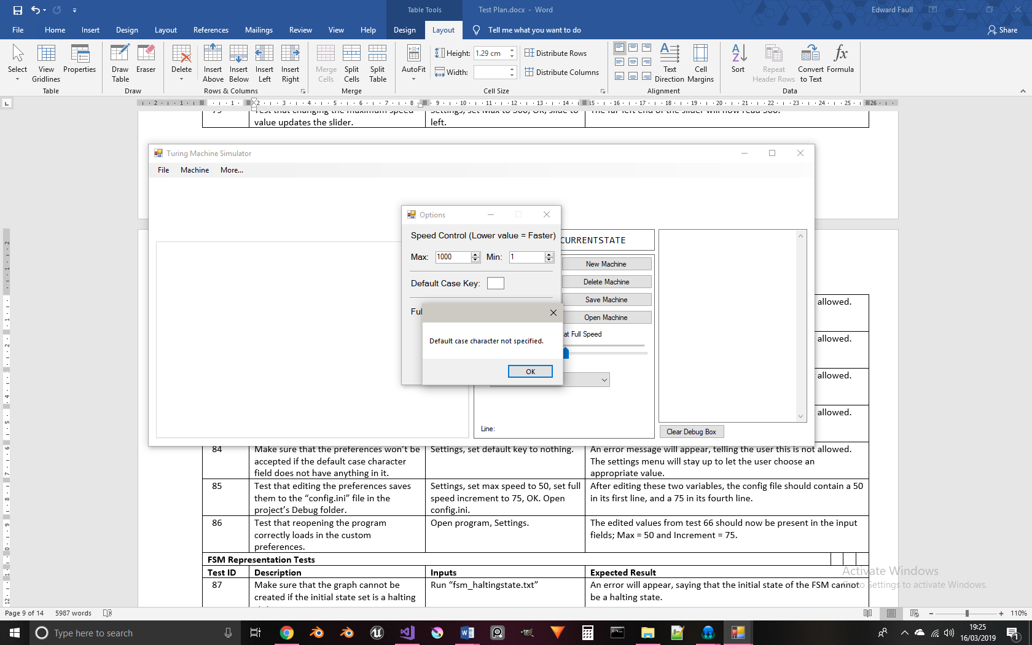

When there is no character at all in the default case key field, an appropriate error message is displayed, telling the user that they need to specify what character to use as the default case key.

For this test, the default case key is set to the character ‘8’:

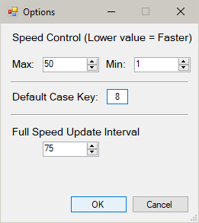

The machine being loaded in is identical to the Addition example, except its default ‘*’ characters are replaced with the new default case key ‘8’:

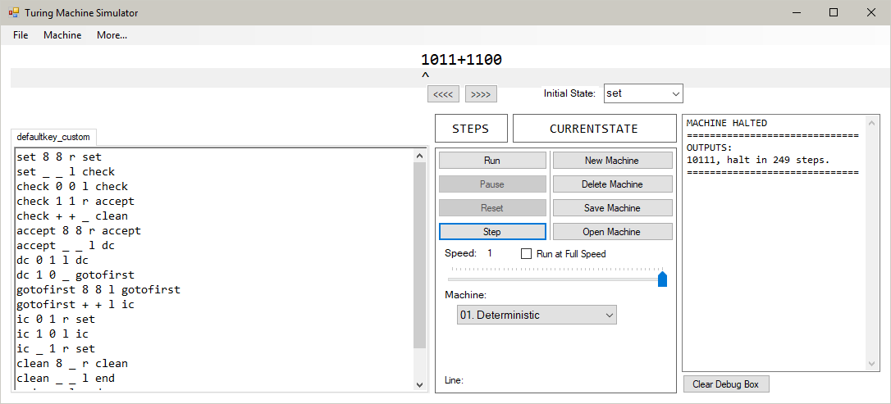

Running the machine produces the correct sum of 1011 and 1100:

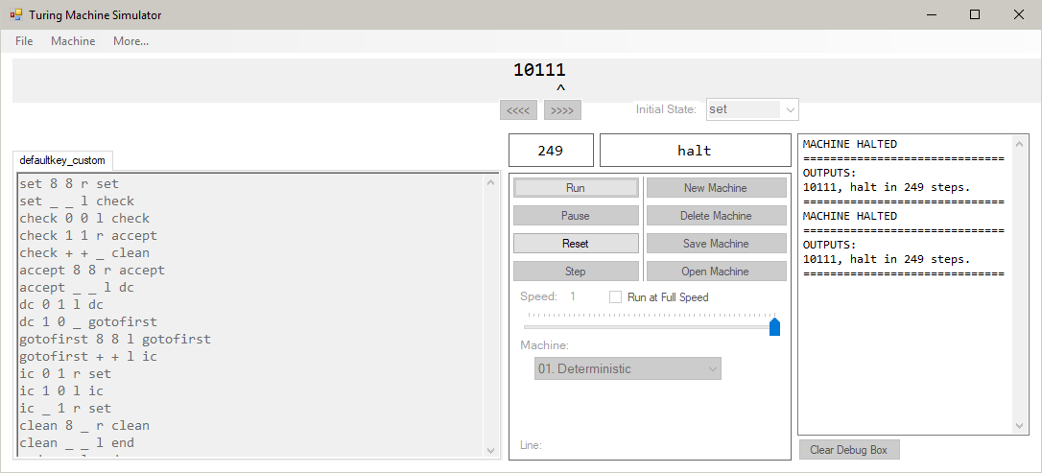

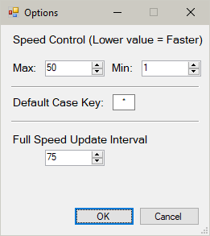

After pressing “OK”, the “config.ini” file is updated and now reads:

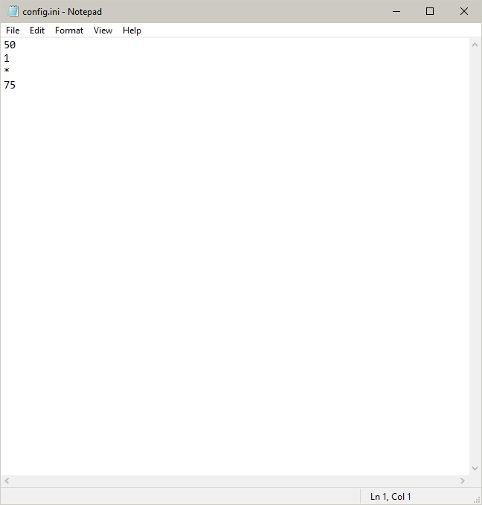

The edited preferences are successfully saved to the config file.

The “config.ini” file reads:



After opening the program, these custom values have been correctly mapped to each field in the Settings menu:

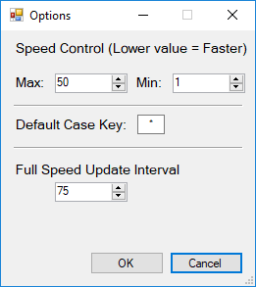

The “config.ini” file is deleted from the Debug folder in the solution:

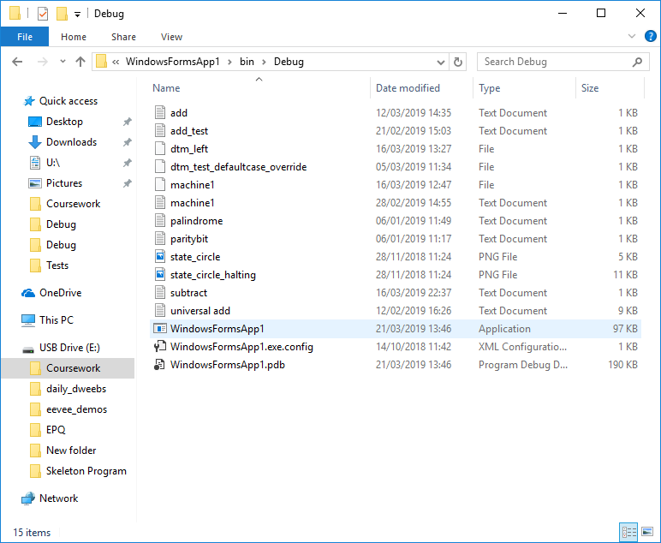

After opening the program, a new “config.ini” file is created. Its contents are the default values:

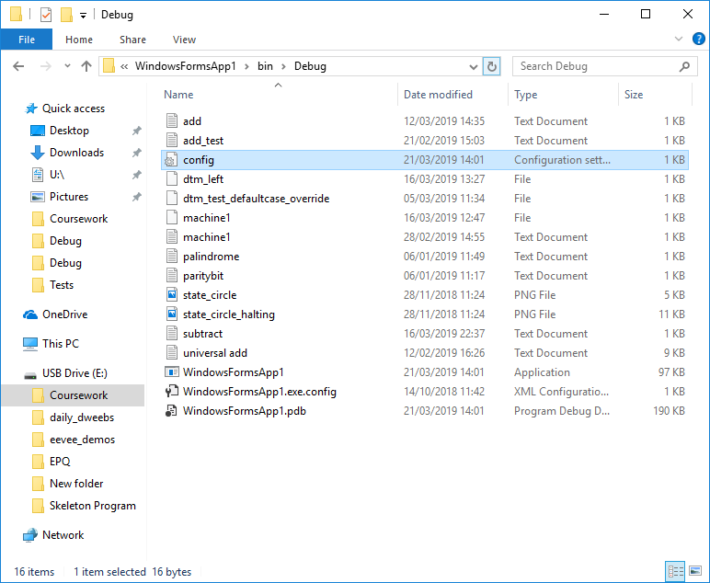

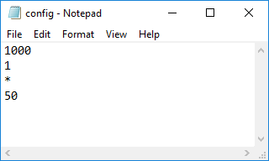

For this test, the edges on the FSM and their labels have been disabled to allow for a clearer image.

The machine to be represented as an FSM is:

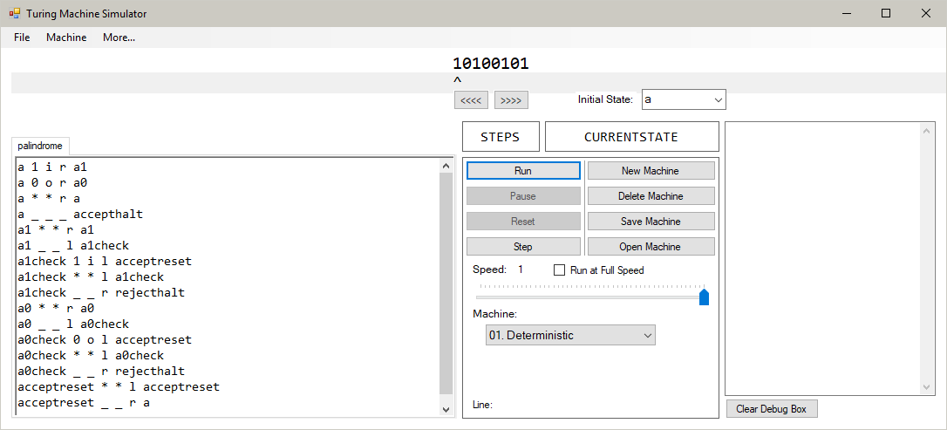

The resulting layout of the states in the FSM is:

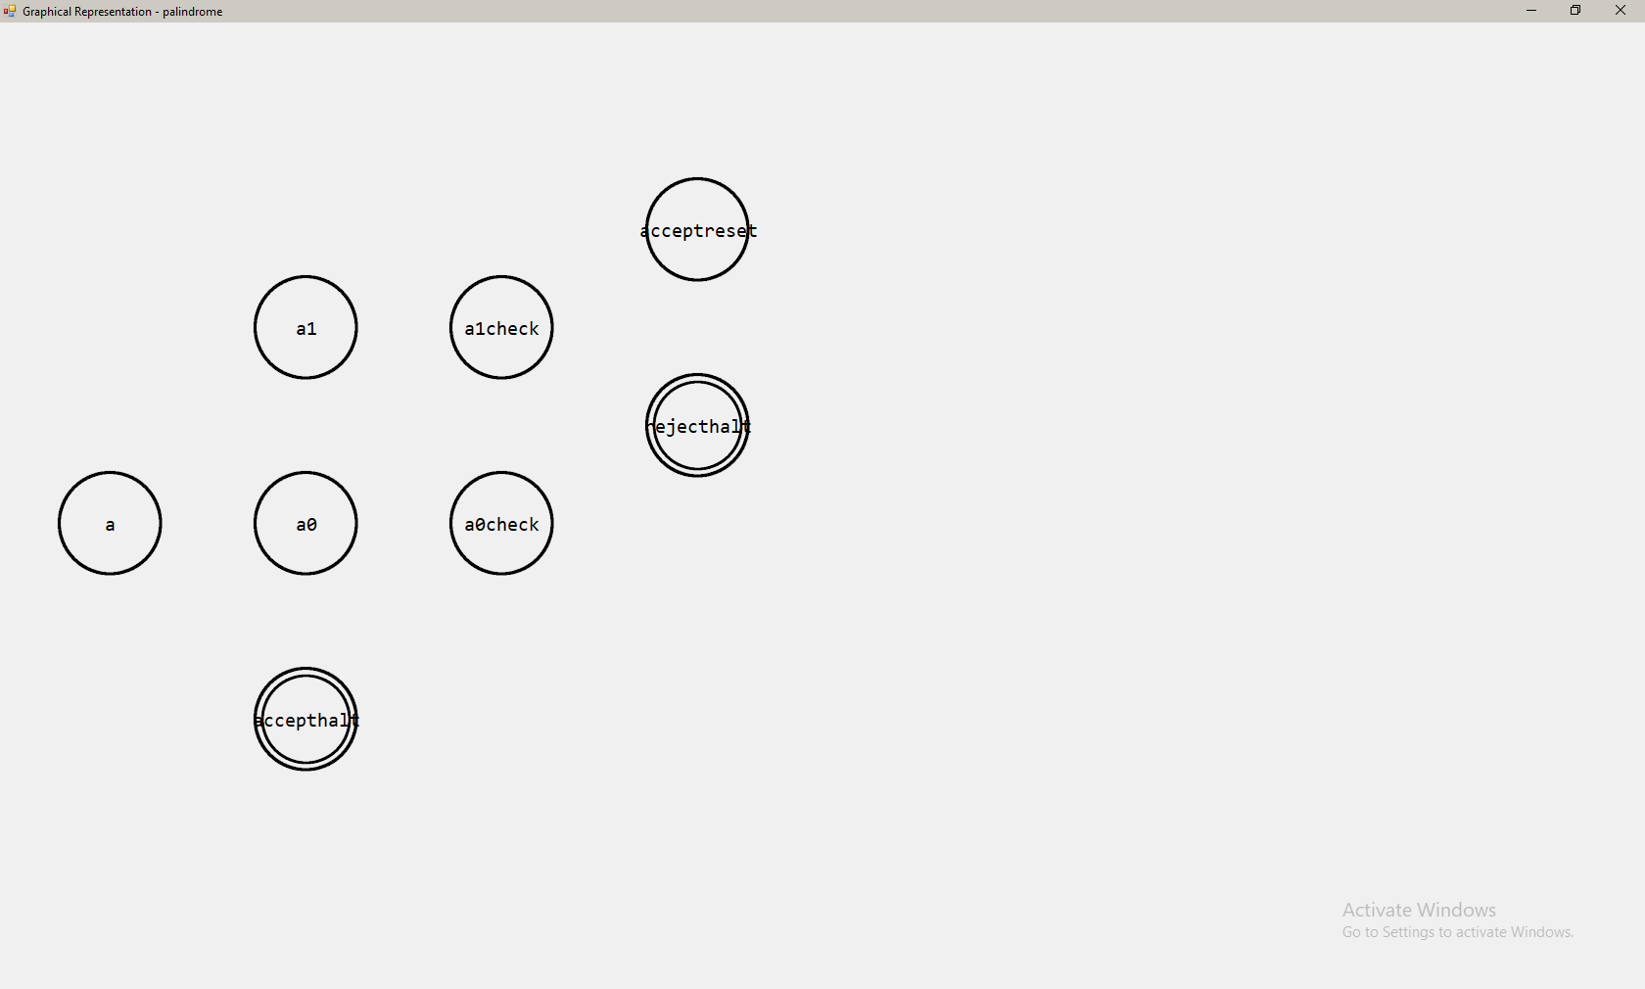

The initial state, ‘a’, is vertically centred and close to the left end of the screen. The three states that can branch away from this state are spaced equally far from ‘a’ horizontally, and states ‘a1’ and ‘accepthalt’ are displaced up and down equally. The two halting states have been given the additional ring around their states to indicate this. Because the method of spawning nodes is depth first, in order of where they are entered in the text editor, the children of state ‘a1’ are spawned first, and so the ‘acceptreset’ and ‘rejecthalt’ states branch from this state and not from state ‘a0’. This shows that the program creates the FSM in a depth first method, as intended.

Edges and labels are now enabled from this test onwards.

The machine to be represented is:

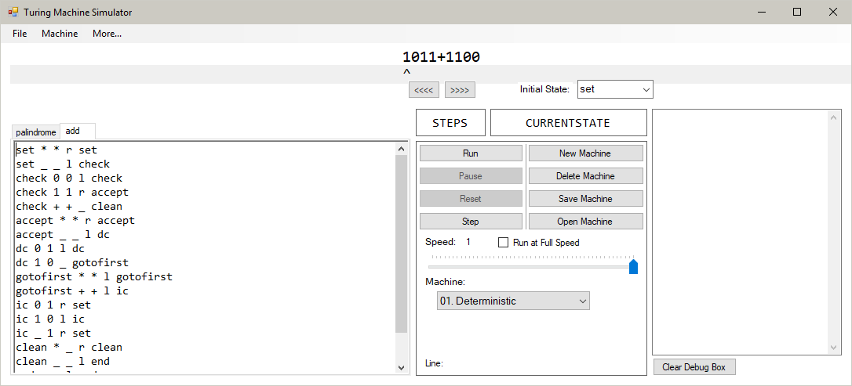

The initial state is spawned vertically centred and an arrow is pointing to it from the edge of the window:

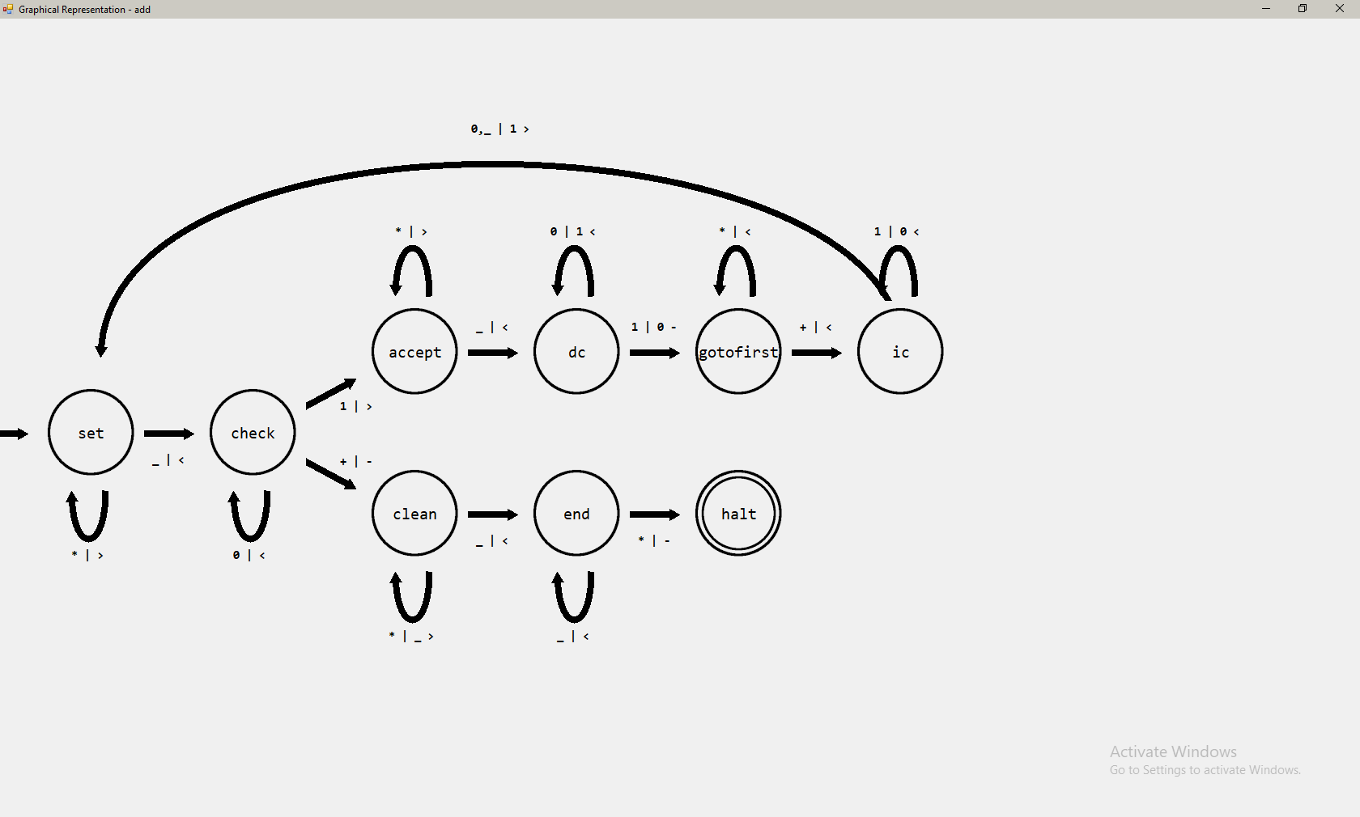

The machine to be displayed has initial state ‘a’ and transition function:

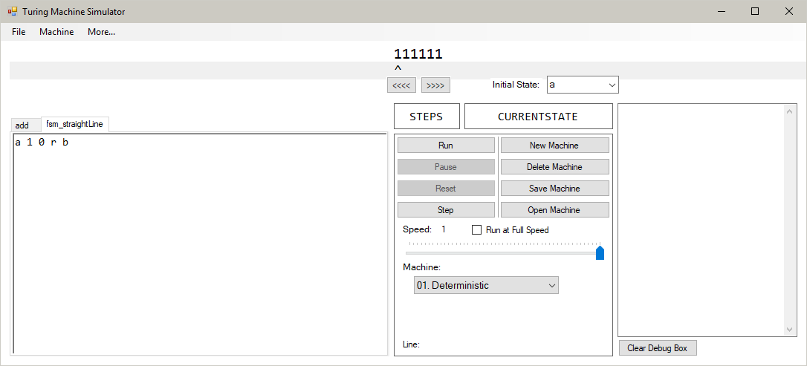

The state ‘b’ is correctly placed vertically in line with the initial state. An arrow points from ‘a’ to ‘b’, and is labelled with information consistent with the transition function; read key ‘1’, write key ‘0’ and move key ‘r’ (converted to ‘>’):

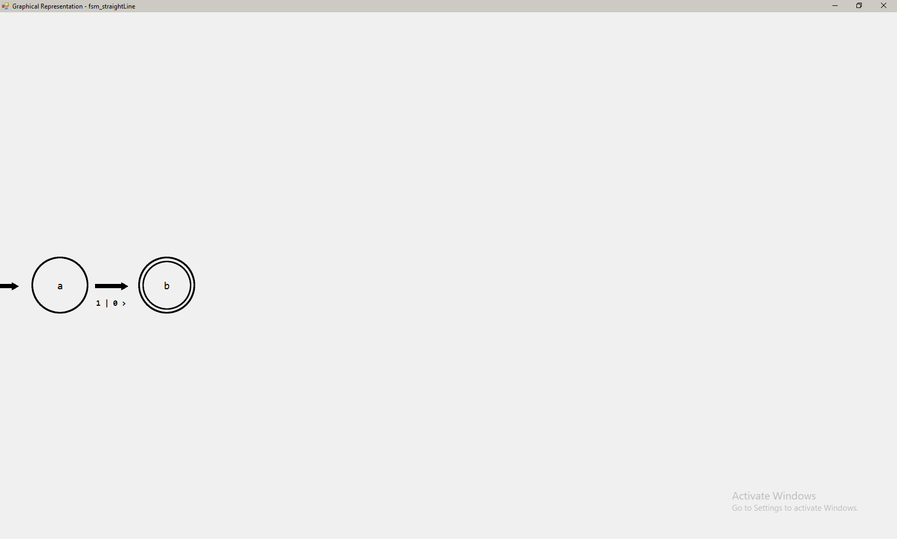

The machine to be displayed has initial state ‘a’ and transition functions:

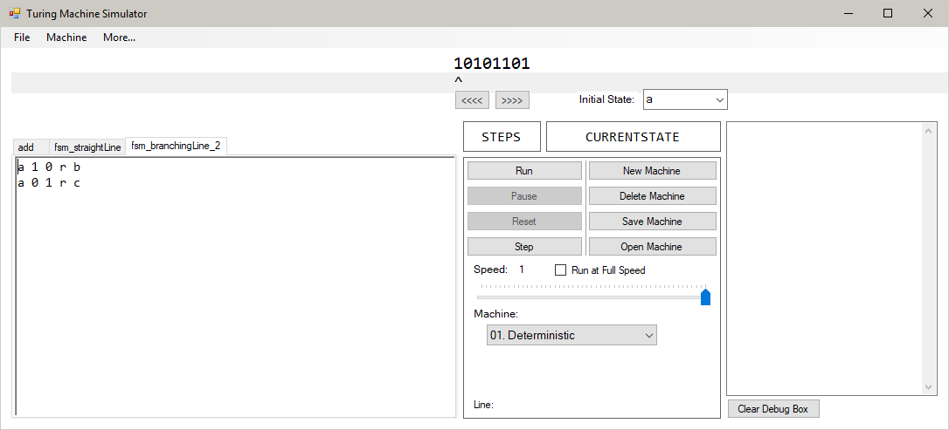

The two states branching away from state ‘a’ are in line with each other horizontally. Both are displaced equally from ‘a’ vertically, in opposite directions. The labels on each edge correctly reflect the transition functions listed above:

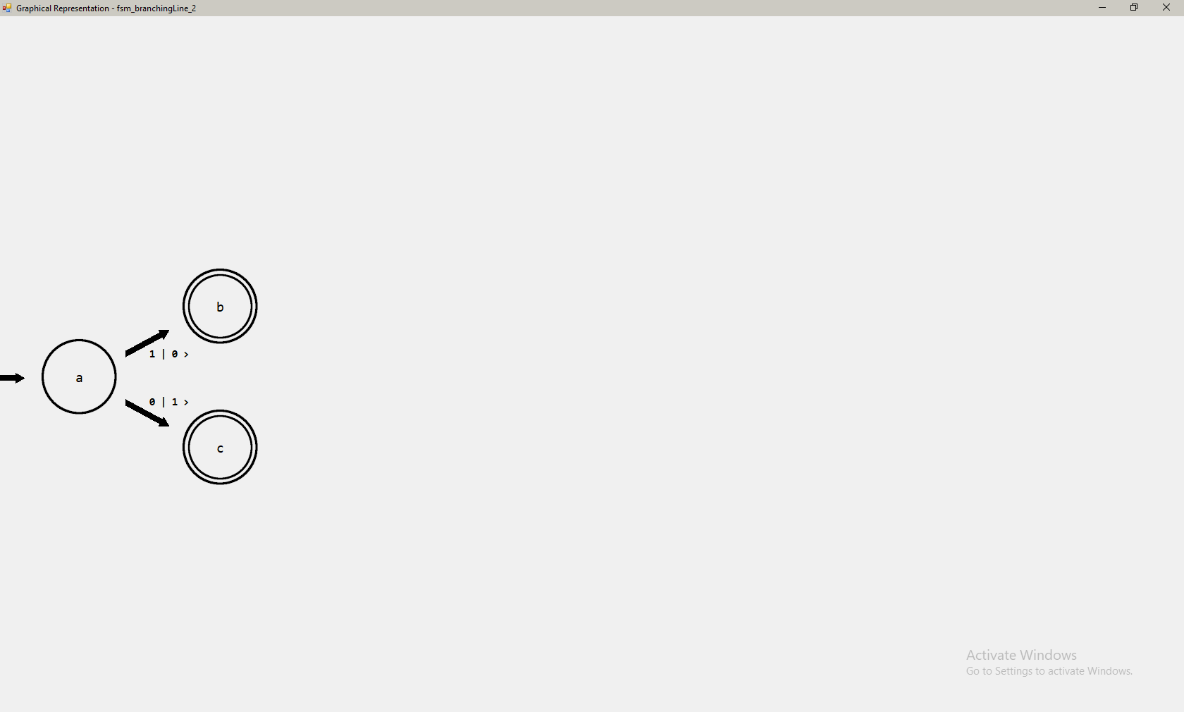

The transition functions used for this machine are shown below:

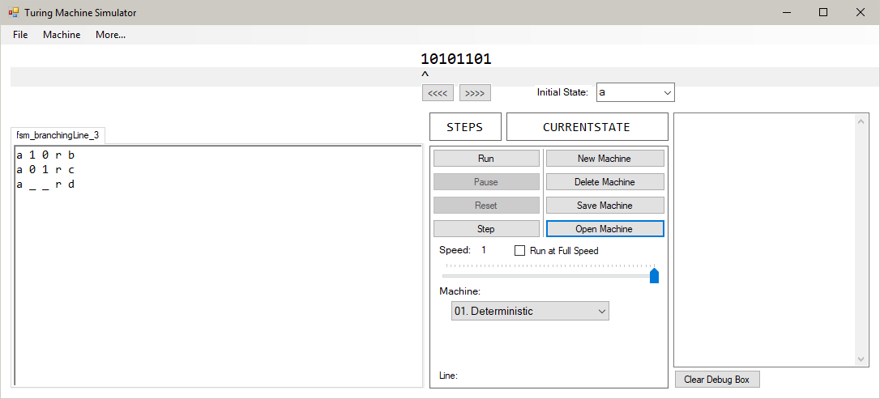

When represented as an FSM:

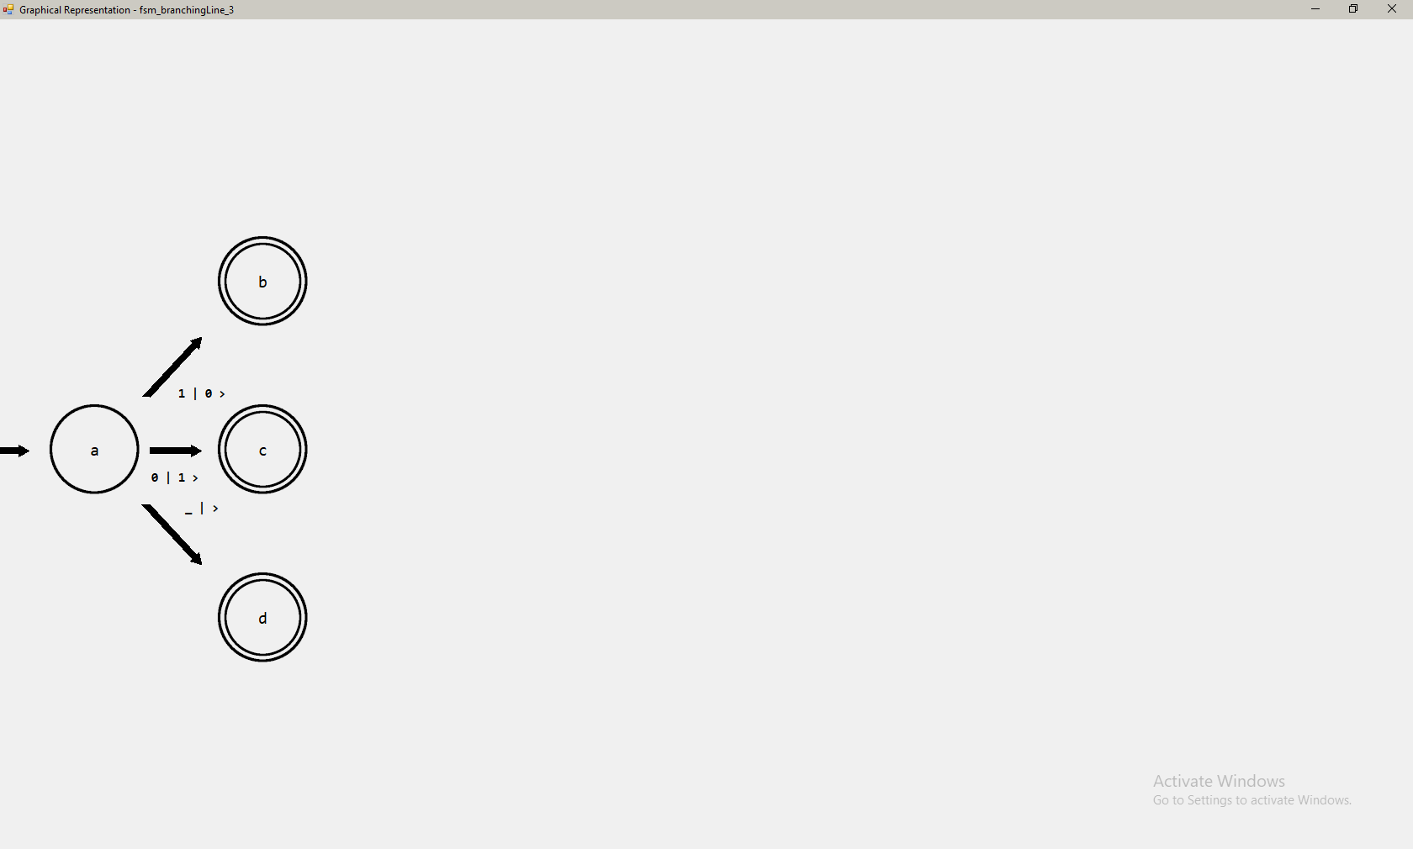

The state ‘c’ is displaced only horizontally from state ‘a’. This is intended when there are an odd number of branching states. The other two states are displaced as intended, with all three states being an equal horizontal distance from ‘a’ and equally spaced in the vertical axis. The labels applied to the edges are correct to the transition functions shown above.

Transition function:

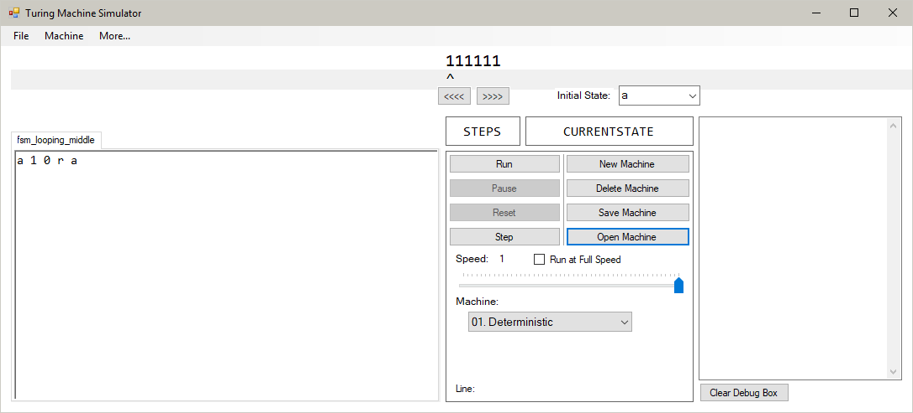

FSM:

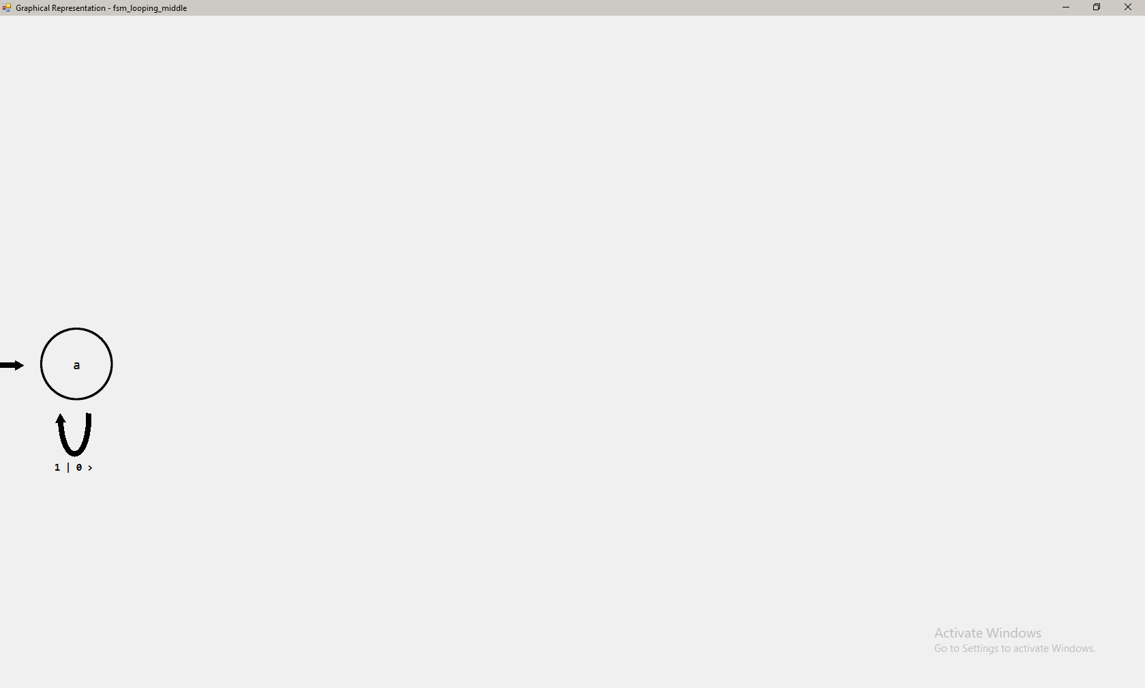

When a transition function returns to the same state as it entered in, a loop is drawn, with the information on the outside of the curve. When the node is in line with the initial state (or is the initial state) in the vertical axis, the loop goes underneath the node.

Transition functions:

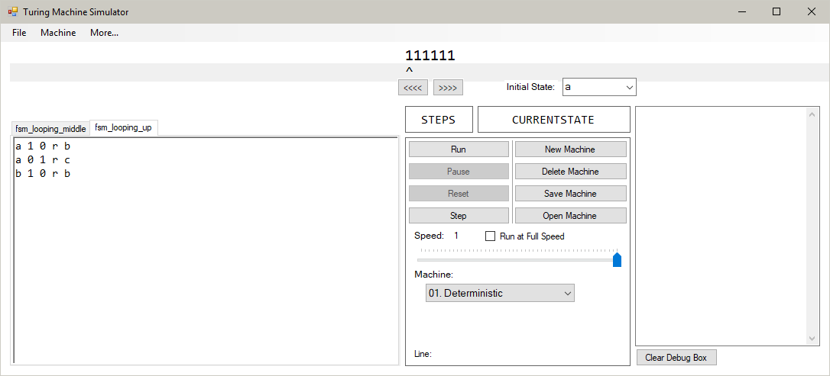

FSM:

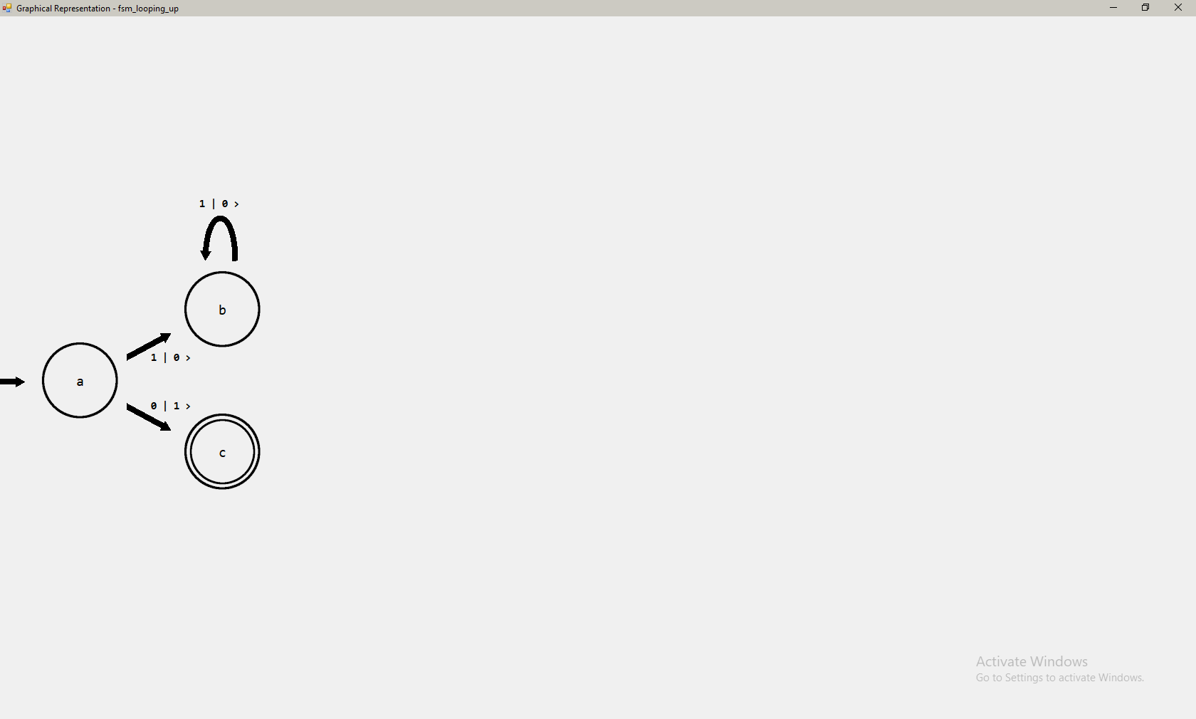

The transition that is being examined in this test is “b 1 0 r b”. This is represented correctly as a loop going back into state ‘b’ from state ‘b’. Because it is above the initial state, the loop goes above the state it comes from. This is done to reduce the amount of collisions between edges and nodes in the FSM to make it easier to read.

Transition functions:

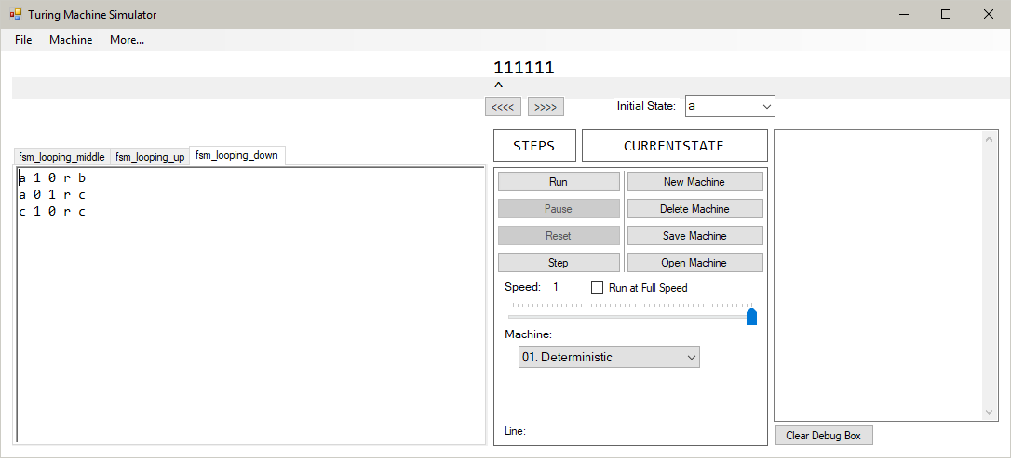

FSM:

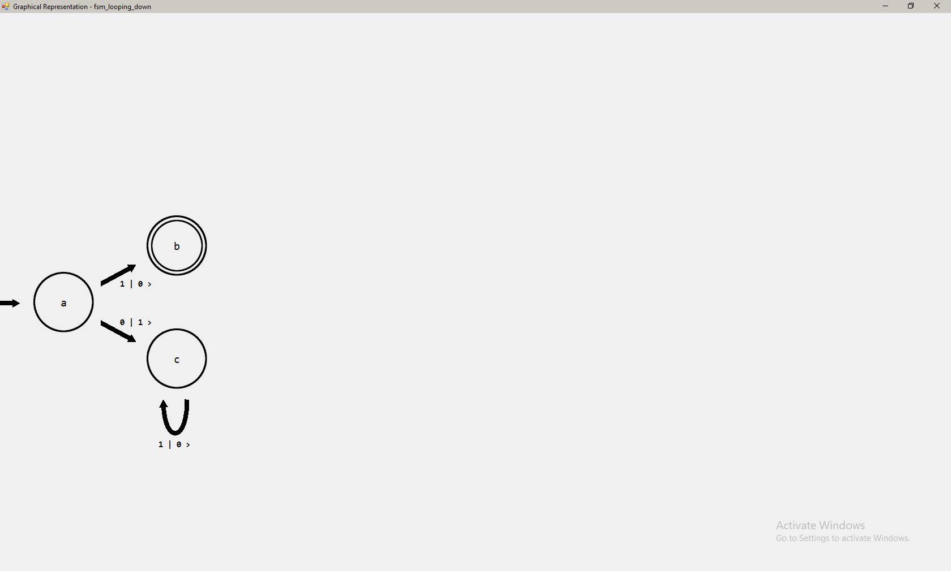

The looping edge in this machine correctly goes below the node. This is intended to happen when the node is below (or in line with, proved in Test 92) the initial state, in order to reduce collisions in the diagram.

Transition functions:

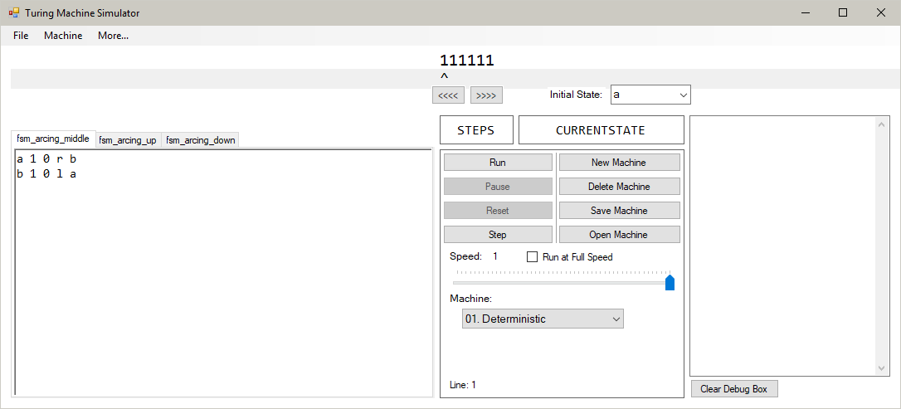

FSM:

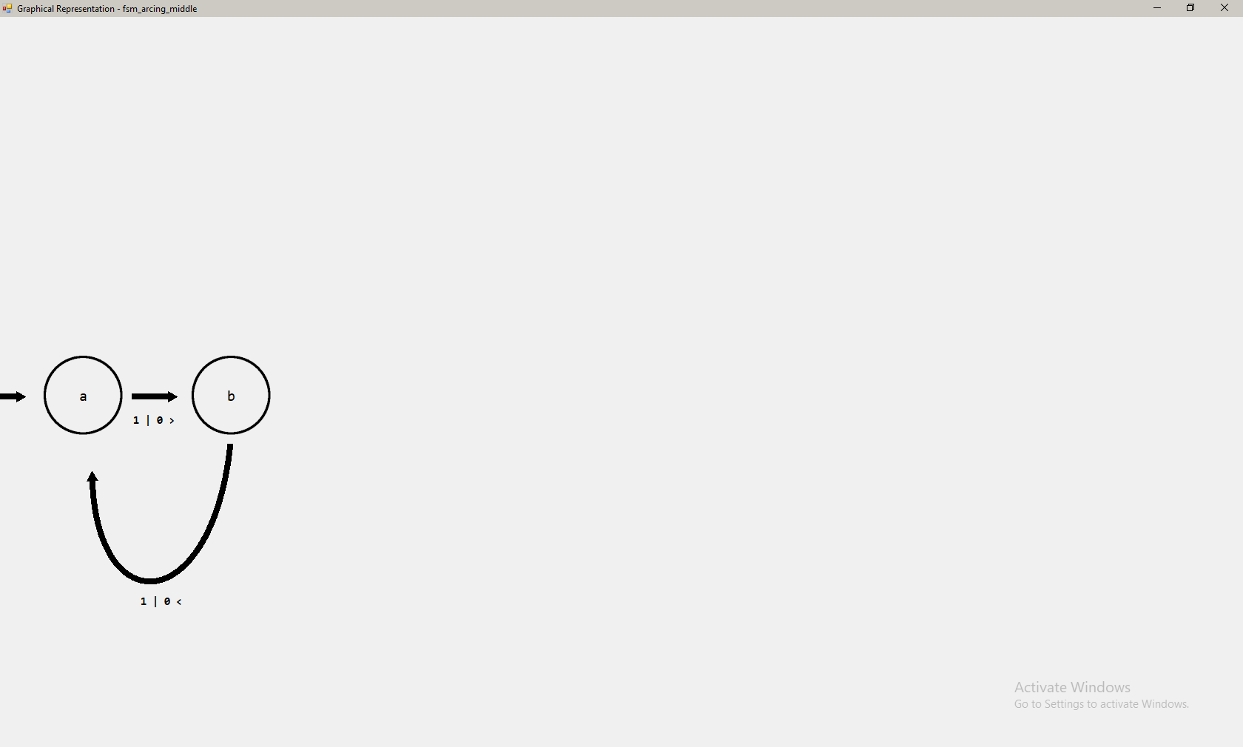

As intended, the arc is drawn below the states when the two states are in line with the initial state. The label is on the outside of the curve and correctly displays all of the information in the transition function it represents (“b 1 0 l a”).

Transition functions:

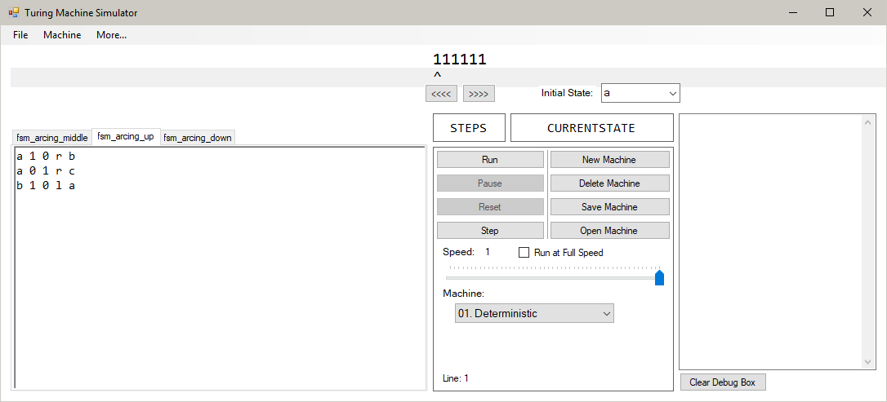

FSM:

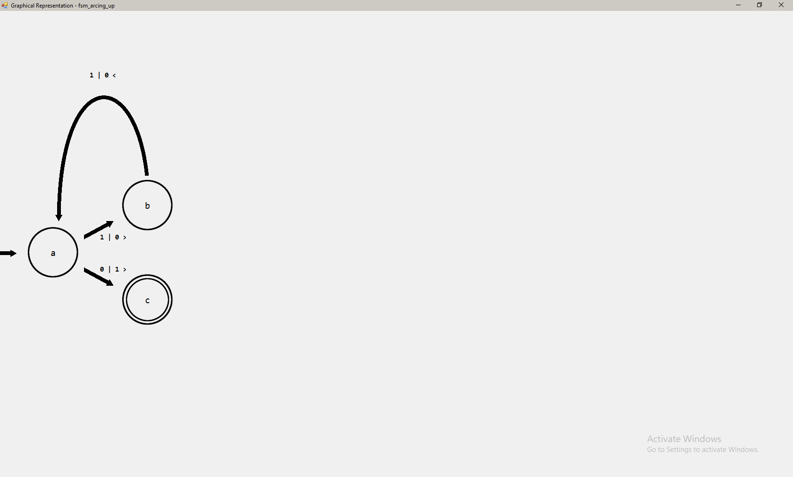

For the same goal of reducing the number of overlapping edges and collisions with state nodes, the arcing edge travels upwards when the initial state of the transition function (‘b’) is above the final state of the transition function (‘a’).

Transition functions:

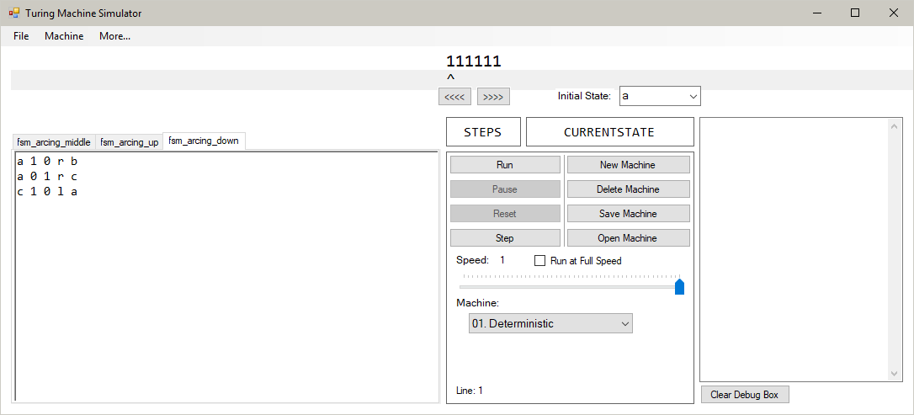

FSM:

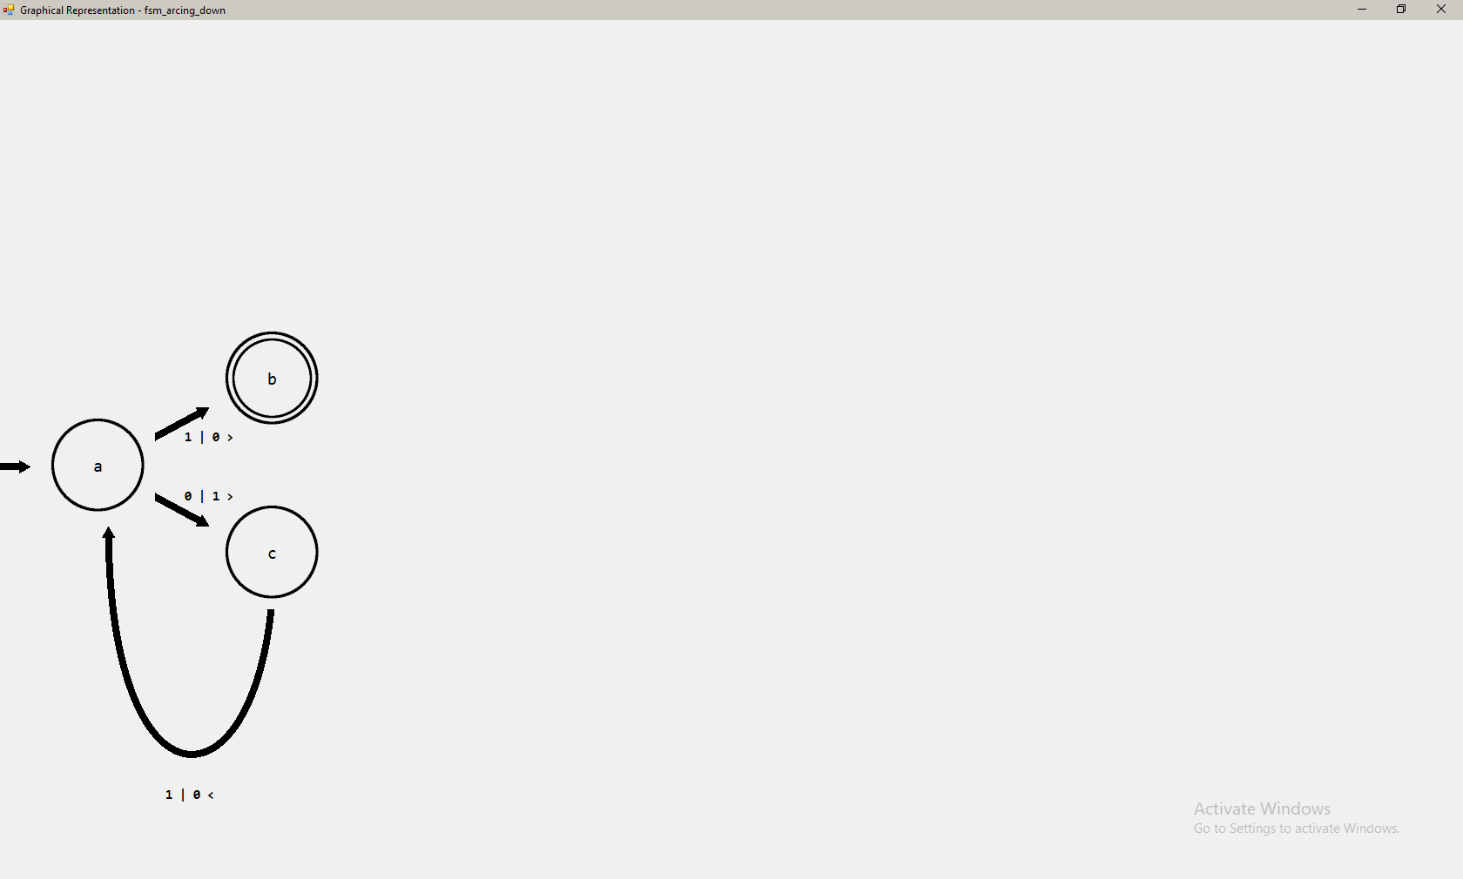

The arc is drawn going down from the initial state of the transition function (‘c’), as it is below the initial state of the FSM. This is intended to reduce the number of collisions in the diagram.

Machine:

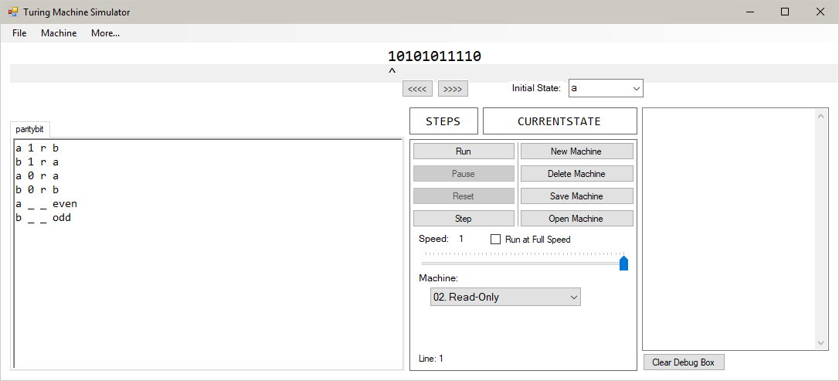

FSM:

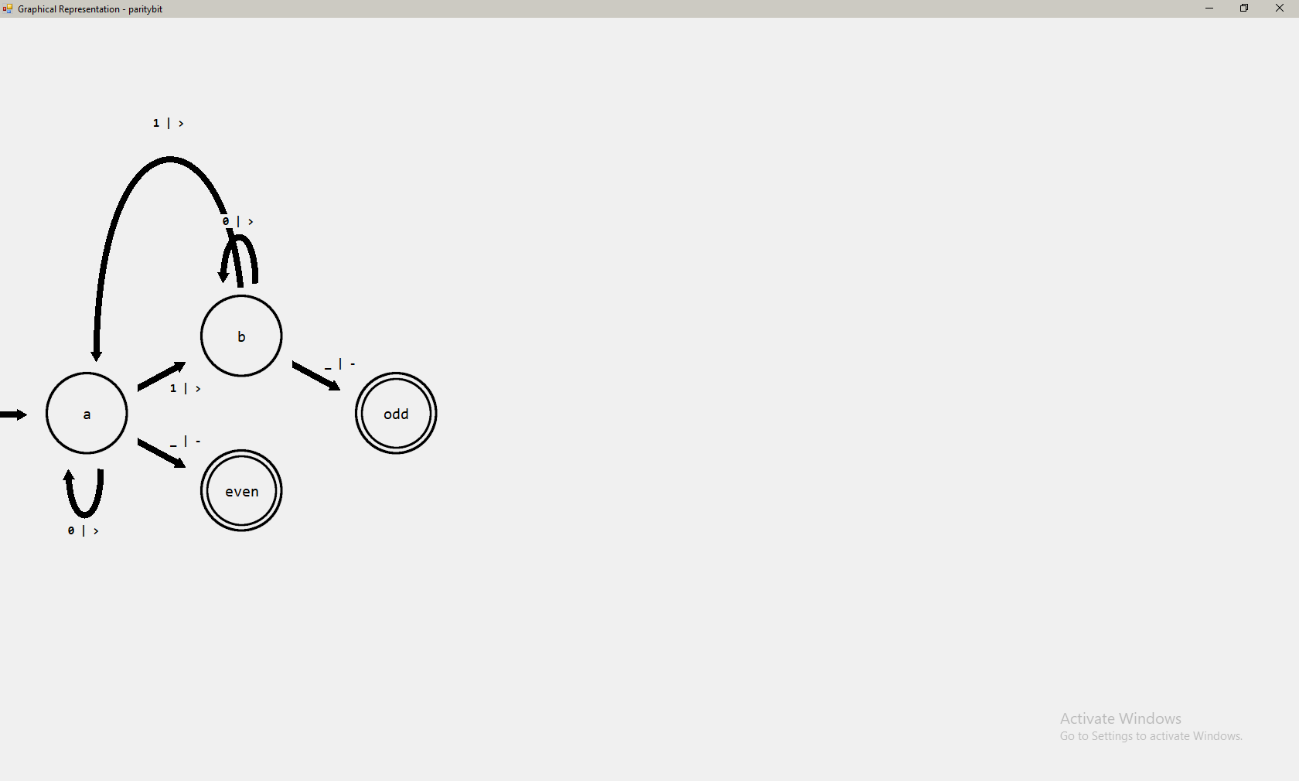

The resulting FSM contains labels containing only two fields, a read key and a move key, separated by a ‘|’.

Transition functions:

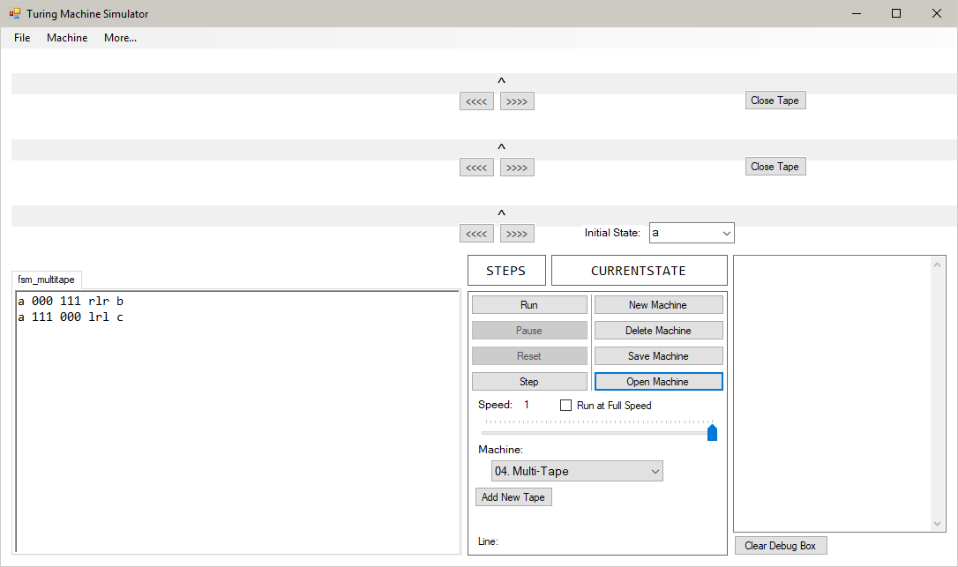

FSM:

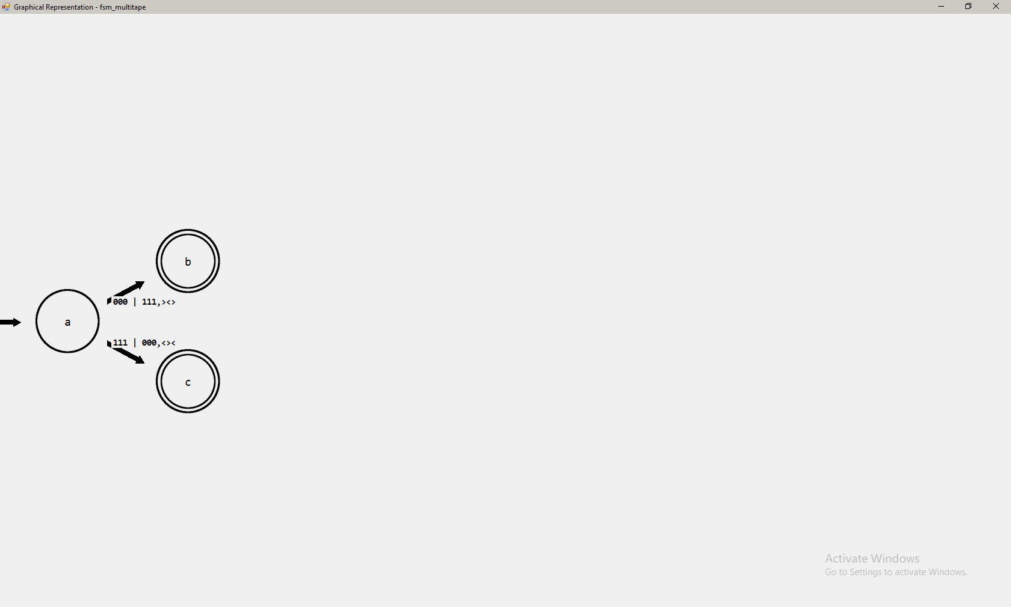

The two labels correctly copy over the information from their linked transition functions. For a-b, the read keys are “000”, write keys are “111” and move keys are “rlr”, converted to “><>”. For a-c, the read keys are “111”, the write keys are “000” and move keys are “lrl”, converted to “<><”.

When attempting to display a Non-Deterministic Turing machine as an FSM by clicking “Display as FSM” in the “Machine” tab, the following error message is displayed:

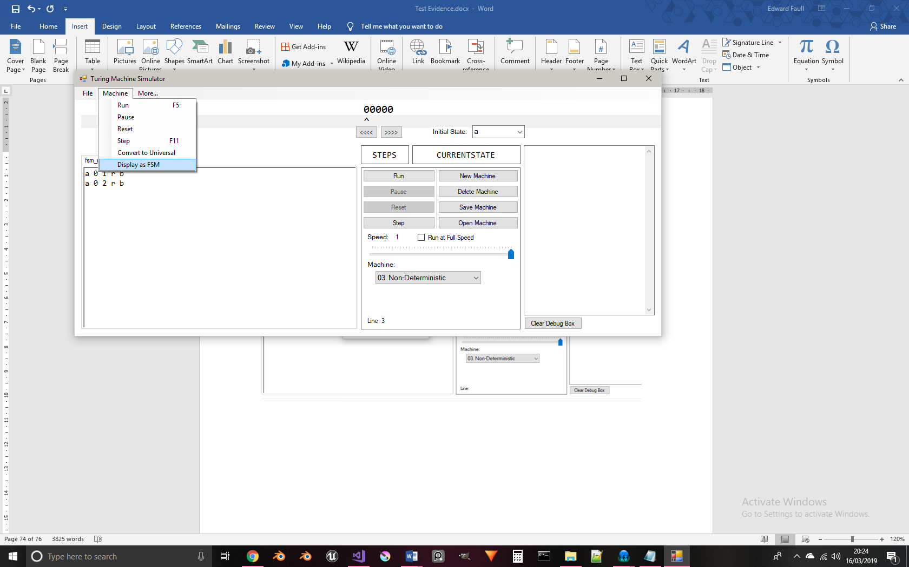

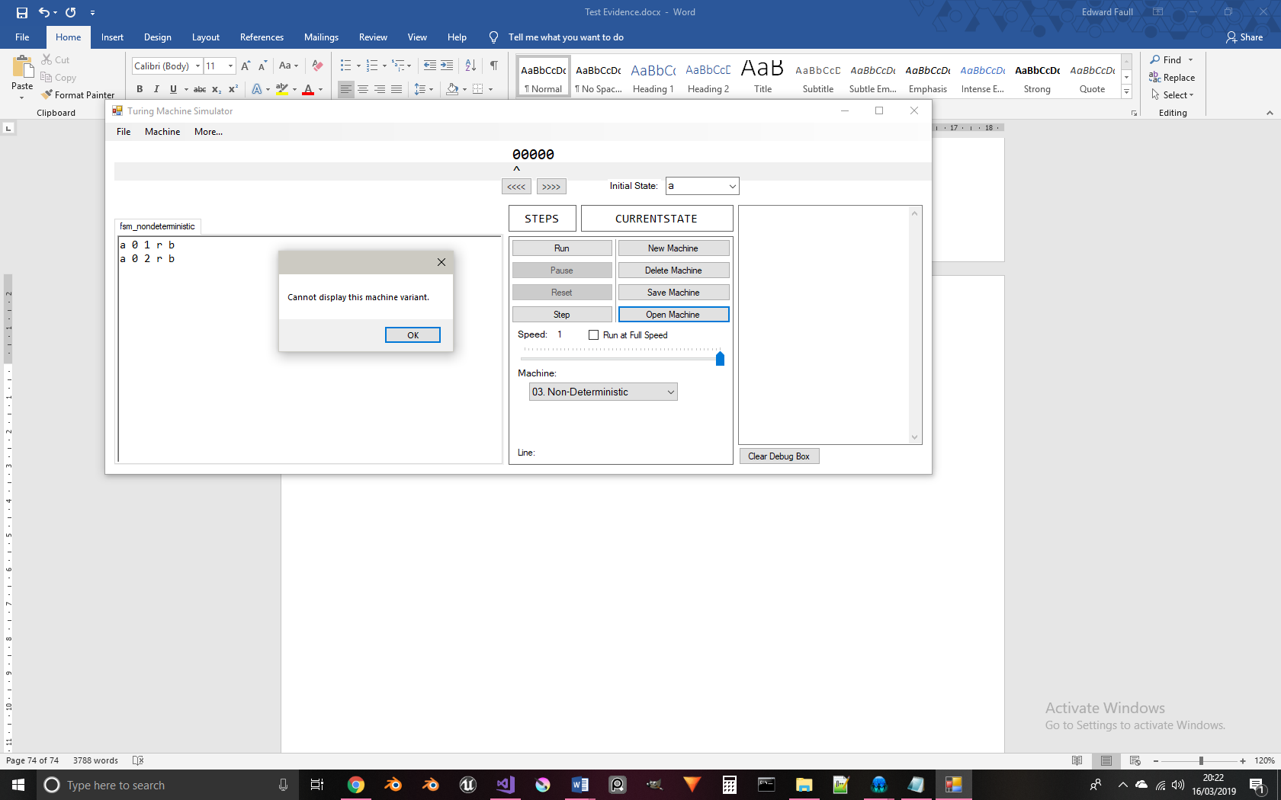

When attempting to display a Universal Turing machine as an FSM by clicking “Display as FSM” in the “Machine” tab, the following error message is displayed:

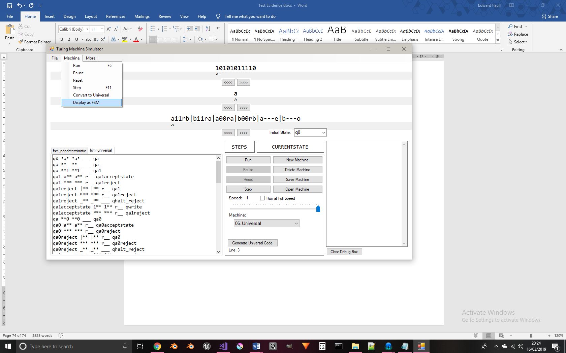

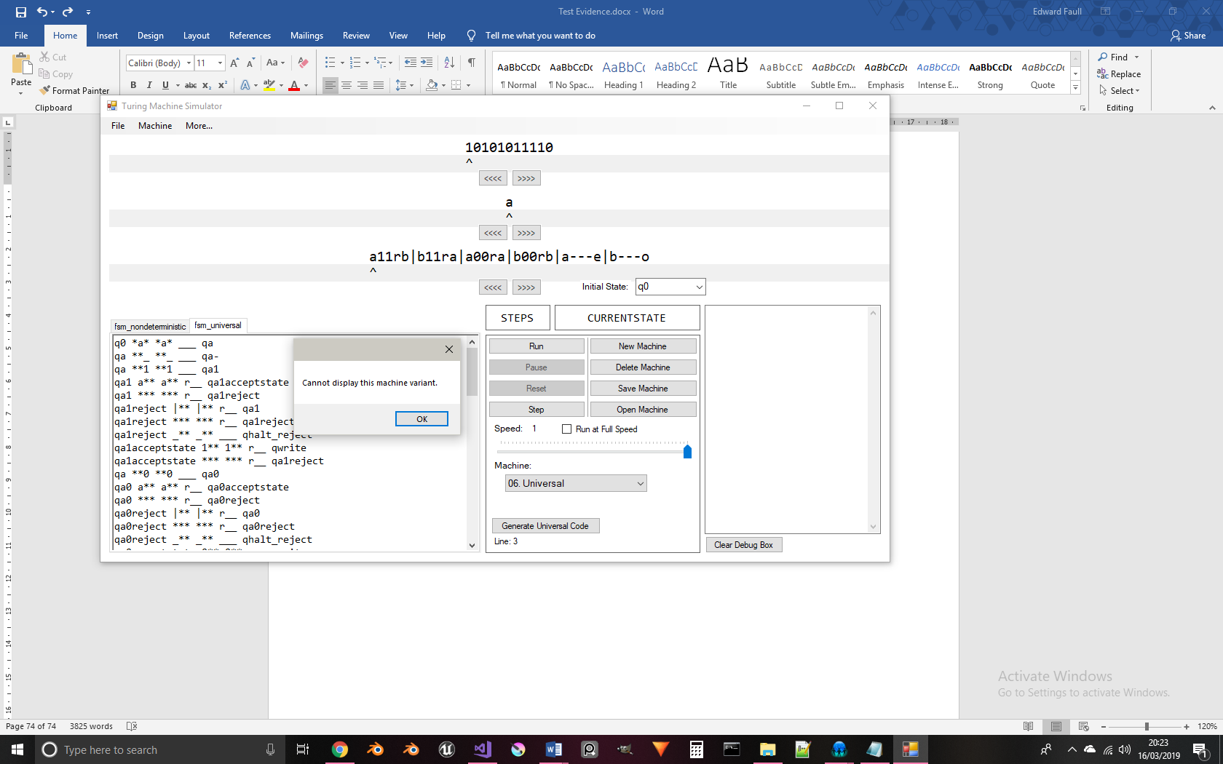

The two transition functions below share the same initial and final states. When the machine is represented as an FSM, the information of these two functions are collected and then reassembled into one label for one edge in the FSM:

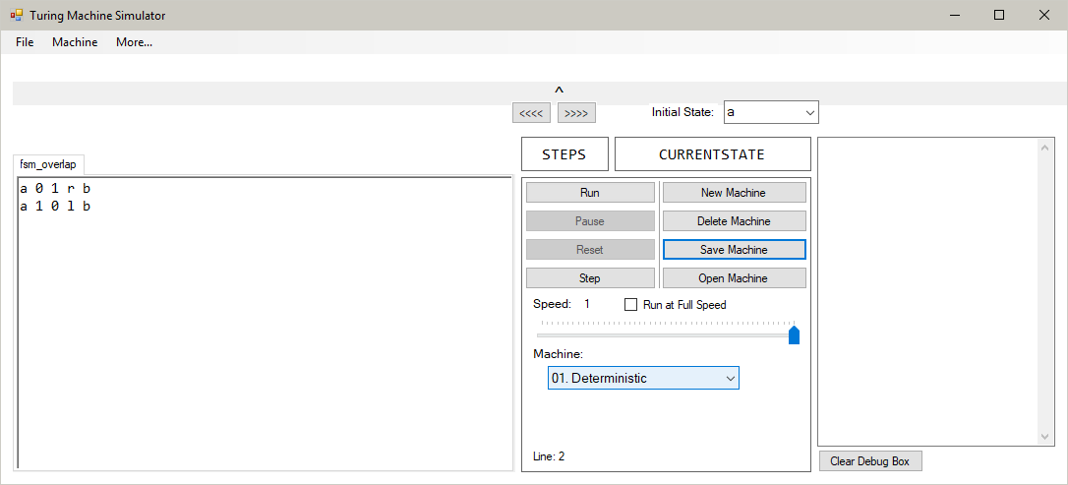

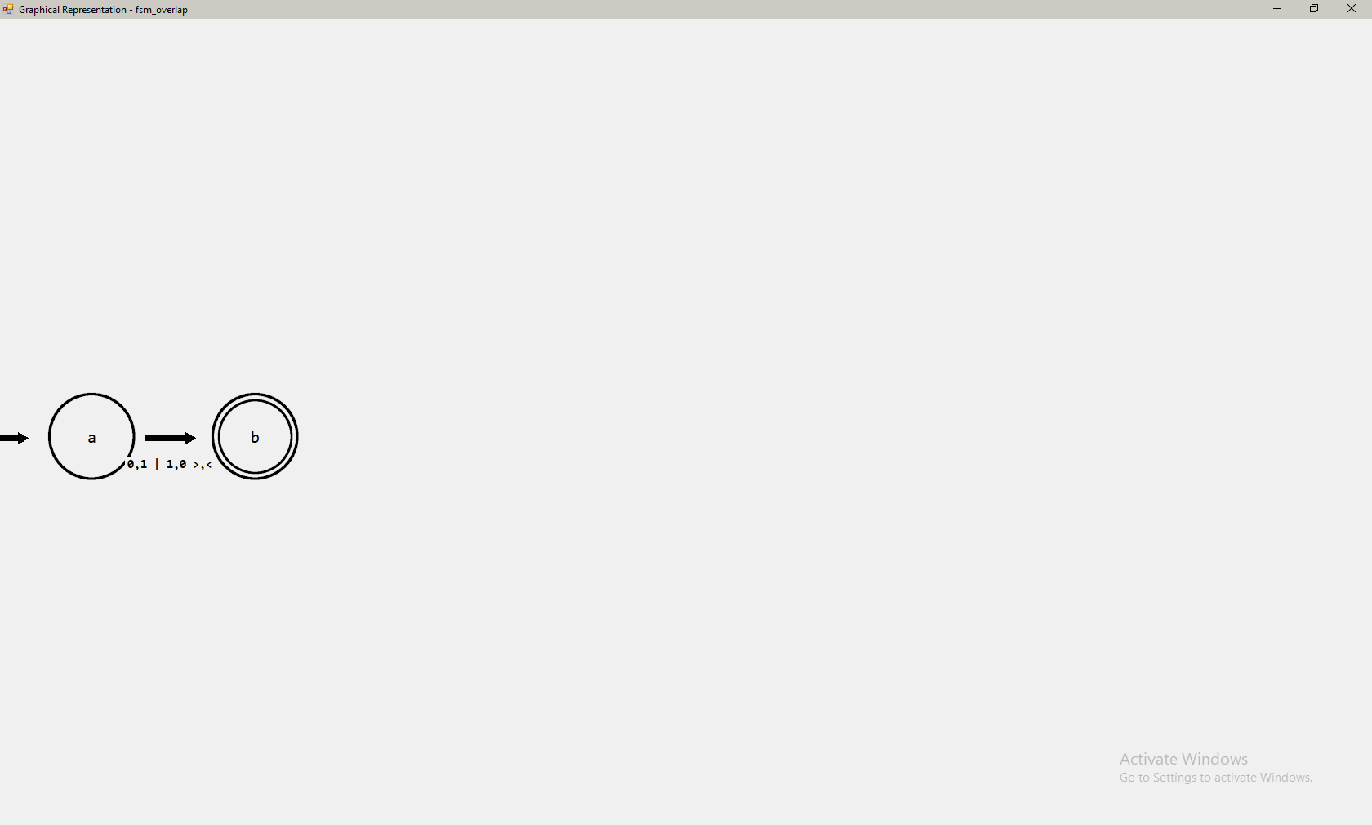

The lists of read, write and move keys are linked. The first item in the list of read keys corresponds to the first write key and the first move key. Thus, the label shows that when state ‘a’ reads a ‘0’, a ‘1’ is written and the read/write head moves write, and when a ‘1’ is read, a ‘0’ is written and the read/write head moves left.

Neither of these two transition functions result in the tape being edited. Because of this, the FSM diagram can be simplified to not show any write keys in the label for this edge, as they are unnecessary:

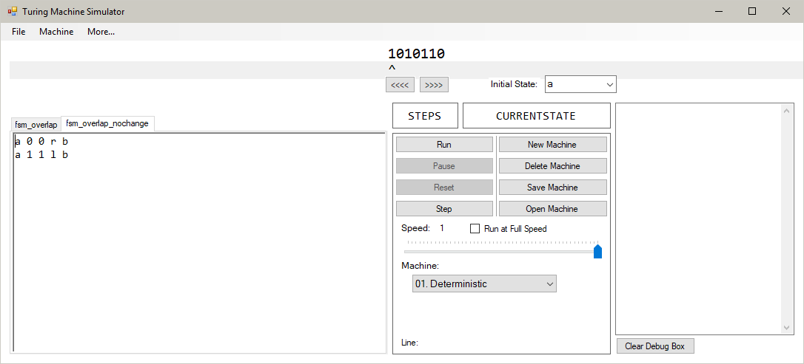

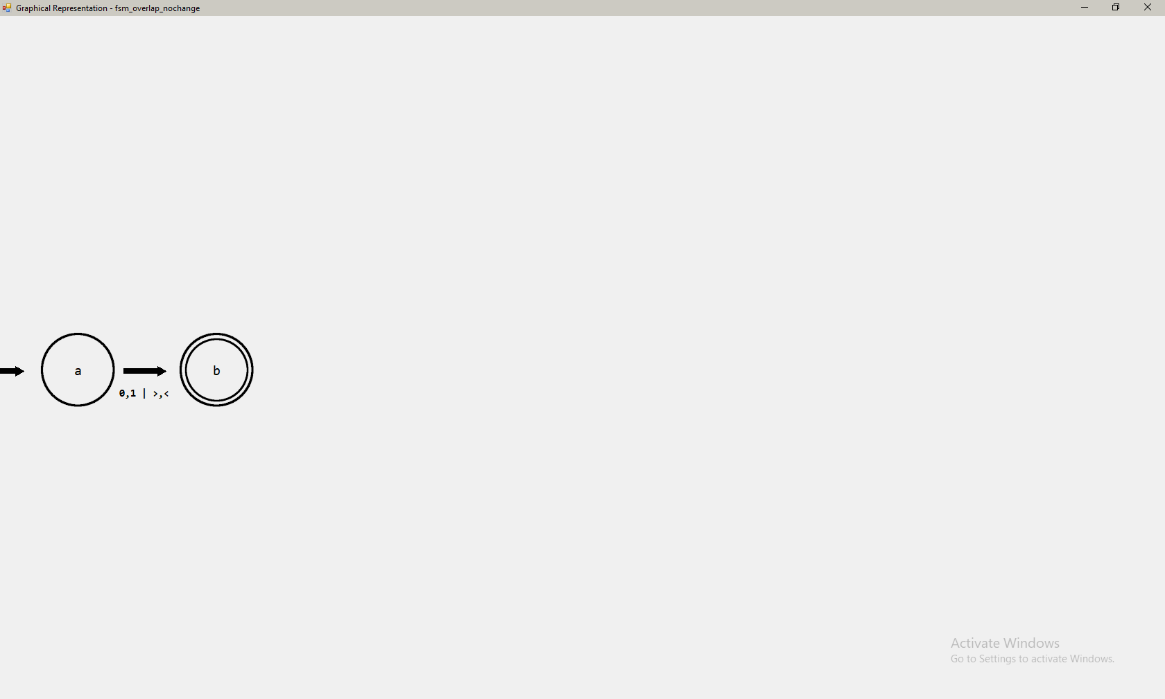

Both of these transition functions result in the same character being written to the tape. In order to reduce the complexity of these combined labels, the write key list of this label can be simplified to just contain one occurrence of the character to be written instead of two:

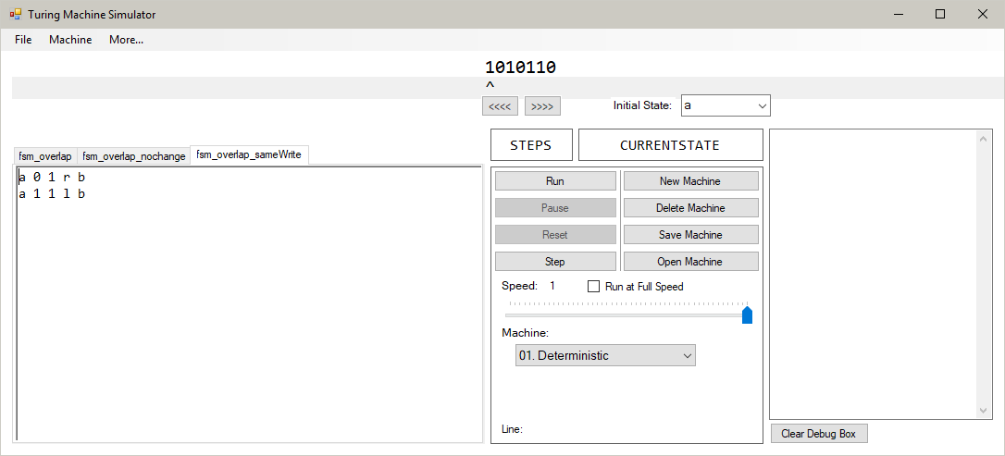

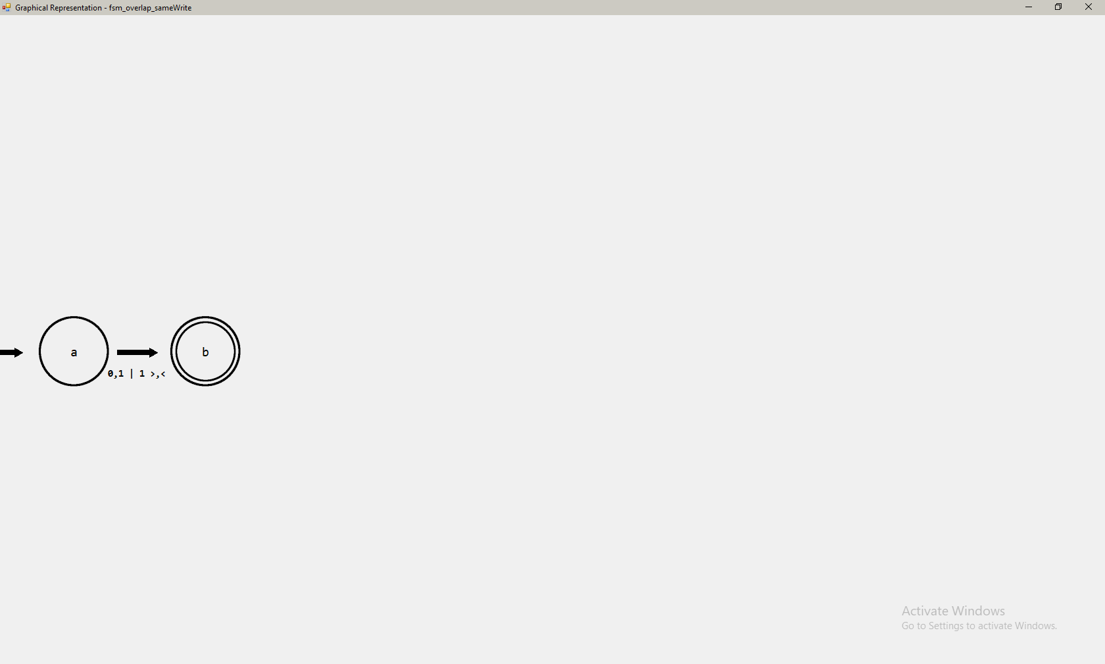

The list of write keys, which would normally read “1,1”, is simplified to simply be “1”.

Both of these functions have the same move key. Similar to write keys, this is simplified in the labels for FSM edges by removing repeated occurrences of this character:

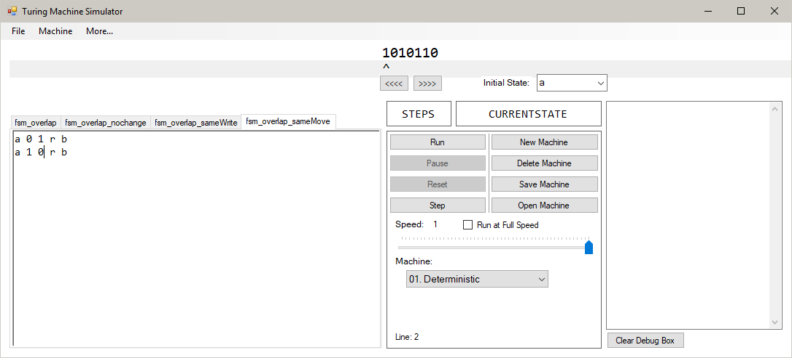

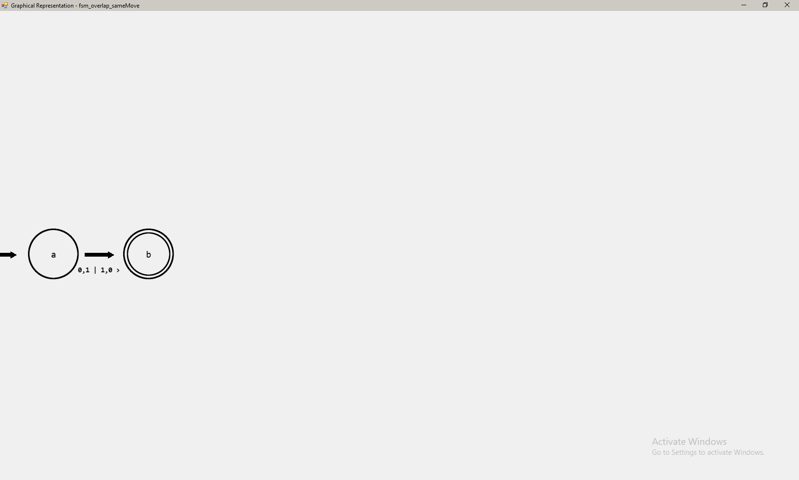

When not simplified, the move key list would read “>,>”, it has been simplified to “>”.

These transition functions share both the same move key and the same write key. This test is to ensure that the results of Tests 104 and 105 can be combined to simplify these overlapping edges further:

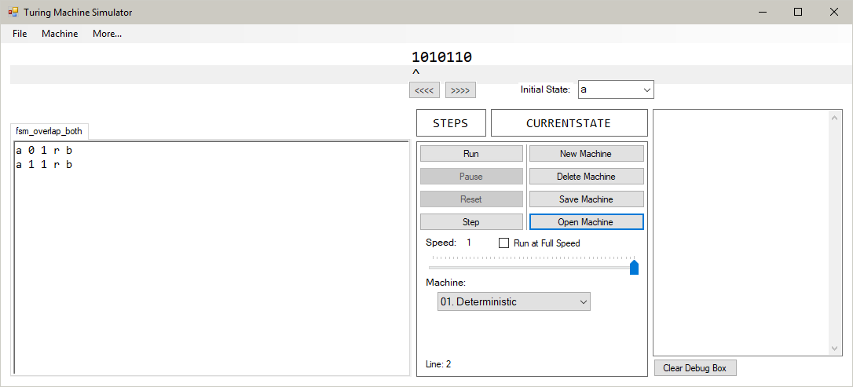

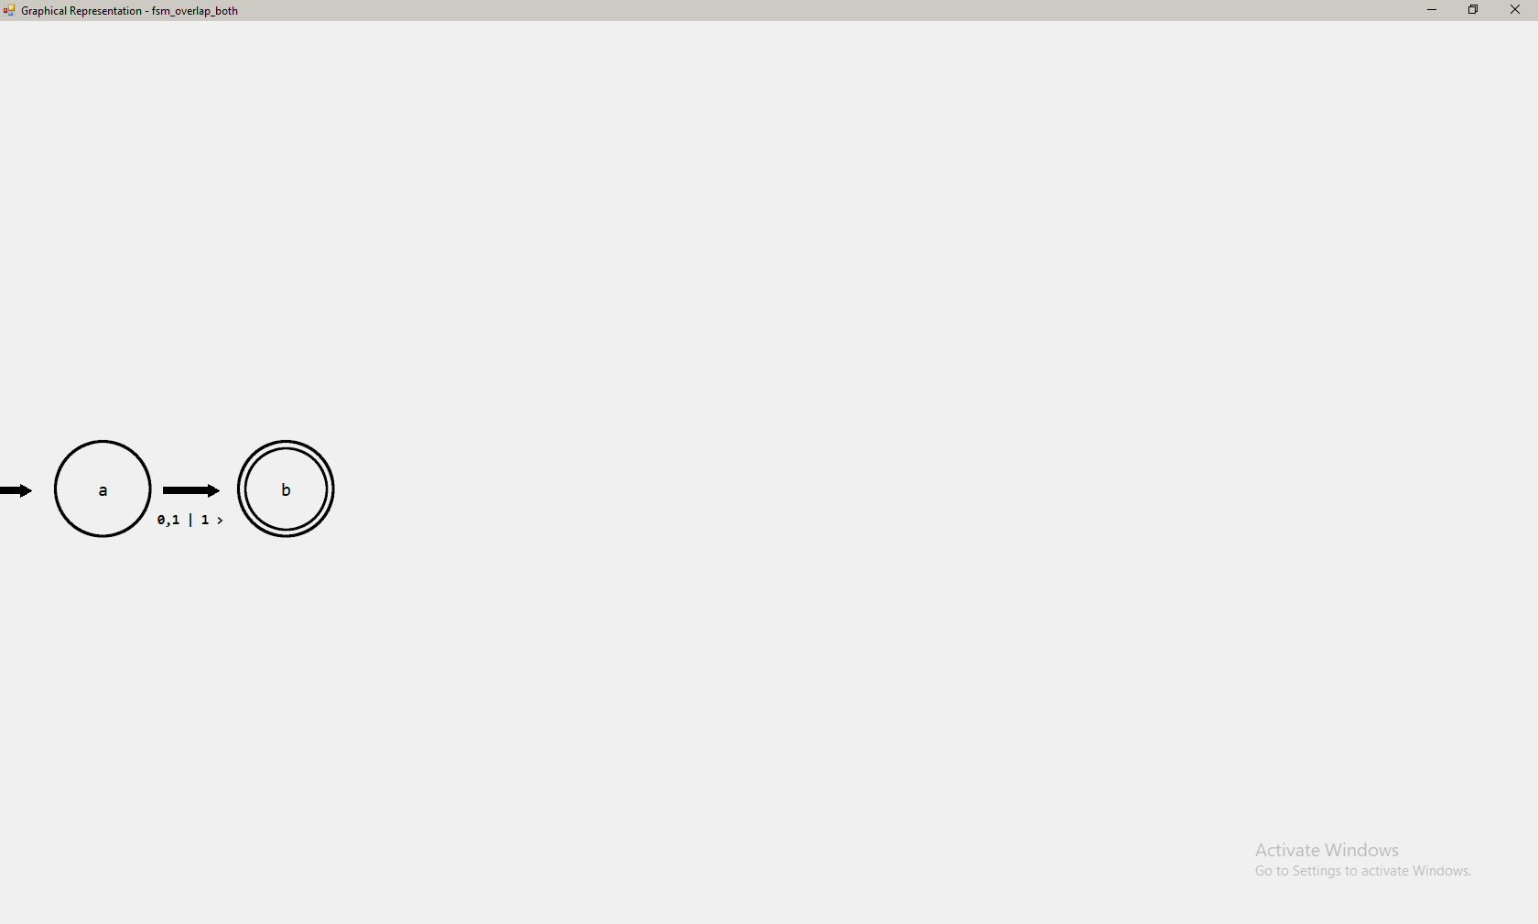

The program successfully simplifies both the move and write key lists down to just one occurrence of each. This feature greatly improves the legibility of combined edges in the FSM.

The Addition example in the program is the typical size of Turing machine that this FSM feature is intended to represent. To improve the legibility and ease of reading these FSMs, I have made sure that the different types of edges overlap as little as possible:



When the two transitions come from states in the same plane, the arcing (ic to set) and looping (dc to dc) transitions are designed to be far away from each other, in order to reduce the risk of the two overlapping and making the FSM more visually complex than intended. In this example, the arcing curve is quite significantly higher than the looping edges. This is to have a margin of error such that if the locations of the sending and destination states of the arcing curve are different, it will still be unlikely that it will interfere with the looping edges.

Displaying the Subtraction example displays the following FSM:

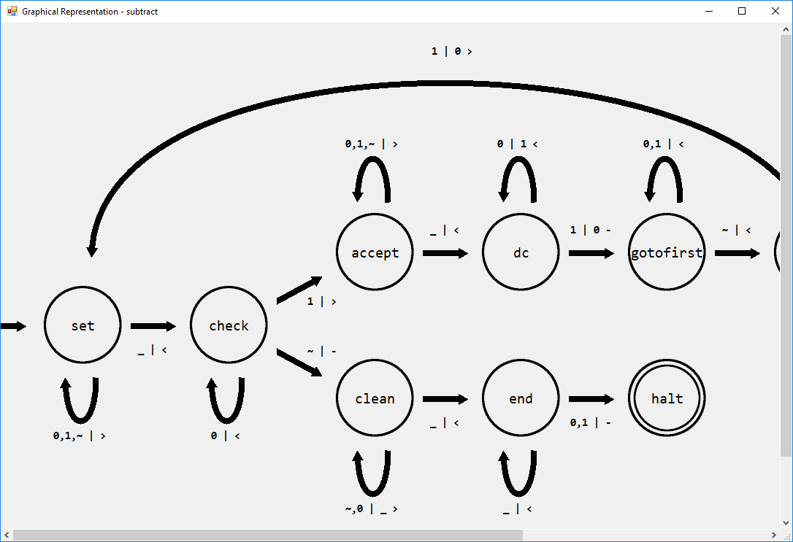

As shown above, when the diagram is not maximised, the FSM goes off screen. When scrolling to the right, the FSM’s edges stay where they are relative to their states:

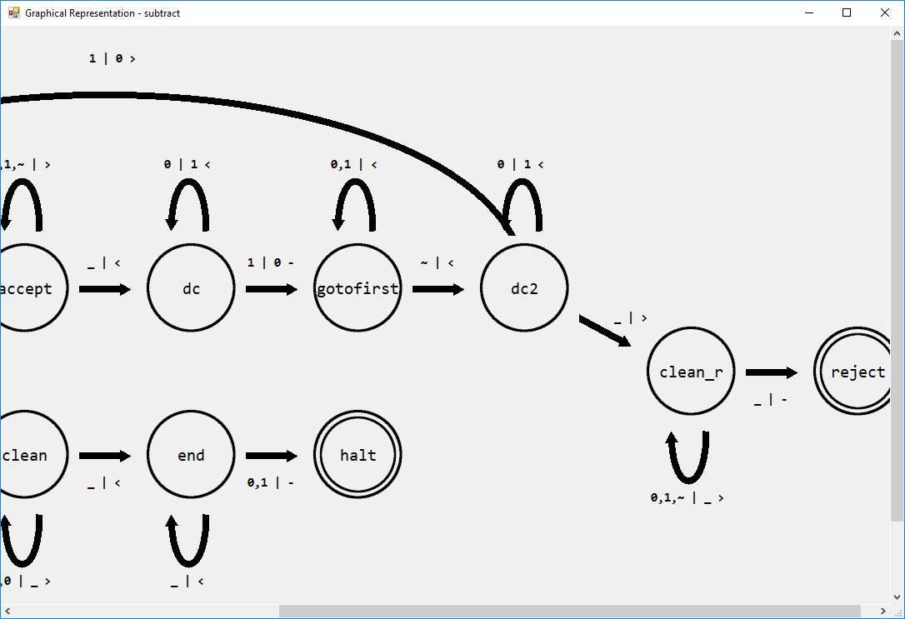

Scrolling back, we can see that the original edges have no issues either:

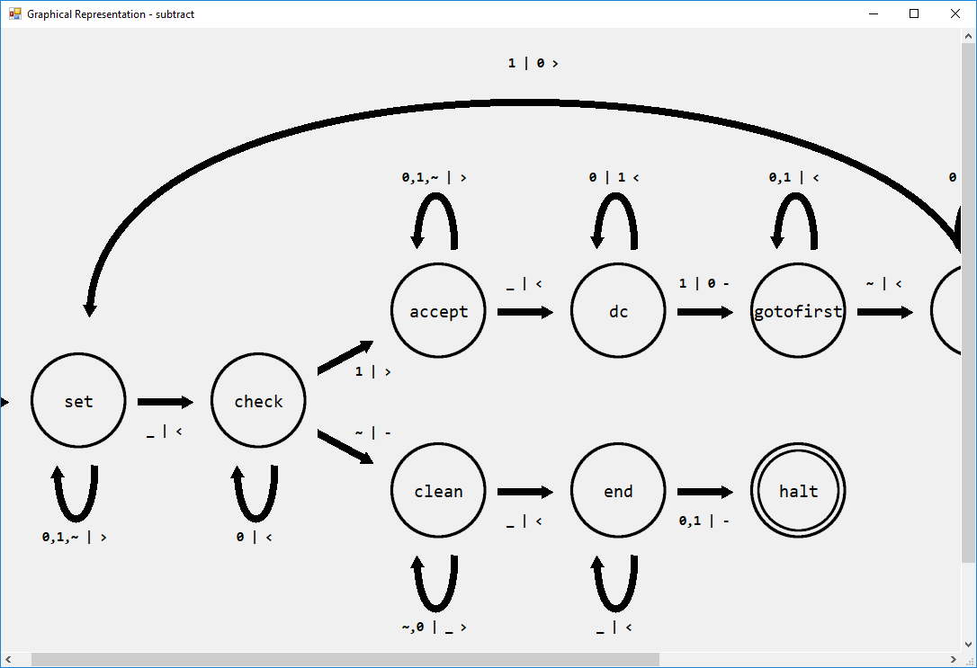

A video showing the scrolling of the form more clearly can be found at: <https://www.youtube.com/watch?v=38SHbtvm1QU&t=28>

The video shows that when the form is scrolled horizontally the edges are quickly redrawn to align with their linked states. This shows that the RefreshEdges method is working as intended.

The machine initially has the following values:

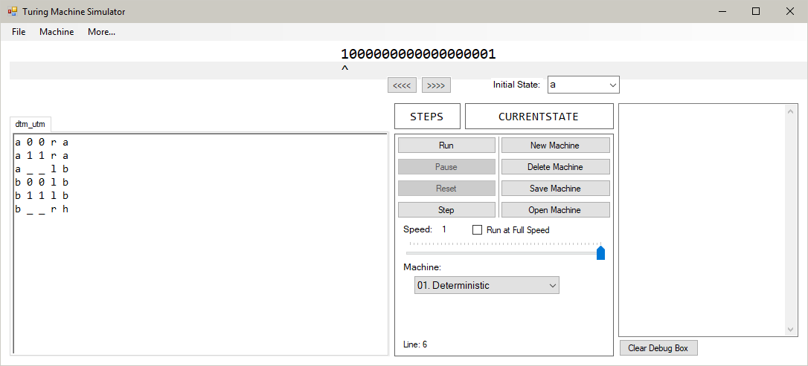

After using “Convert to Universal”, the machine becomes a Universal Turing machine, and its information is loaded onto the tapes:

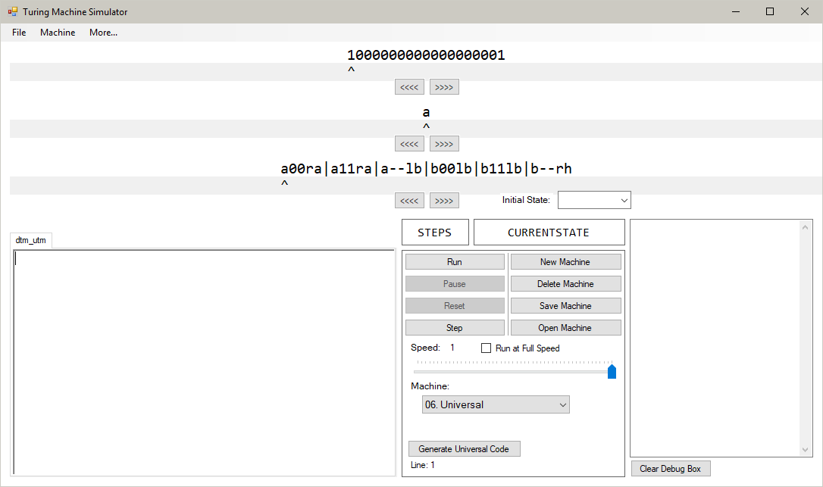

The bottom tape, known as the Instruction Tape, contains the instructions from the DTM. They are entered in the order they were entered in the text editor, and all spaces are converted into ‘-‘s to remove ambiguity between blank spaces on the simulated DTM and blank spaces in the UTM instruction set.

Pressing the “Generate Universal Code” button creates a long list of transition functions and places them in the text editor. The initial state of the machine is set to ‘q0’. The list of functions cannot realistically be checked line-by-line to make sure they are valid, and this will be verified in the next few tests, which prove that the instruction set can simulate any DTM with the same parameters as the one that the set was generated for.

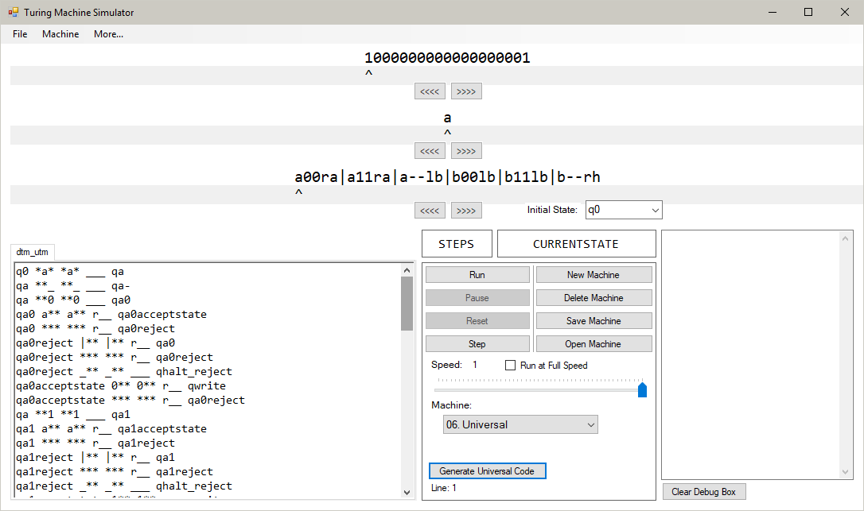

Running the “dtm-utm.txt” machine in its normal DTM state produces the following result:

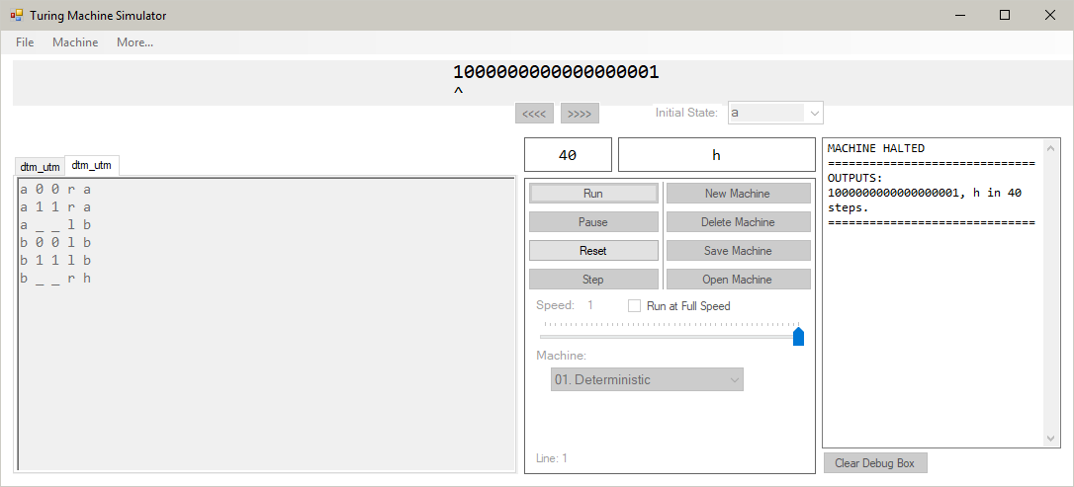

The final state of the machine is ‘h’, the contents of the tape does not change and the read/write head ends in the same position it started in. Running the UTM version of this machine results in the following:

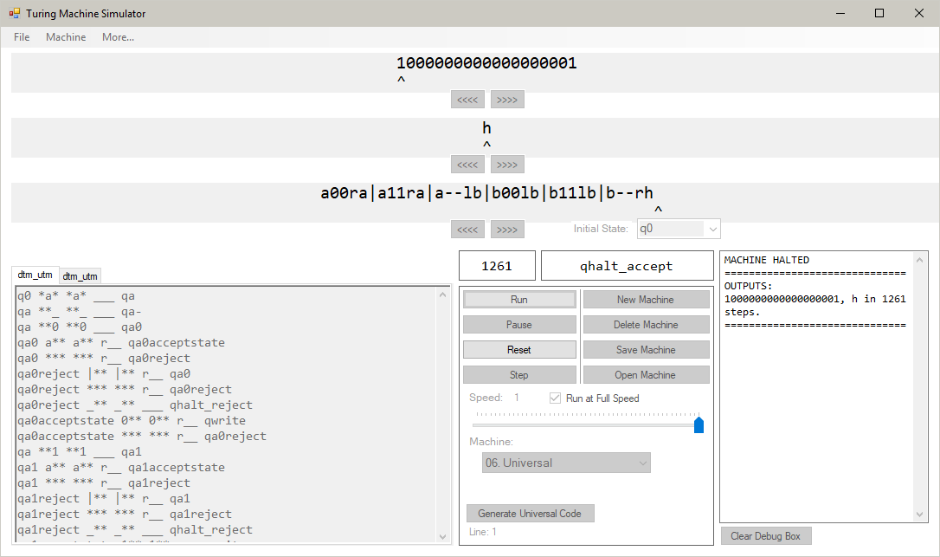

This process is completed over a significantly larger number of steps; however, the result is the same. The final state of the DTM is ‘h’, the contents of the DTM tape has not changed, and its read/write head ends in the same position as it began in. This test proves that the generated code can successfully simulate the DTM it was generated for.

The transition function set used in this machine is the exact same as the one generated in Test 110. The only difference is the Instruction tape, where the first two transition functions have been slightly edited to invert the bits (set 1 to 0, set 0 to 1) of the data tape:

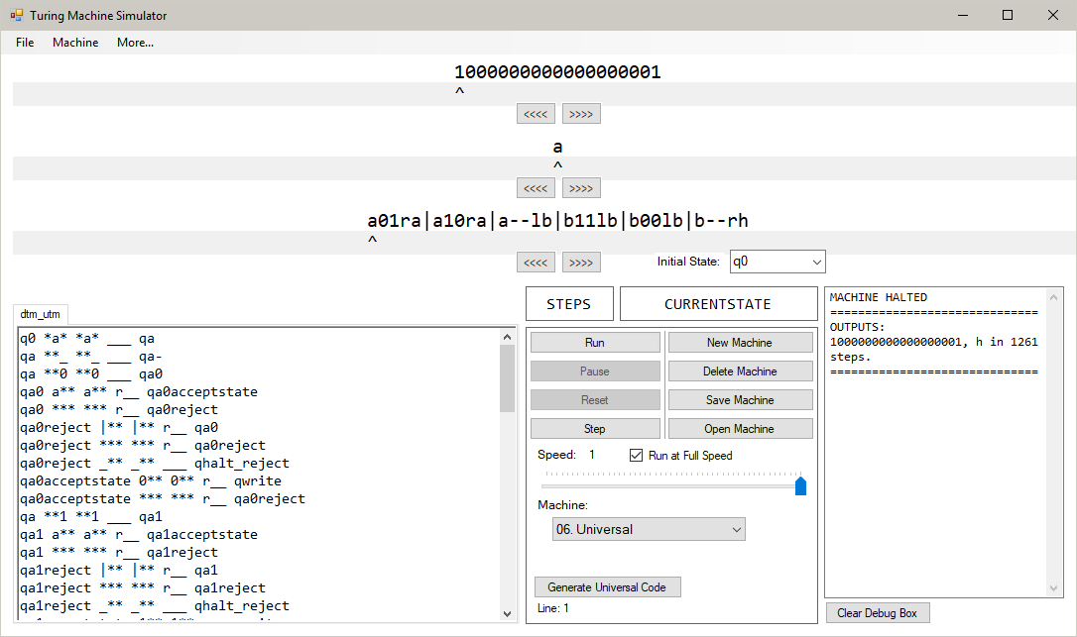

After running the machine, the result is the following:

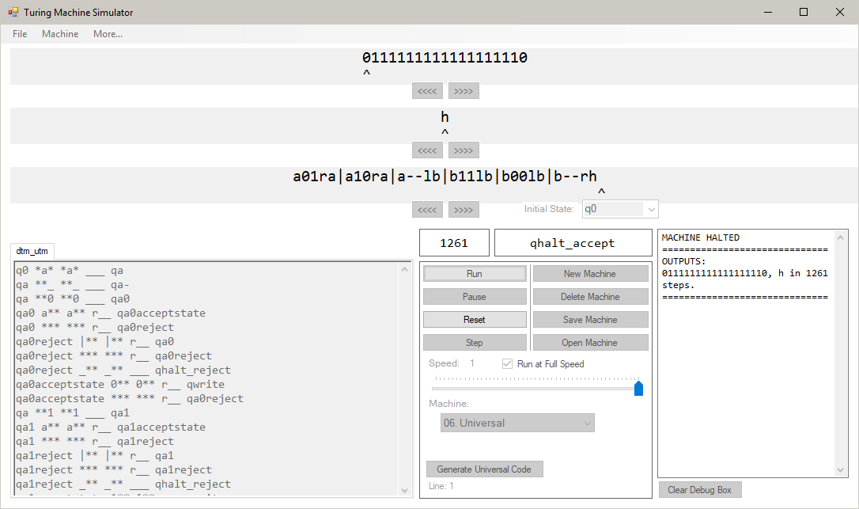

The generated UTM code successfully simulated a DTM with a different set of transition functions to what it was generated with. This example shows that the algorithm doesn’t just imitate a DTM by knowing the steps beforehand and simply repeating them, but actually evaluates which transition function to accept and perform based on the inputs from the State and Data tapes.

The machine to be converted into the UTM is displayed below:

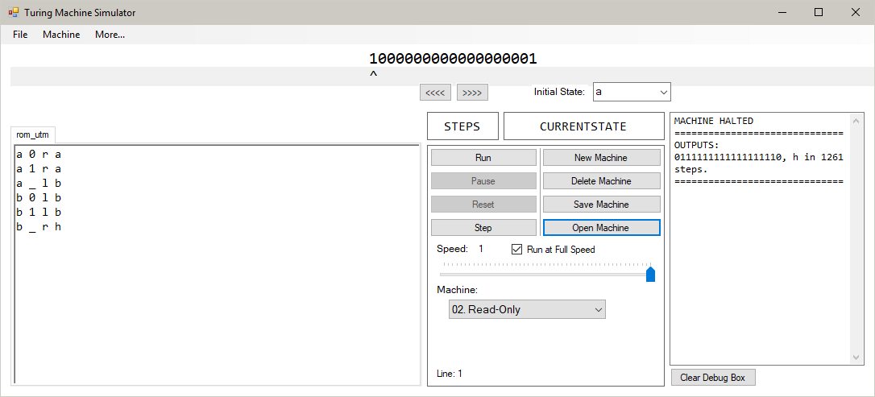

After pressing “Convert to Universal”, the following tapes are placed on a Universal Turing machine:

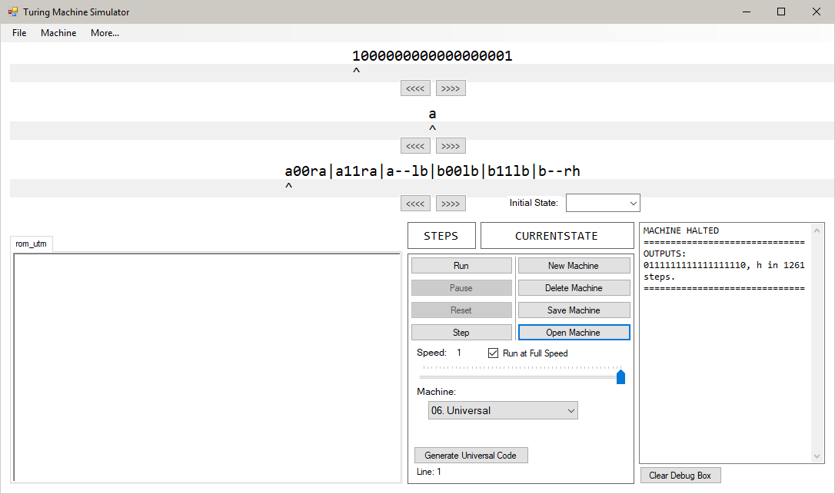

The tape from the DTM is replicated onto the top tape of the UTM, the initial state from the DTM is placed on the middle tape, and the instruction set is placed on the bottom tape. Copies of the read keys are added onto each transition function in order to convert them into Deterministic functions that simply don’t edit the tape. The UTM in my program is not Read-Only, so the transition functions must have all five of the required fields in order to operate correctly.

The machine to be converted contains 53 states. Their identifiers are a-z, A-Z, and ‘53rdstate’. Because the states on the UTM are case-sensitive letters, there can only be 52 states. This limit cannot be exceeded, and having the ‘53rdstate’ included means the machine cannot be converted into a Universal Turing machine. When this occurs, the following error message is presented to the user:

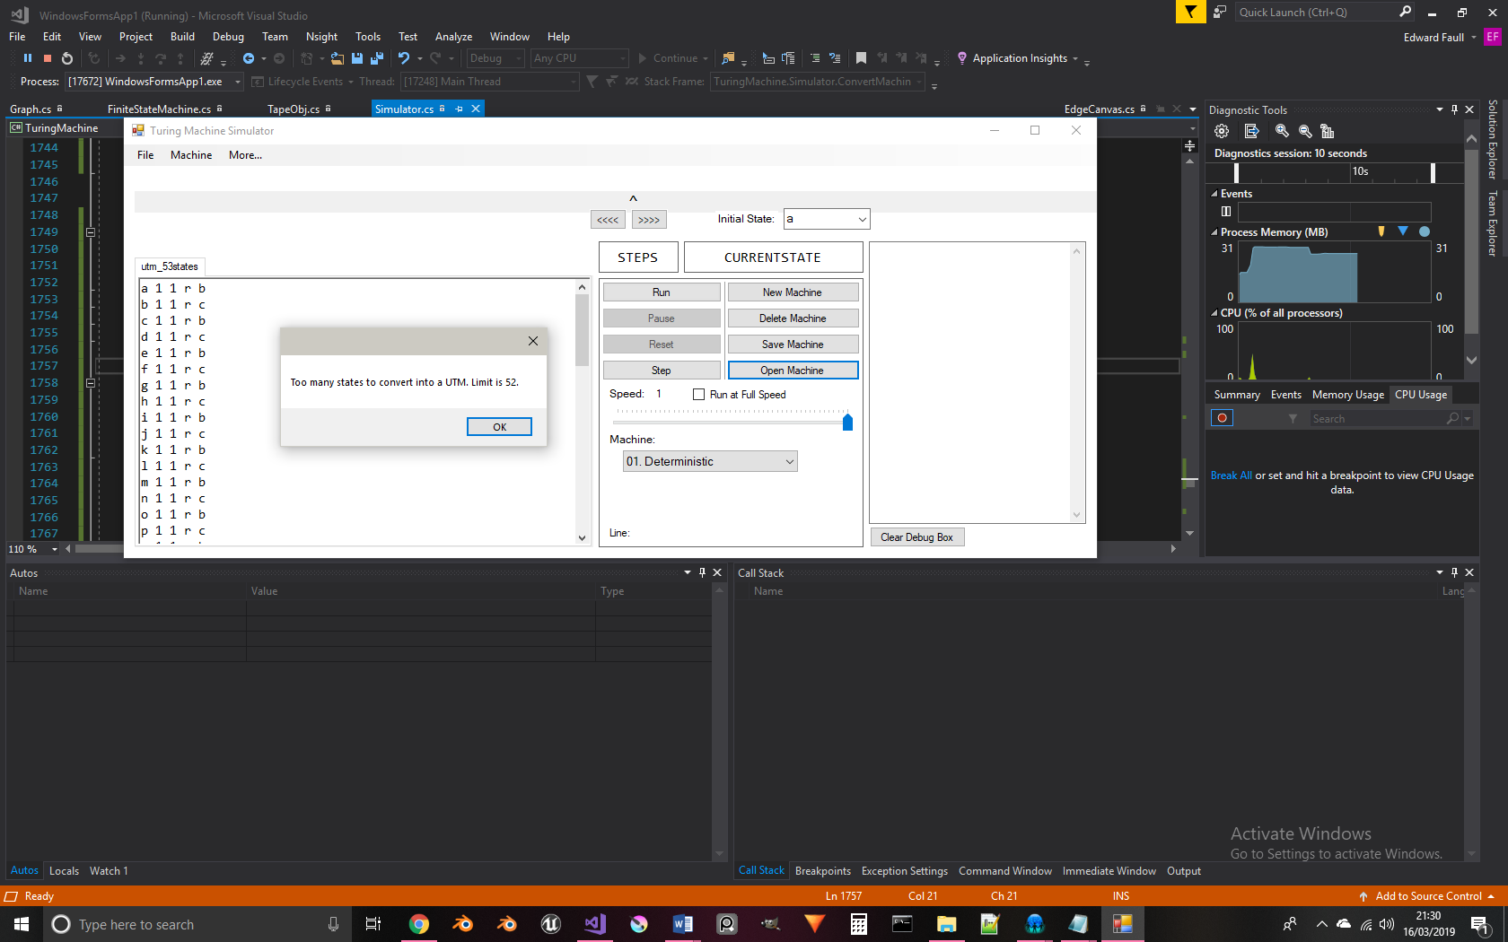

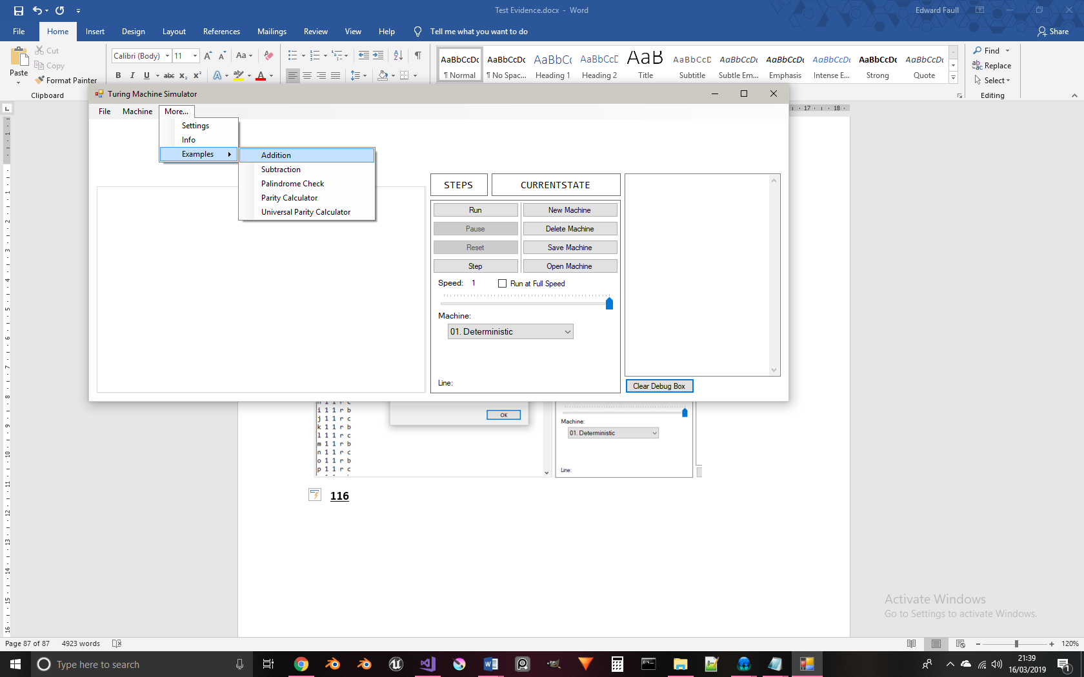

Selecting the “Addition” example opens the “add.txt” file from the Debug folder:

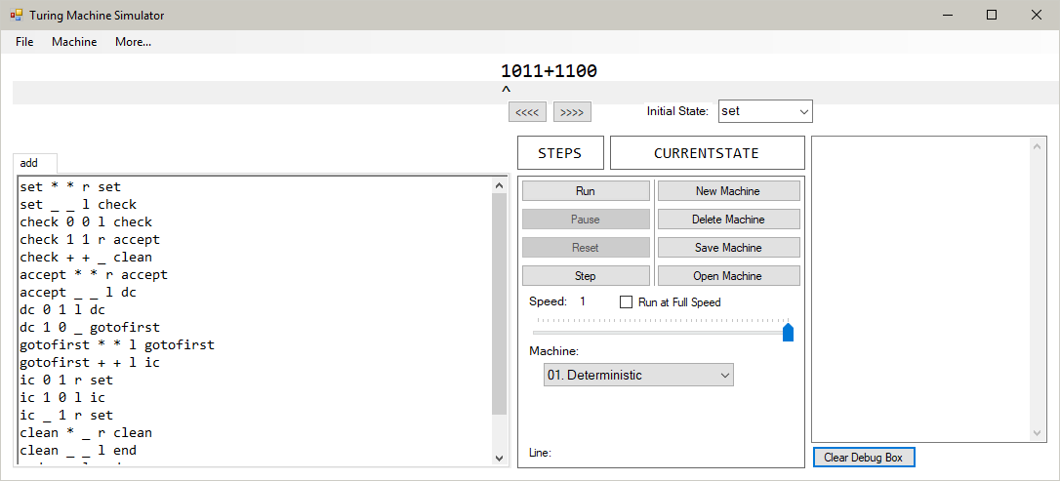

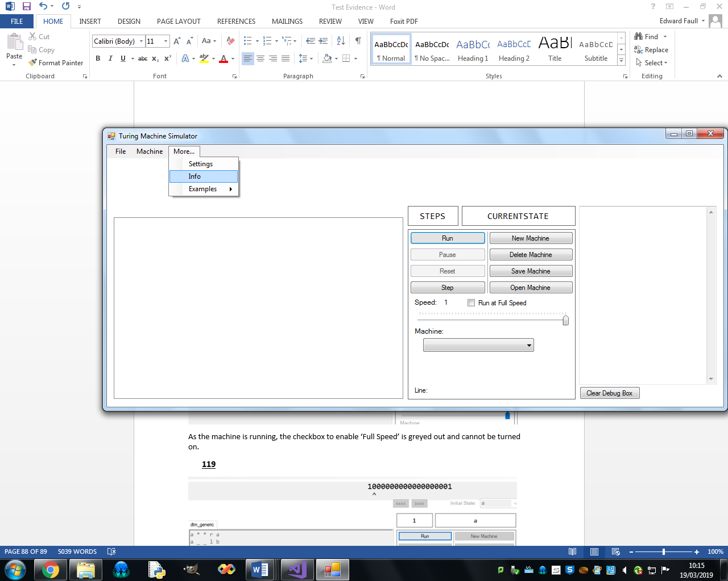

Pressing the “Info” button opens the following window:

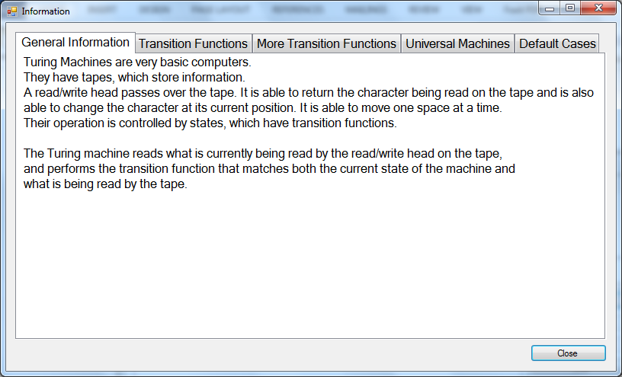

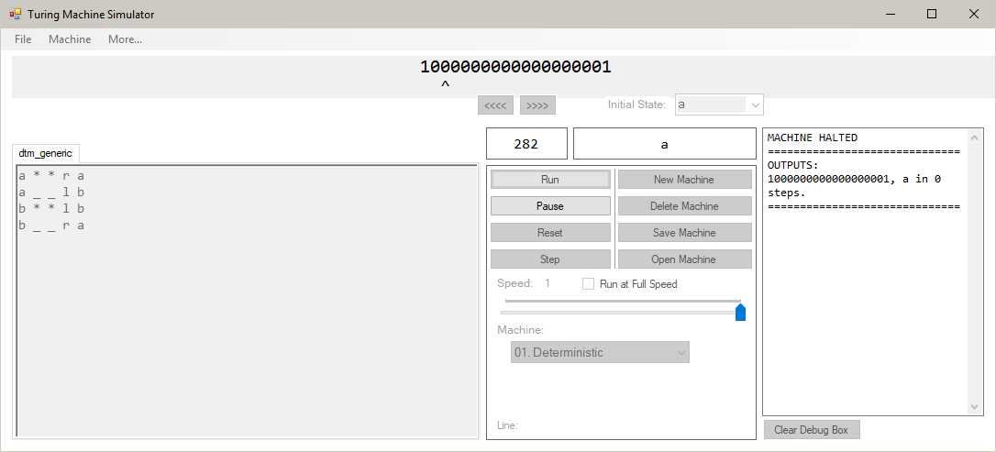

As the machine is running, the checkbox to enable ‘Full Speed’ is greyed out and cannot be turned on.

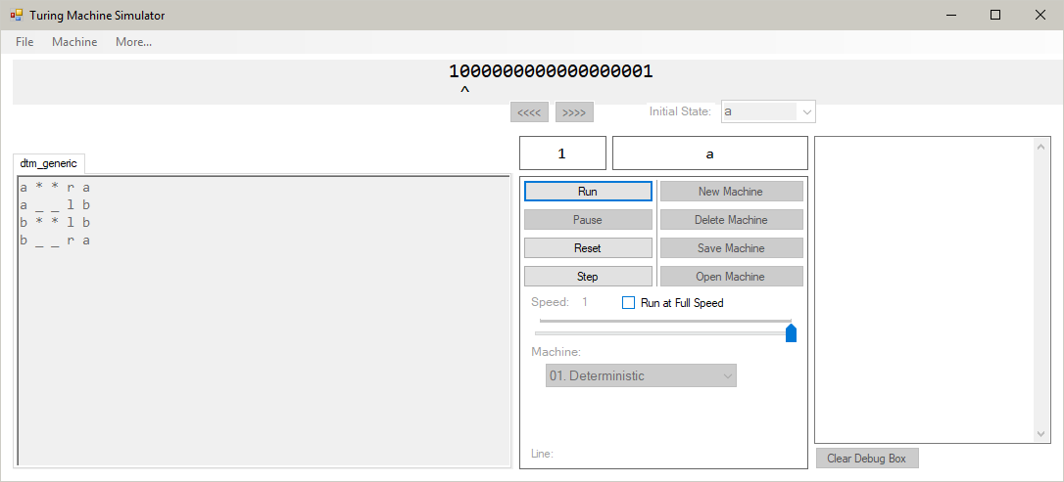

When the machine is compiled, but paused, the checkbox to enable ‘Full Speed’ can be used.

The interval of the fastTimer has been increased to 200ms for this test.

After running the machine, there is a second’s pause before the machine updates. At this point, the machine has not performed any operations:

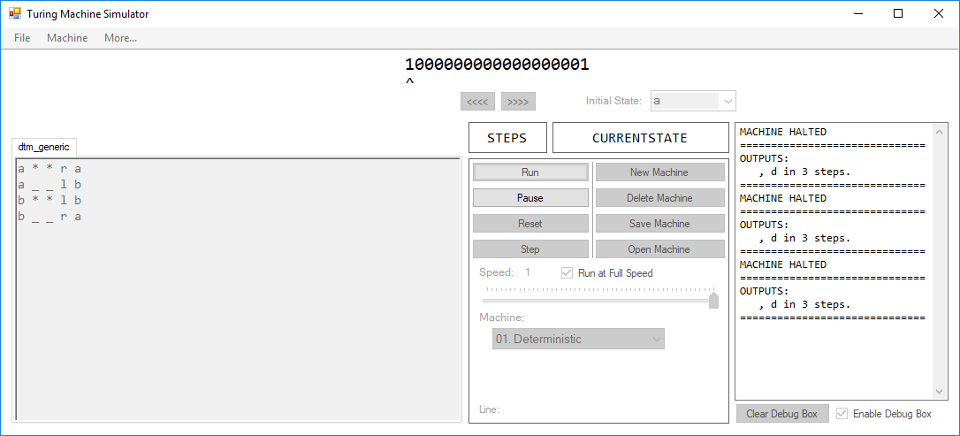

After this, the machine updates, completing 50 steps in one go. This can be seen by the fact that the step counter has increased from nothing to 50:

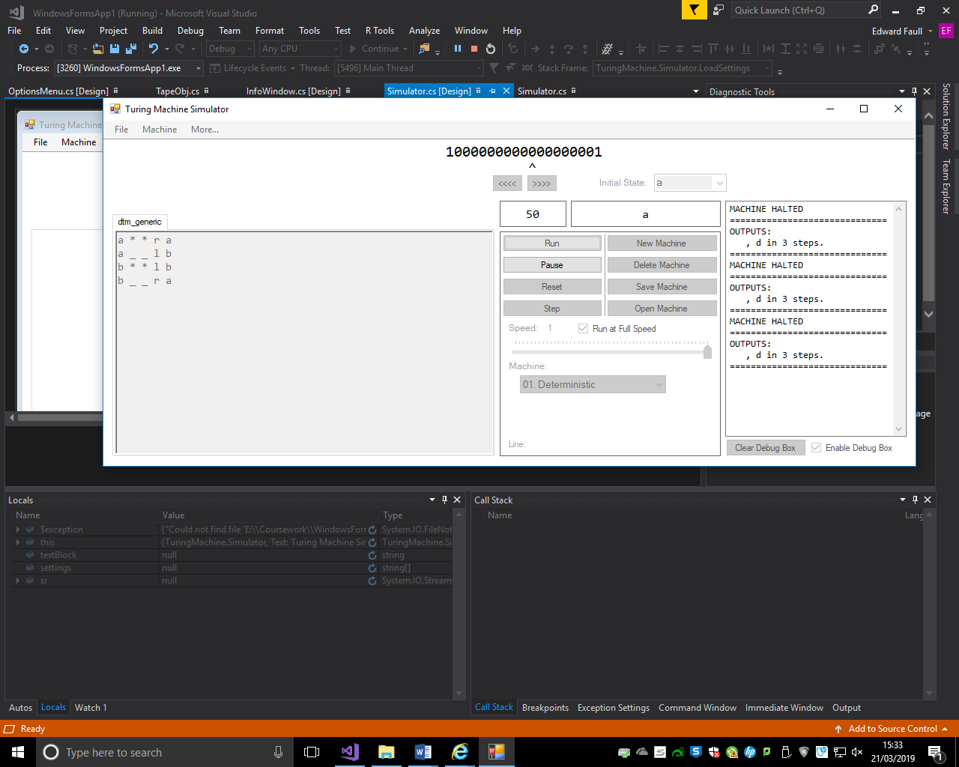

After incrementing to 50, another second’s pause occurs, and the machine then updates to 100, performing another 50 steps:

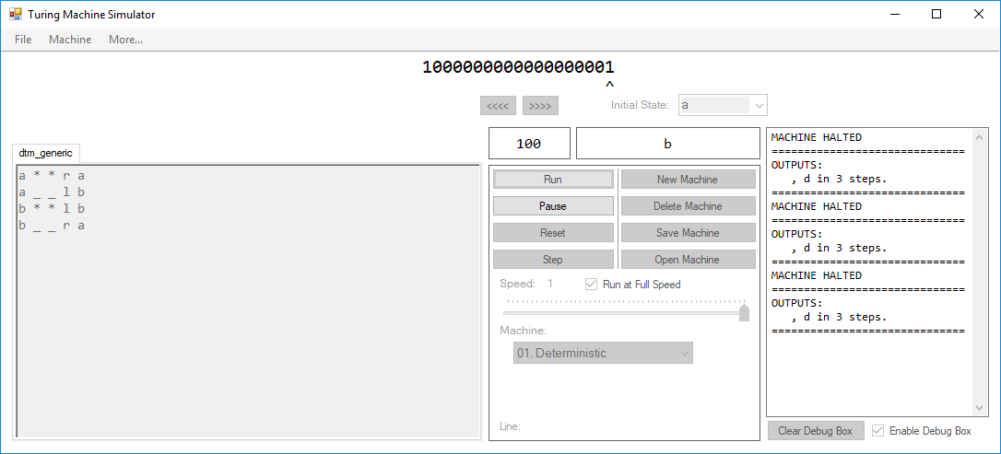

A video showing this process as a continuous clip can be found at: [https://www.youtube.com/watch?v=38SHbtvm1QU&t=46](https://www.youtube.com/watch?v=38SHbtvm1QU&t=)

The interval of the fastTimer has been increased to 200ms for this test.

Similarly to Test 122, the machine performs a constant number of steps. Starting at the beginning, the machine is:

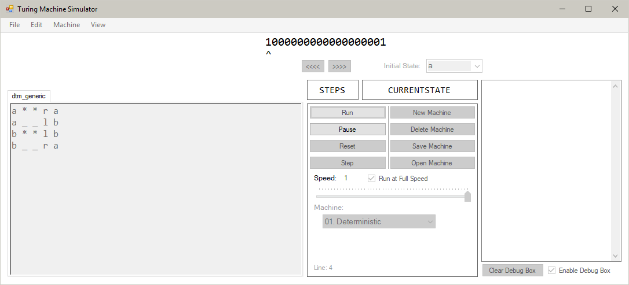

Initially the step counter is blank. After the first tick of the fastTimer object, the machine increments by 500:

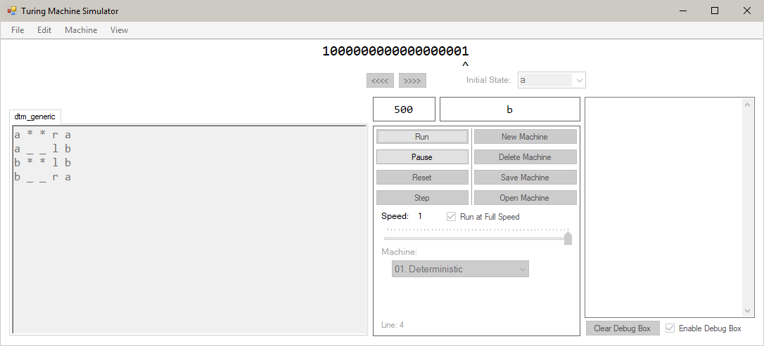

After the second tick, the machine increments by another 500:

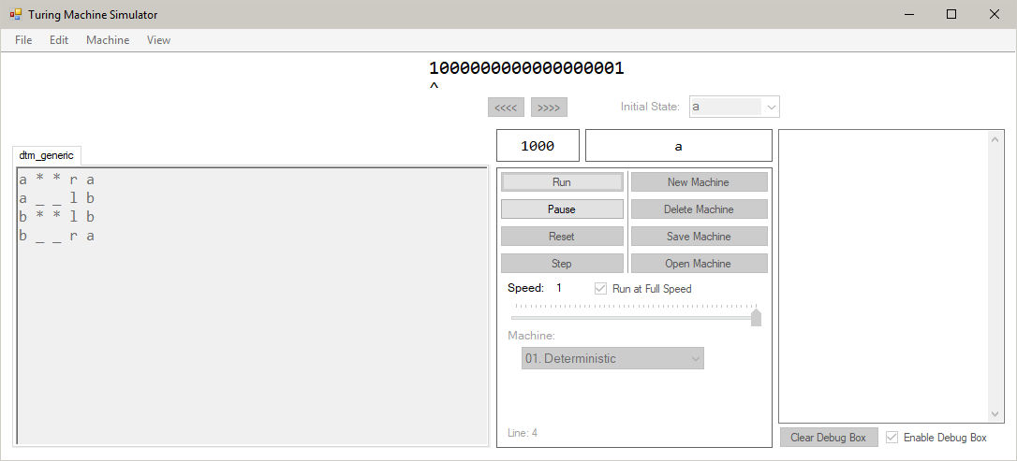

A video showing this process as a continuous clip can be found at: [https://www.youtube.com/watch?v=38SHbtvm1QU&t=63](https://www.youtube.com/watch?v=38SHbtvm1QU&t=)

The additional method added for this test is:

int time = 0;

private void IncreaseTime(object sender, EventArgs e)

{

time += 1;

}

This method is called every 100ms by a timer object. The timer object is enabled when running the machine (pg. 217):

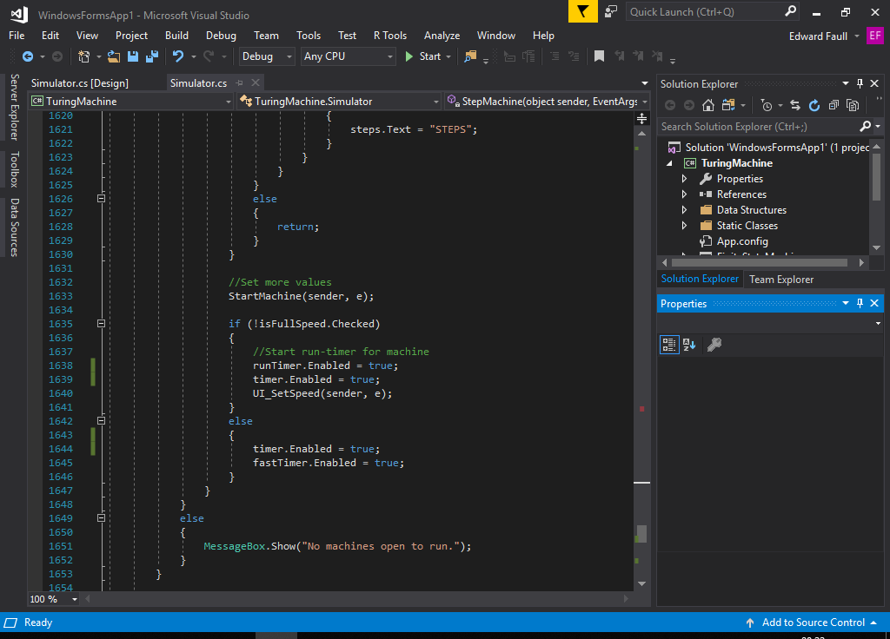

The program will hit a breakpoint at the HaltMachine subroutine (pg. 214), where a watch will allow us to find how many times the timer ticked, and then the time taken for the machine to execute:

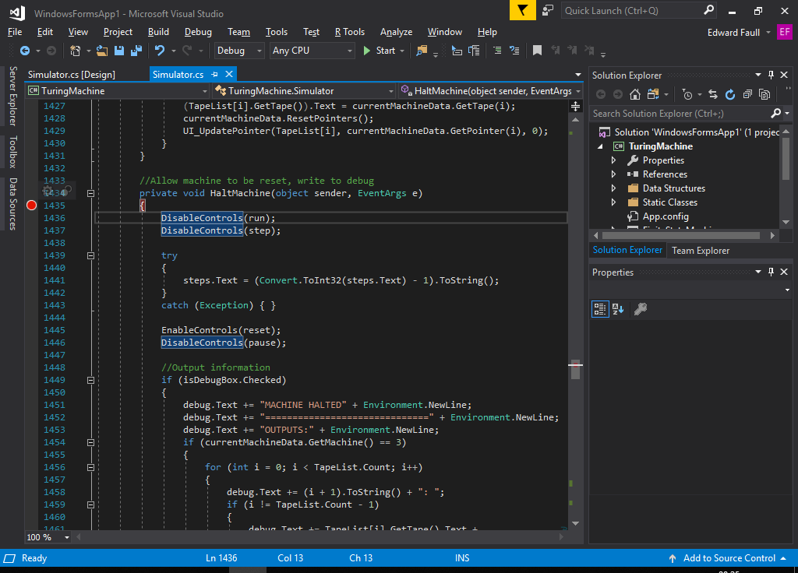

The tape used in the Addition machine is:

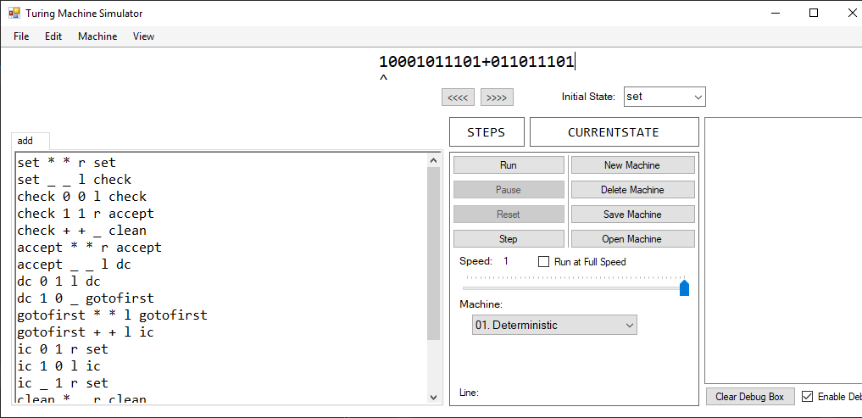

After running the machine at normal speed (where speed = 1 millisecond), the resulting time value is:

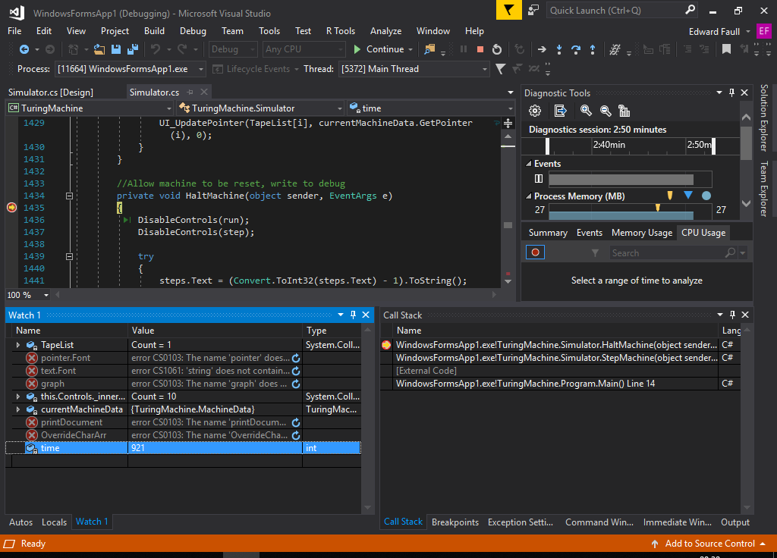

This is 921 * 100ms, which is 92.1 seconds.

After running the machine at full speed (where increment = 50 steps), the resulting time value is:

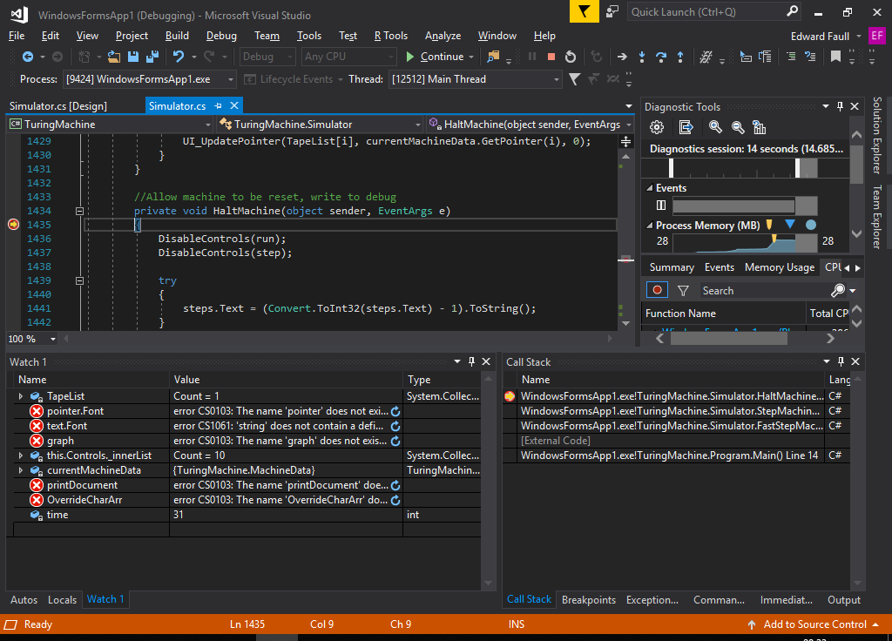

The timer ticked 31 times through the operation, meaning the time taken is 31 * 100ms which is 3.1 seconds.

We can see that running the machine at full speed is significantly faster than running the machine at normal speed.

Before checking the box, the speed slider is clear and can be selected:

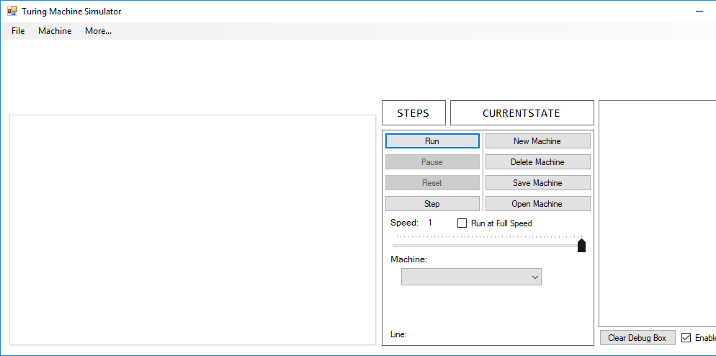

Checking the box causes the slider to be unusable:

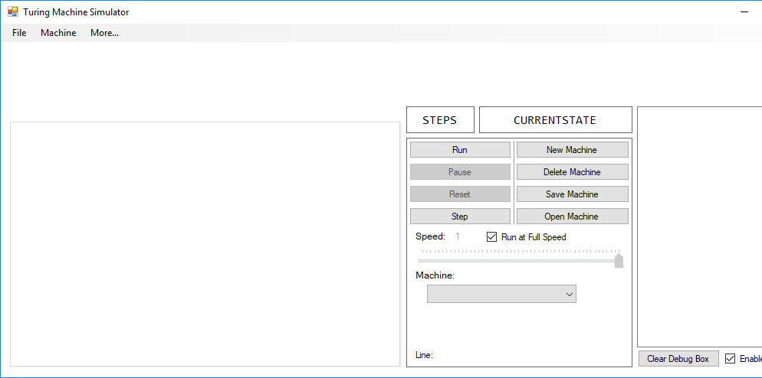

The value of the slider is also disabled to indicate that this value is not being used.

Before unchecking the box, the speed slider is disabled and the label that displays its value is also disabled. Unchecking the box does the following:

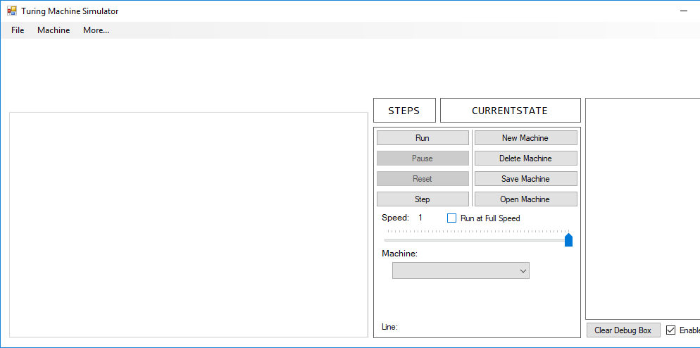

The label is now no longer greyed out, indicating that this value is being used. The slider is now usable, as shown here:

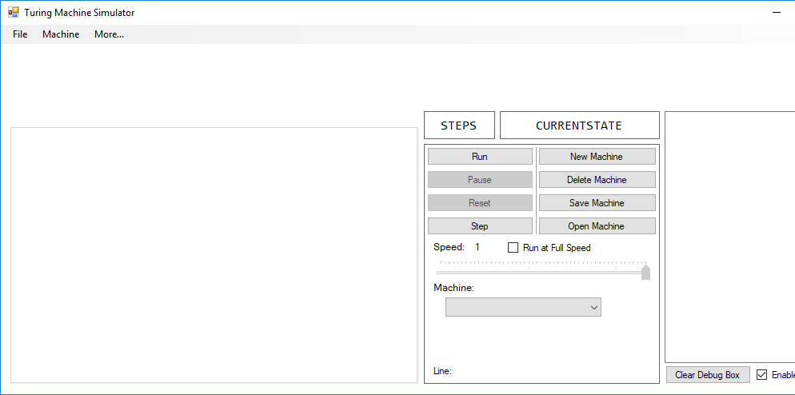

Running the machine writes the following text to the debug box:

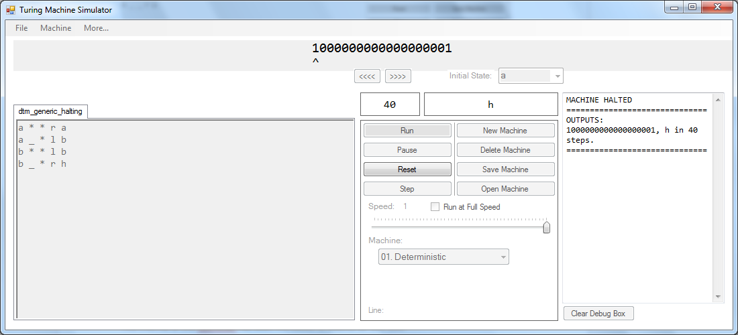

After pressing the “Clear Debug Box” button, the contents of the box is cleared:

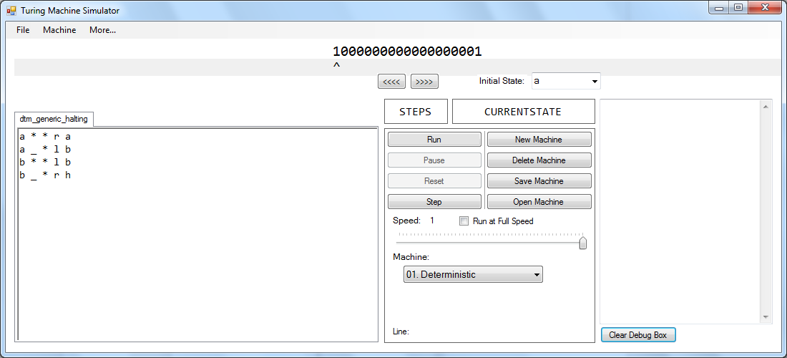

The debug box, before running, is blank:

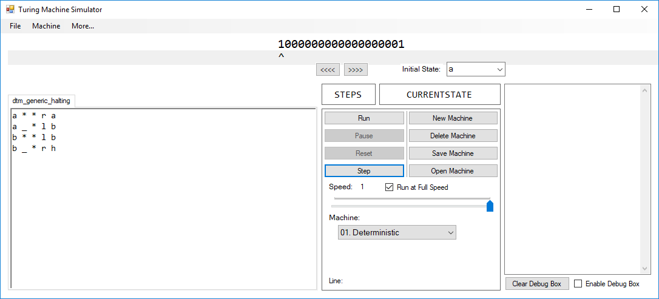

After running the machine, the debug box is still blank:

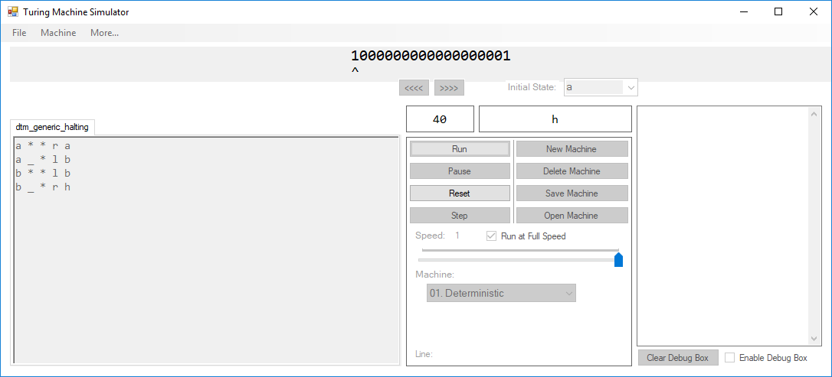

When adding text to the first line in the text editor, the line number is 1:

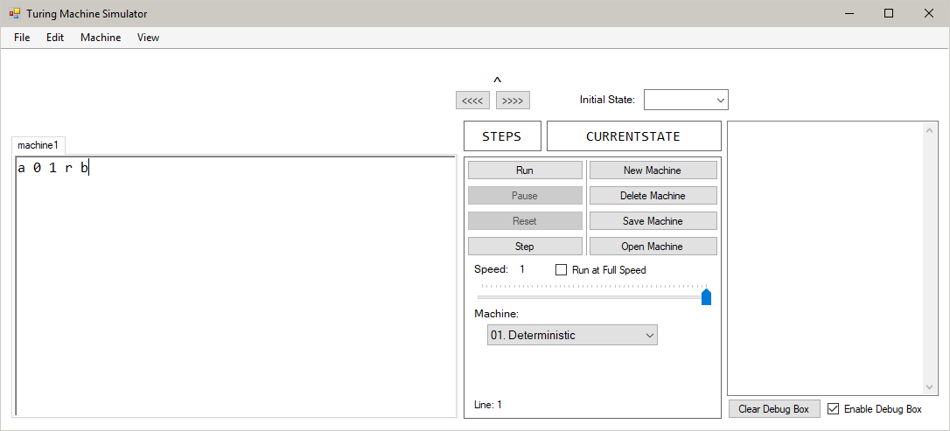

When editing the second line, the line number is 2:

